Easiest Front Zipper Application
(must have fly allowances on pattern)
- Finish edges of fly (not shown in picture)
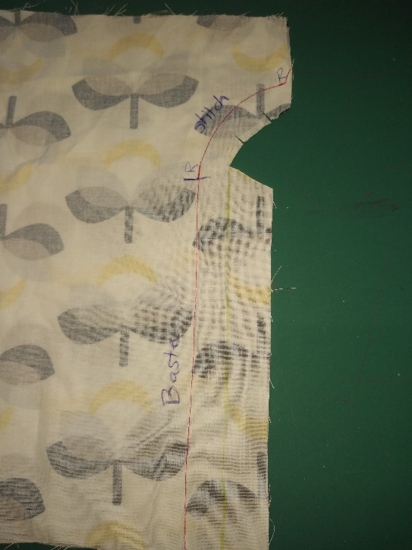
- Right sides together sew crotch seam in a regular stitch length at 5/8” seam allowance to bottom of fly. Reverse. Baste to the waist.
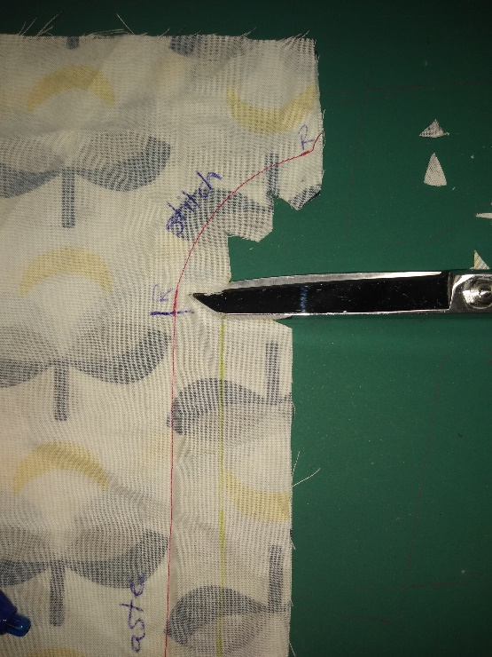
- Clip the curve and at the bottom of the fly.
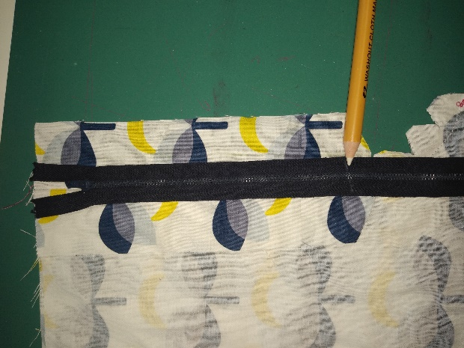
- Zipper should be length of fly. Shorten if needed. (I have not shortened the zipper in these pictures, because they are a sample.)
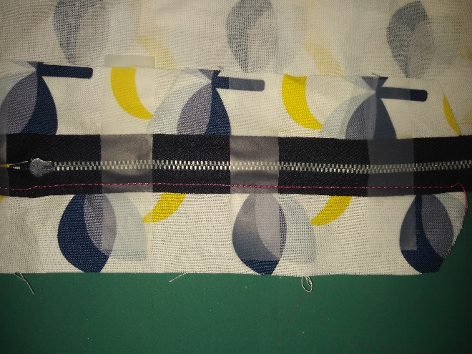
These pictures are for the zipper opening to the left, traditionally for ladies’ garments.
- Sew the zipper down the right side. (Please note that I am sewing the zipper from the bottom to the top.)
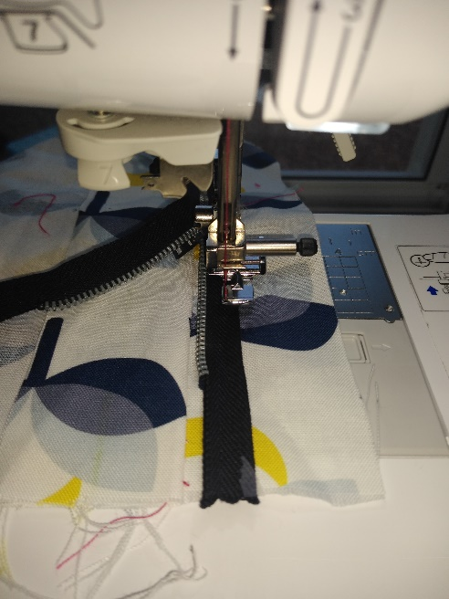
- When you get close to the zipper pull, with the needle down, lift the presser foot and carefully unzip the zipper a little so you don’t have to sew around the zipper pull.
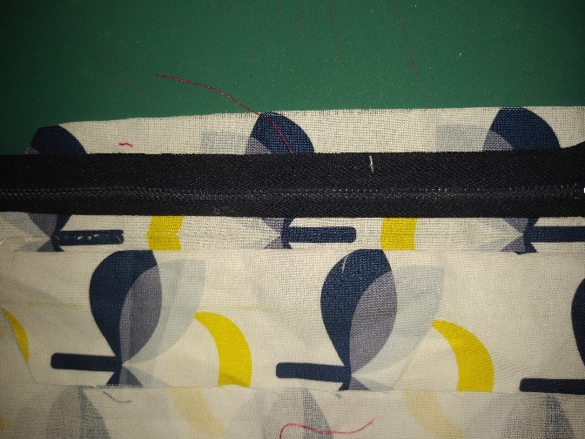
- Fold zipper right side up.
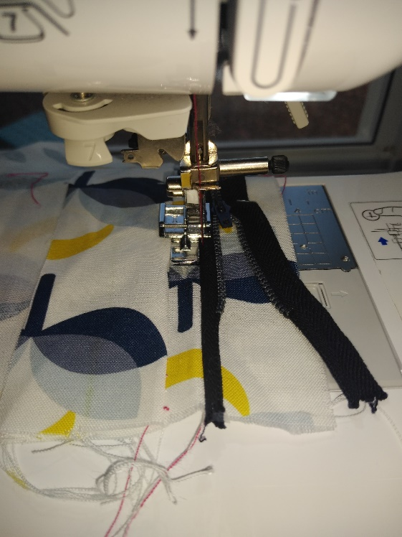
- Top stitch along edge of zipper.
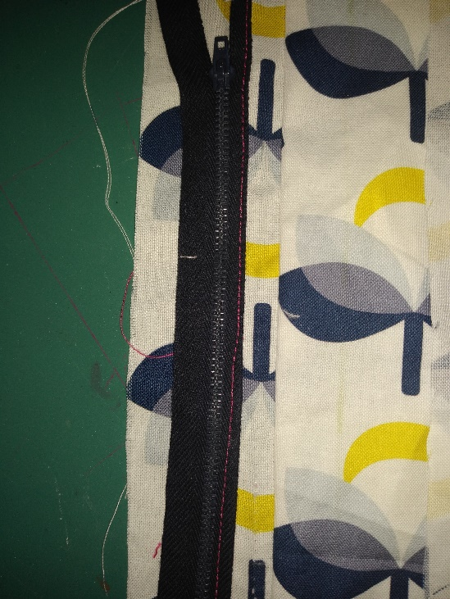
- This shows top stitching. Fold the other half of the fly over the zipper.
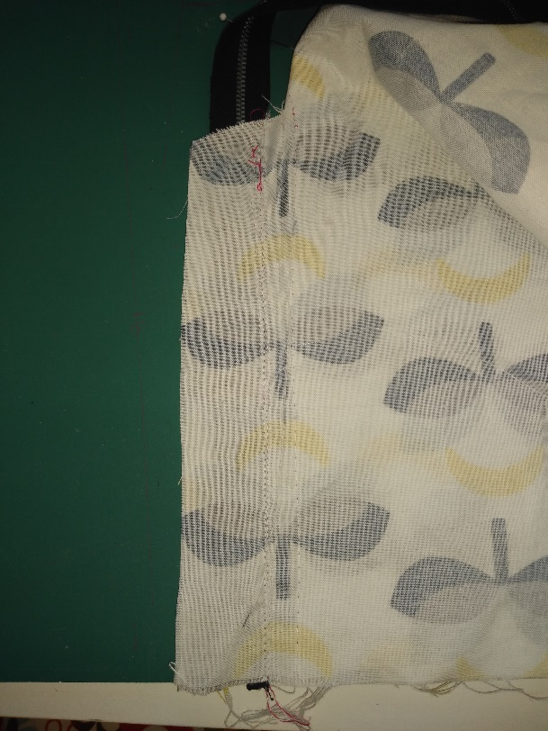
- Shorts are folded right sides together with fly allowances lined up.
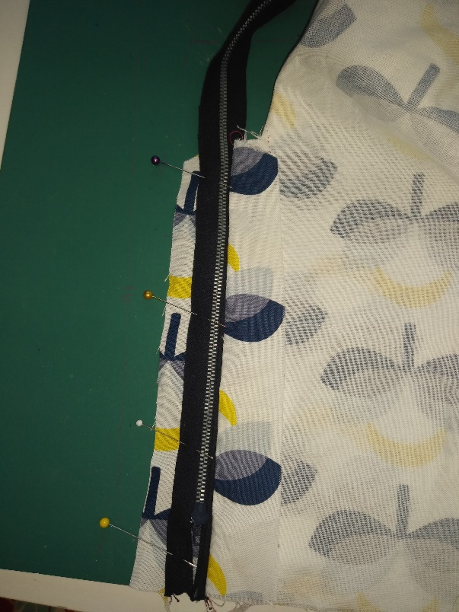
- Lay zipper flat on the unsewn fly allowance. Notice the fly allowance that the zipper is sewn onto is folded out of the way. Pin free zipper edge to unsewn fly allowance.
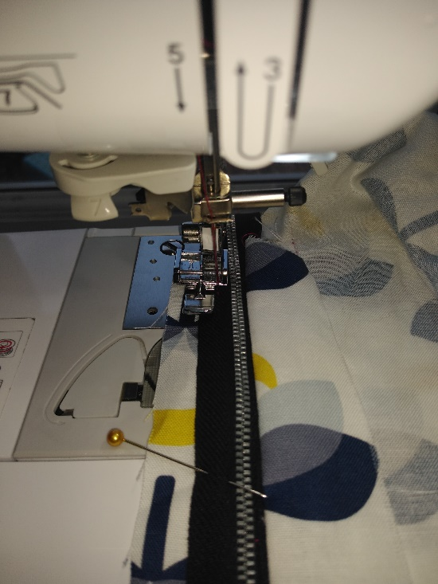
- Adjust zipper foot to proper side of zipper tape and sew.
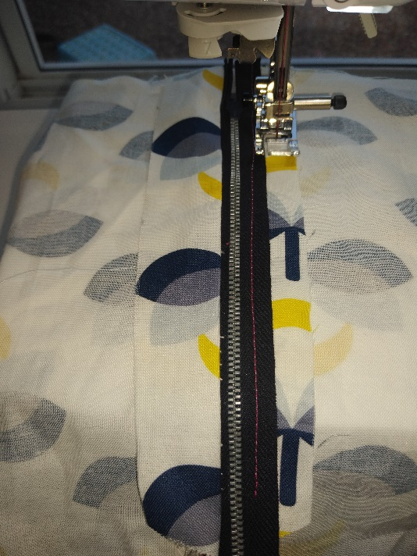
- (I like to do this from the wrong side, so I can use the cut edge of the fly allowance as a guide. Some people do it from the topside and draw stitching lines.) Stitch most of the way down the edge of the fly.

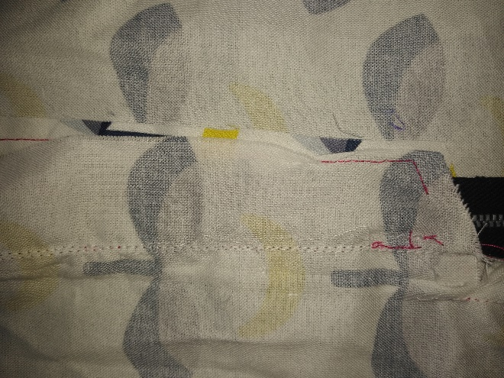
- Fold the other edge of the fly allowance over the zipper and finish sewing around the bottom of the fly. Be careful not to cross the center front seam. (Please note that this step is not complete in this photo, because I am going to take the zipper out.)
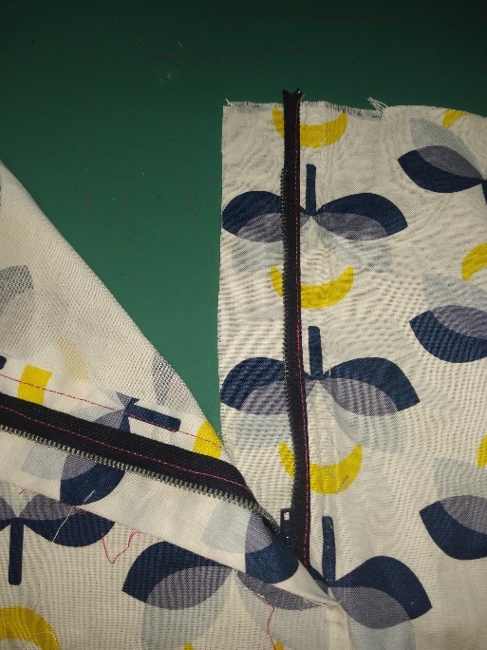
- Turn to right side. Take out the basting stitches. (Please note that I did not finish the edges of the fly allowance in this photo. Do this prior to starting. I forgot.)
If you like videos, I found this video particularly helpful. https://youtu.be/rRyFpasYJ-8

