Where should I start?
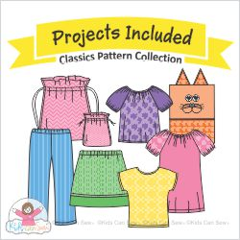
Students 8 to 11
This pattern book can only be purchased through me. This is written especially for younger students to be able to follow the pattern instructions. It is a great and easy introduction to using commercial patterns.

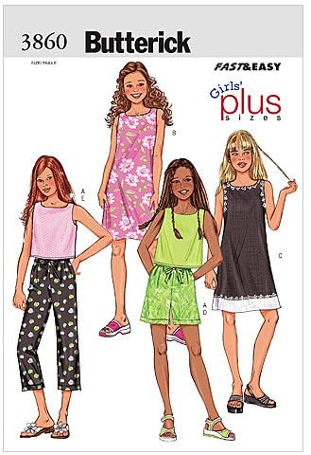
Students 11-13
This pattern has sizes 7-14. It is more complicated than the packet above. This has elastic waistband in the pants. Woven cottons.

I have several of these patterns, if you would like to order it with the sewing kit.

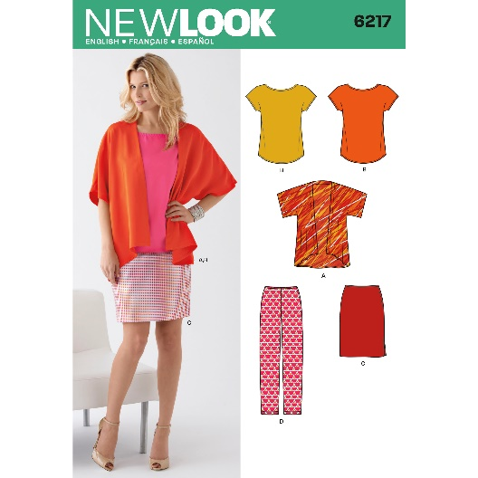
Adults and Teens wearing adult misses sizes
I have several of these patterns, if you would like to order it.

As you can see, I like New Look patterns. I find that they have some pretty fashionable styles that are very easy to make and the patterns are reasonably priced. I recommend that beginners look for easy to sew patterns like Kwik Sew, See and Sew, New Look and many Butterick, McCalls or Simplicity patterns. Avoid Burda and Vogue for now. They tend to be more complicated.

These are good beginner patterns for older teens and adults. What I look for in a beginner pattern is:
- Cost – Patterns can cost $30 each. I like beginners to keep pattern costs under $10. These are around $5-10 each.
- Fabric – 100% woven cotton for the first few projects. It is the easiest fabric to work with. It is easy to be successful with woven cotton.
- Multiple items in one pattern, so you get your money’s worth.
- Easy – simple straight lines without lots of details that will just frustrate you. Casual fit.
- Few pattern pieces for each garment. 2-3
- Minimal notions – zippers, buttons, trims, bias tape.
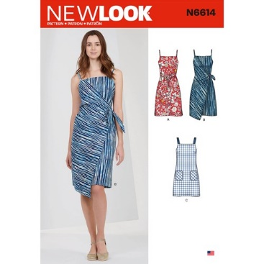
- Elastic waistband is preferred for beginners, but a regular zipper is okay or up to 3 buttons. Very simple or no sleeves.

There are many different skills to learn to sew. Each one has its own learning curve.
- Learn how to comfortably use the sewing machine.
- Learning how to handle fabric
- How to lay out patterns for cutting
- Learning how to pin
- How to cut fabric
- Basic construction
- Getting comfortable with construction
- Learning finishing techniques
- Fabrics that need special handling (all the ones you like)

This pattern was chosen by a young lady for her second project. It will be challenging. Views A and C were recommended. Note the straight lines. Woven cotton and a zipper.
It is important to pick a pattern that you will like and that you can successfully complete. Please always check with me if you have any questions.
Tracy@OneStitchAtATime.org

