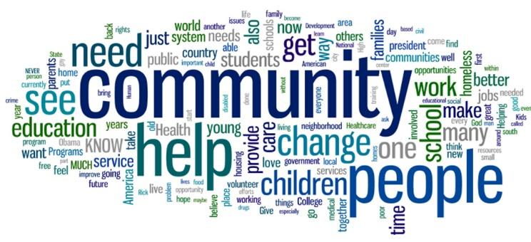
THE NOBLE
FOUNDATION

Mission:
To ensure all marginalized communities can gain the connections, knowledge, and empowerment to build a more just, equitable, and healthy society. We support the idea that “the commUNITY knows what the commUNITY needs and has the abilities, tools, and power to respond and organize together.

Vision:
We envision a community where all people are inspired to live, work, and play through their natural leadership abilities by recognizing commUNITY strengths and power.

Values:
  - Honor of all cultures, lifestyles, and beliefs as necessary voices to ensure our work produces safety and respect towards all communities.
  - Commitment to ensuring all vulnerable and traumatized community members are addressed without judgment.
  - Respect to diversity of thoughts, abilities, perspectives, and the environment of all individuals
  - Confidence in the influence and power of creating community partnerships.
  - Passion for ensuring our programs are delivered with integrity and excellence.

