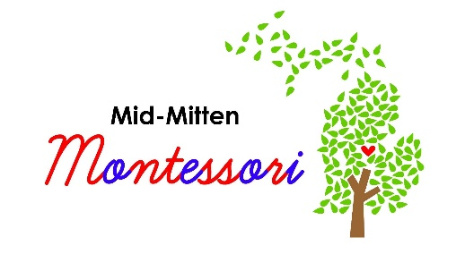

Programs Offered
Program 1=M-F 7:45 AM to 12:45 PM
This program offers three (3) uninterrupted hours of Montessori instruction in the classroom for preschool, kindergarten, and first grade students. It also includes lunch, and outdoor recess. Morning snack provided.
Program 2=M-F 7:45 AM to 3:45 PM
This program offers three (3) uninterrupted hours of Montessori instruction in the classroom for preschool, kindergarten, and first grade students. Lunch, outdoor recess, then 2.5 hours of afternoon classroom instruction and/or nap. Morning and afternoon snack provided.
Program 3=M-F 7:45 AM to 5:30 PM
This program offers three (3) uninterrupted hours of Montessori instruction in the classroom for preschool, kindergarten, and first grade students. Lunch, outdoor recess, then 2.5 hours of afternoon classroom instruction and/or nap. Morning and afternoon snack provided. It ALSO includes aftercare where children can do open play, outside time, and/or special projects. Caregivers can pick up their child anytime between 3:45 and 5:30.

Discounts available:
10% sibling discount (for youngest enrolled sibling)
Extra Fees
Grain/Snack fee $25/ month
Child under 3 as of 1 Sept. $165/month (Max $495 total)

