Name:__________________________ Date:_____/_____/_____
INSTRUCTIONS: Please use the diagram below to indicate the symptoms you have experienced over the past 24 hours. Use the key to indicate the type of symptoms.
KEY:
Pins and Needles = 000000 Stabbing = / / / / / /
Burning = xxxxxxx Deep Ache = zzzzzz
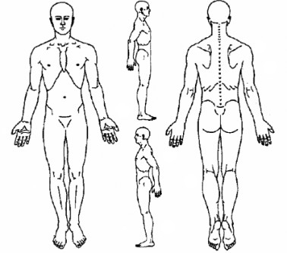

Please rate you current level of pain on the following scale (circle one):

0 1 2 3 4 5 6 7 8 9 10
(no pain) (worst imaginable pain)

Please rate your worst level of pain in the last 24 hours on the following scale (circle one):

0 1 2 3 4 5 6 7 8 9 10
(no pain) (worst imaginable pain)

Please rate your best level of pain in the last 24 hours on the following scale (circle one):

0 1 2 3 4 5 6 7 8 9 10
(no pain) (worst imaginable pain)

