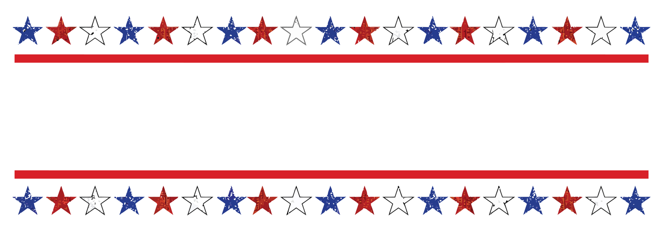
America’s Patriotic Home Celebrates Armed Forces Day
75th Annual Armed Forces Day May 12th- 17th, 2026 Hawthorne Nevada

Traci Paulson, Vendor Coordinator Armed Forces Day Committee
PO Box 1992 | Hawthorne, NV 89415 | www.ArmedForcesDayNV.com (website) Armed.forces.day@outlook.com (e-mail) traci-btt@sbcglobal.net
Vendor Application 2026
Company or Organization: _______________________Contact Person: ___________________
Mailing Address: __________________________________________________________
*Contact Phone: ____________________ Email: ________________________________
*Liability Ins. Company & Policy #: _____________________________________________
*Tax ID or SS #: ____________________________________________________________
Brief Description of your Booth Set Up: ________________________________________
________________________________________________________________________
List of Products You Will Be Selling at the Event (Vendors selling same items may be limited):
Please attach a list if needed. INFORMATION ONLY VENDORS ARE FREE! (Cannot sell Anything!)
___________________________________________________________________________
SELECT THE SPACE SIZE NEEDED AND IF POWER IS NEEDED
All spaces are outdoors. Please plan accordingly.
Do you use a generator Yes____ No____This will affect placement and must be disclosed with application.
___10 X 10 / $30.00 per day ______ Food Vendors add $25.00 per day. _________
___10 X 25 / $50.00 per day ______ Tattoo Vendors add $15.00 per day. ________
___15 X 20 / $75.00 per day ______ Power is an additional $10 per day per outlet-total____ Water available for use, you need to haul to your space, no hook ups available
Non-profit - Merchandise vendors pay a flat fee of $20 for the whole event!
Non-profit – Food vendors pay a space fee of $20 a day!

Total of above choices. ___________Payment can be made by check/money order in the mail or on the vendor page of the Armed Forces Day Website (Put your vendor’s name in the notes)
Days you’ll be set up: Tues ___ Wed ___ Thurs ___ Fri ___ Sat ___
Please call vendor coordinator upon arrival. Phone # to be provided when app is accepted.

PLEASE RETURN THIS SIGNED PAGE WITH THE COMPLETED APPLICATION PAGE BY 4/25/26!
ALL VENDORS
SUBMISSION DEADLINE IS APRIL 25TH, 2026.
Vendor set up begins at 9:00am on Tuesday, all vendors must be completely set up by Saturday at 10:00am. It is recommended to unload your vehicle entirely before setting your booth(s) up. Unloading space is limited and you may be asked to move your vehicle to allow other vendors to have access. There will be NO REFUNDS after May 7th, some exceptions may apply.
FOOD VENDORS
Please send a copy of your Temporary Health Permit when you have obtained it. Contact the Health department at least one month prior to the Armed Forces Day Event to secure approval in time to avoid loss of vendor fee. NO REFUNDS shall be issued to food vendors who fail to receive proper health permits. *This Also Applies to Tattoo Vendors*

ARMED FORCES DAY COMMITTEE RELEASE OF LIABILITY AGREEMENT
The undersigned wishes to participate in the 75th Annual Armed Forces Day Celebration as a vendor. The provisions of the agreement apply to me, my entity, group or organization and our invited guests. I agree to abide by all applicable rules and regulations as read on Page 3 (rules page). Failure to do so may result in revocation of permission to participate in future Armed Forces Day Celebrations in Hawthorne, Nevada. I agree to reimburse Mineral County for any damage done to its property by myself or any other person associated with myself or my group. I also agree to save and hold Mineral County, the Armed Forces Day Committee and its officers, agents, volunteers, and employees harmless from any person or damage to any property arising out of my activities.
I certify that I have the authority to enter into this agreement on behalf of the entity or organization described on the application and I am executing this agreement on its behalf.
Name or Individual/Guardian/Organization: ____________________________________
Print Name: ______________________________________________________________
Authorized Signature: _________________________________ Date: _______________
Welcome to the 75th Annual Armed Forces Day Event in Hawthorne Nevada (Mineral County).

For you to better understand what your vending experience could be, here’s a brief description of our event.
Hawthorne is America’s Patriotic Home. Our community has been celebrating our Armed Forces for over 74 years. Many individuals, military, politicians, and organizations come here instead of the cities because of our pride in and for our military. Hawthorne is the location of the largest Army ammunition depot, which supports our event immensely. Hawthorne AFD is growing again, and headed back to the weeklong family event it once was. We have many small events all week long, such as an Elementary school patriotic concert, bicycle parade, bands, possible water fights, scavenger hunts, Class reunions etc. On Friday night there’s a firework show, yet the main event is always the parade on Saturday. Armed Forces Day! Family and friends start arriving the week before the main event. They and our locals enjoy new opportunities to shop, whether it be for trinkets, or new food options. Give us a chance to support you. Come early so we can buy before the crowds.
We will be expanding the marketing of our event this year by posting on as many social media sites as possible, sending letters to surrounding area’s news and radio stations, posting flyers in other communities and handing out “save the date” cards and flyers at other events around Nevada throughout the year.
Our County Commissioners have allowed the Armed Forces Day Committee to open up vending earlier in the week to give vendors an opportunity to make up your fees and set up at your pace. We as a committee have chosen to give vendors “free days” to do just that. Vendors who pay for Thursday, Friday and Saturday may show up as early as Tuesday and set up to sell for no additional fee. Additionally, if any vendor is headed to another event for the weekend of May12th-17th and would like to stop here to sell during the week, you are welcome to pay for any day(s) you’d like to be here starting Tuesday May 12, 2025. Please understand that means you may be here ON Tuesday Morning. Setting up on Monday is not allowed.

Armed Forces Day Event Rules
All vendors must comply with the following rules during the duration of the AFD event.
- All vendor applications filled out completely with fees included must be received by April 25th, 2026.
- All vendors must follow the direction of the Vendor Coordinator and the Armed Forces Day committee Members. NO AGGRESSIVE BEHAVIOR WILL BE TOLERATED.
- Vendors may NOT sell poppers, realistic or air guns, smoke bombs, stink bombs or silly string of any kind.
- Vendors are responsible for securing all merchandise. The AFD Committee is not liable for loss of property or sales.
- All vendors canopies MUST be anchored.
- It is the responsibility of each vendor to leave their area clean each day and at the end of the event. Please place garbage in provided trash cans.
- NO PETS permitted in the designated vendor areas.
- Vendors will refrain from Alcohol consumption while open for business.
- FOOD VENDORS will provide their own hand wash stations.
- Vendors with Generators will not be allowed in the main parking lot of the El Capitan.
- Please Print all information legibly.

All Vendors Must Complete and Return Sales Tax Paperwork at the End of the Event!

