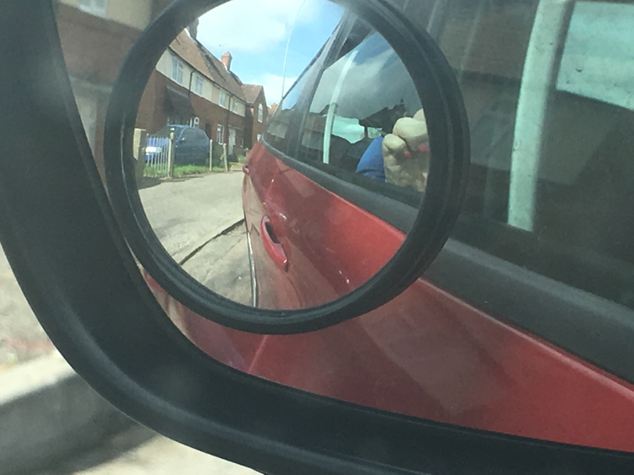
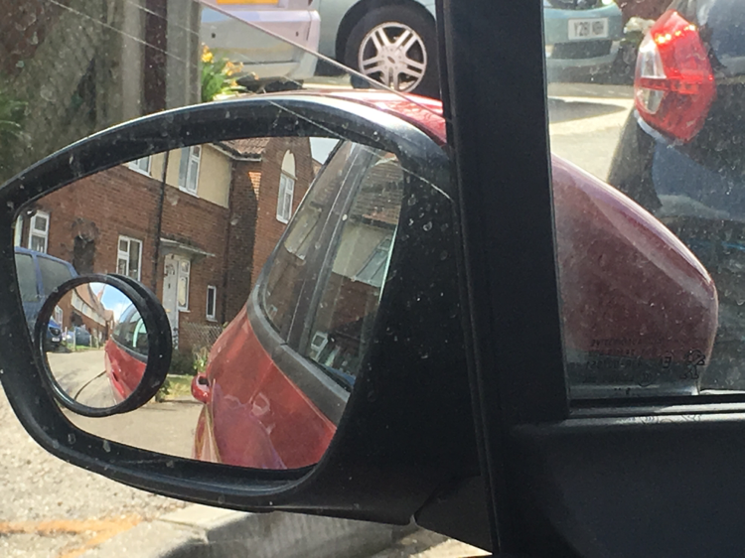
Sandy's Driving School

Parallel Park

1: pull up alongside the chosen vehicle leaving about an arms length/car door length between you and the vehicle. Go straight into reverse so any vehicle coming up behind you will know what you're doing.
2: all round observations. Reverse back until the front/rear (whichever way its facing) of the vehicle appears half way across the back passenger window.
3: check over your right shoulder. One turn with the wheel to the left (because we want the back of the car to go left, remember when reversing we steer the way we want the back to go and the opposite way we want the front to go). Keep going until you get to 2 o clock.
4: all round observations then one full turn to the right (this straightens up our wheels again so we can go back straight). Keep going until you find the ‘v’ shape between the car and the curb (this is us getting our back wheels where we want them to be, so don't get too close to the curb and don't be too far out if you can help it).
5: all round observations then full lock to the right (this brings the front of the car in towards the curb.
6: when the car is straight then straighten the wheel, this is a turn and a half to get off of full lock.

Fixing

If you need to fix your manoeuvre remember that in reverse you steer the way you want the back to go and the opposite way for the front of the car. Just as when you are in forward gears and if you want the front of the car to go left you steer left but the back will swing out to the right. Try to keep the car moving slowly so it's easier for you to fix it, to observe and keep control. Commit to fixing it in one direction if you can, i.e if you have space to fix going forward and need to get nearer the curb then you'd go into first, move the front nearer the curb by turning the wheel left then moving the back in by turning the wheel right then straightening the wheel and reversing back to a decent distance. Same with fixing going back, you'd steer left in reverse to get the back closer to curb and then right in reverse to get the front in.

