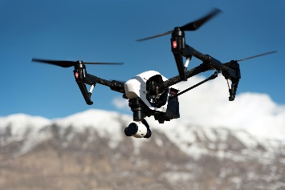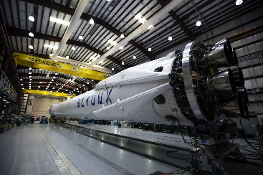

* National Team – Engineering for the Missile Defense Agency: May 2022 – Present. Lockheed Martin Senior Systems Engineer employee.
* NASA – Huntsville Operations Support Center: Feb 2020 – Apr 2022. Colsa Corp Senior Systems Engineer employee.
* Naval Surface Warfare Center, Dahlgren Division – Gun Fire Control and Integration Branch. Senior Principal Information Security Engineer

COMPANY SNAPSHOT

Our mission at eXtc, Inc. is to provide focused, extreme solutions to technical project tasks in a highly flexible manner. We bring to bear years of experience in working with the federal government on critical tasks for our nation’s security and defense.

**DUNS SAM UEI**

078452688 F1NTRBQGBRH4

**CAGE Code**

6S5H8

**NAICS**

541712 – Research and Development in the Physical, Engineering and Life Sciences [Primary]

541611 - Administrative Management and General Management Consulting Services

541690 – Other Scientific & Technology Consulting Services

336411 – Aircraft Manufacturing

928110 – Space Force

**Contact Information:**

John F Dawson

Founder and President

Email: [jfdawson@extremal.us](mailto:jfdawson@extremal.us)

Phone: (205) 533-3829

Website: www.extremal.us

**Core Competencies**

eXtc is a service disabled veteran owned small business specializing in project management, systems engineering and cybersecurity located in central Alabama. Our interests focus on space systems, autonomous robotics, weapons integration and research and development. We are enthusiastic to contribute to your development needs.

eXtc provides a high level of expertise over a broad range of scientific and technical disciplines from requirements definition to integration, testing and deployment. Our core competencies include:

* Software Development Lifecycle
* Hardware Design and Fabrication
* Project Management services

**Differentiators**

* Over 30 years of defense contracting experience
* Project Management, Cybersecurity and Systems Engineering expertise
* Hardware and software weapons systems integration

**Past Experience**

**Extremal Technology Corporation, Inc.**

**eXtc Capability Statement**