Earning A Merit Badge

Four Steps in Boy Scout Advancement
- The Scout learns.
- The Scout is tested.
- The Scout is reviewed.
- The Scout is recognized.
Broad Range of Subjects
- More than 130 merit badges in 14 subject areas
  - Agribusiness
  - Arts and crafts
  - Business and industry
  - Communications
  - Conservation
  - Hobbies
  - Natural science
  - Personal development
  - Physical science
  - Professions
  - Public service
  - Sports
  - Trades
  - Transportation
Benefits of Merit Badges
- Contribution to the aims of Scouting: citizenship, character, and fitness
- Development of confidence, self-reliance, and social skills
- Physical fitness and healthy lifestyles
- Career and hobby choices may result
- Exposure to positive role models
Merit Badge Process
- Scout indicates interest; discusses with unit leader;
gets counselor name and blue card
- Scout contacts counselor
- Scout/Counselor first meeting
- Subsequent Scout/counselor meetings
- Scout completed requirements
- Counselor approves completion
- Scout returns completed merit badge card to unit leader
- Unit reports advancement and obtains badge for presentation

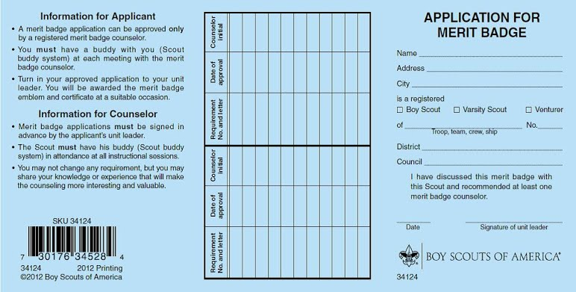
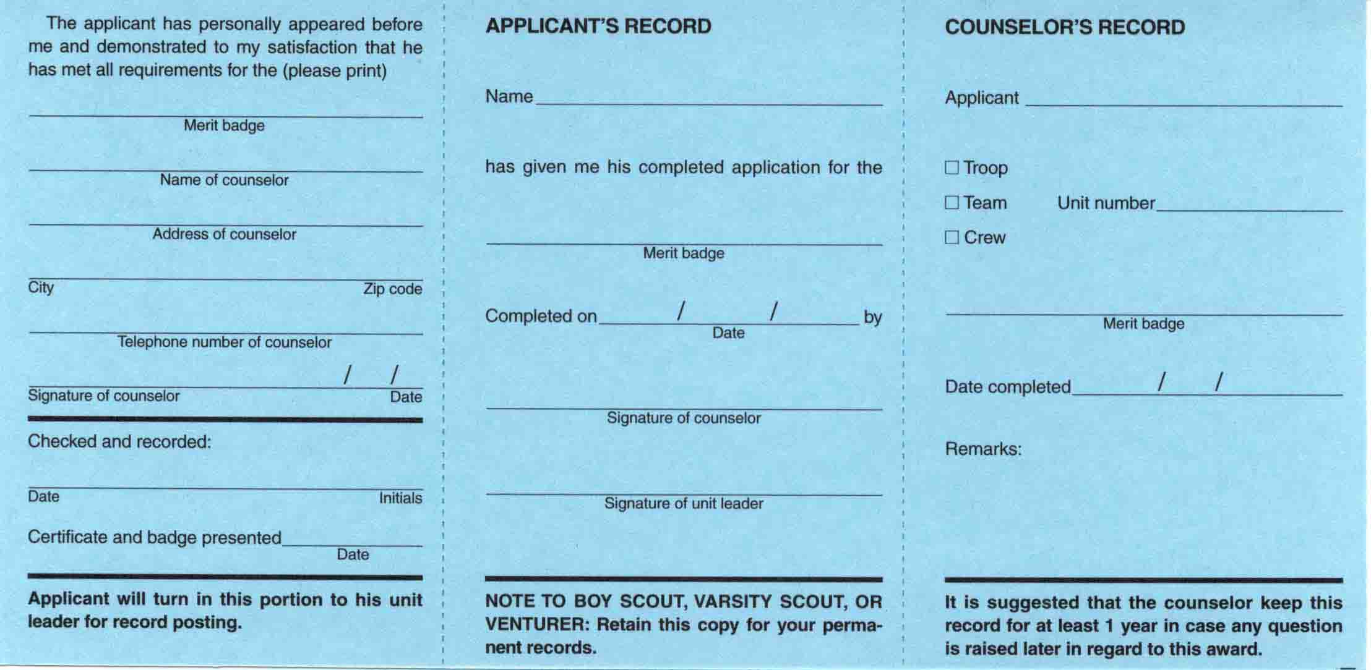
Blue Cards
- The merit badge counselor records and initials the front of the card in the middle section as each requirement is completed.
- The back of the card is not signed in either place until all requirements are fulfilled.
- Partials do not expire as long as the Scout is a registered youth member.
- Accepting a “partial” is at the follow-up counselor’s discretion.

Merit Badge Requirements
- Not Flexible, must be fulfilled as written
- A single activity may fulfill more than one requirement if…
  - Requirements match and have the same intent.
  - It is not specifically disallowed.
  - The Scout remembers safety content.
  - Common sense suggests that meeting the requirement more than once is unnecessary.
  - Merit badge requirements must not be waived or changed for any Scout.
  - Scouts with disabilities—either permanent, or expected to last at least two years or beyond age 18—still may advance.
  - The “Application for Alternative Eagle Scout Rank Merit Badges” may be found at: www.scouting.org/filestore/pdf/512-730.pdf
  - Worksheets may be used to meet “in writing” requirements.
  - Worksheets are not a substitute for “telling,” “showing,” or “demonstrating,” etc.
Merit Badge Counselors
A second counselor review may be warranted if:
A Scout, to whom it has been made clear that only registered and approved counselors are to be used, chooses to ignore this mandated procedure.
It becomes plainly evident that it could not have been possible for a Scout to actually and personally fulfill requirements as written. In this case a limited recourse is available, according to the details outlined in topic 7.0.4.7.

Merit Badge Q & A

At what age or rank may Boy Scouts work on merit badges?
There is no limit if registered as a Scout.
What is the maximum number of merit badges a Scout may work on at the same time?
There is no limit.
Is a Scout allowed to begin work on a merit badge without his unit leader’s approval?
Approval is no longer required; a discussion is now held.
If a Scout has too many unfinished merit badges, may the Scoutmaster limit how many others he may begin?
During the discussion of a new merit badge, the Scoutmaster should provide counseling
on what to do.

Is it appropriate to tell a Scout he must earn all or most of his Eagle-required badges before he earns any others?
A Scoutmaster could only suggest this.
Is the Scoutmaster permitted to serve as a troop merit badge counselor for some merit badges like Camping or Hiking?
This is permitted only if the unit leader is registered and approved as a counselor.
What is the maximum number of badges a youth may earn from one counselor?
There is no BSA limit. A unit leader may set a limit, but it must apply to all Scouts in the unit.
How many badges may one counselor be approved to counsel?
National places no limit on this. Councils may do so, within reason.
May you counsel your own son?
Yes, but generally it is better for Scouts to learn from a variety of adults.
May you counsel in other units, districts, or councils?
Yes.
Due to tight schedules, is a camp staff member allowed to make minor adjustments so requirements can be finished at camp?
Absolutely not.
Once you are registered and approved as a counselor, at what point must you re-register and become re-approved?
Annually.

