2019 MEMBERSHIP FORM
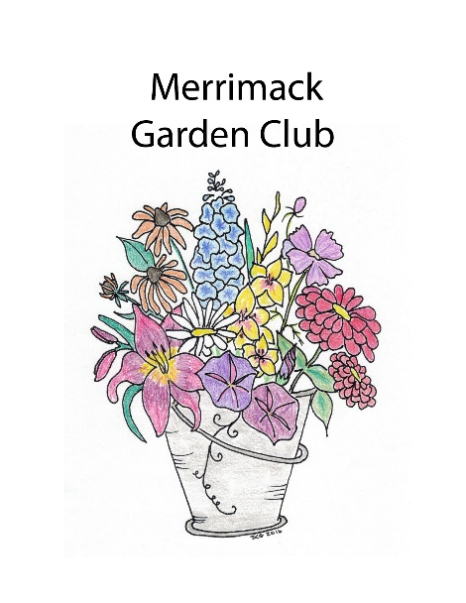
$25.00 Made Payable to Merrimack Garden Club
Mail to: Merrimack Garden Club
PO Box 426
Merrimack NH 03054

NAME

ADDRESS

PHONE CELL TEXT Y or N

EMAIL NEWSLETTER Y OR N

BIRTHDAY DAY AND MONTH (only)

OR BRING THIS FORM TO THE NEXT MEETING WE WOULD LOVE TO MEET YOU!

