Press

National Enquirer Article
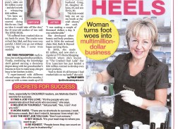

As Seen In National Publications
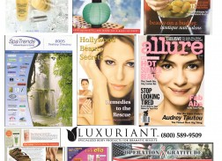

Fran Drescher Private Label – Fran Brand
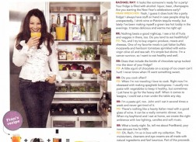
Private label formulation of niche products in the natural skincare sector

Luxuriant Donations – Operation Gratitude
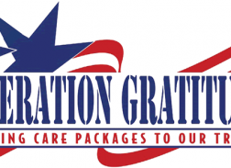
From the Luxuriant Archives: Team Tulip is assisted a woman inspired non-profit organization, Operation Gratitude in packaging their quarter millionth package that was sent to deployed troops on June 16, 2007. CEO, Clark states, “It’s amazing how one woman can make an impact”.
Luxuriant, LLC an Oceanside, CA based natural actives body care/cosmetics company is donating 10 thousand pieces of its Signature Product Cracked Heel Repair and its equally incredible Solid Stick Lotion to Operation Gratitude for our deployed U.S. military troops.

Luxuriant on the Discovery Channel show “Pitchmen”
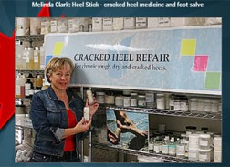
See Luxuriant on the Discovery Channel show “Pitchmen”

As Seen in Elle
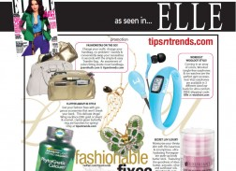
Luxuriant Solid Body Butter featured in Elle magazine

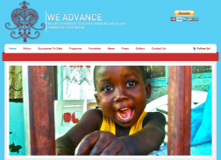
As part of Luxuriant, LLC’s mission to give back to our community we recently donated cases of Cracked Heel Repair to the non-profit We Advance. WE ADVANCE is a women’s rights based grassroots movement that focuses on capacity building. They work in some of the poorest slums in all of the western hemisphere – Wharf

Luxuriant, LLC Founder/CEO Interview on LA Talk Live
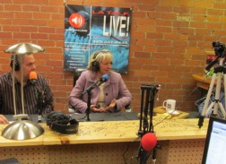
Melinda Clark Elrod, Founder/CEO of Luxuriant, LLC discusses her amazing crop of hydroponic heirloom lettuce with renowned Chef Richard Petty on the hit culinary/food talk show “Let’s Do Lunch with Chef Richard Petty” on LATalkLive on January 12, 2013.

