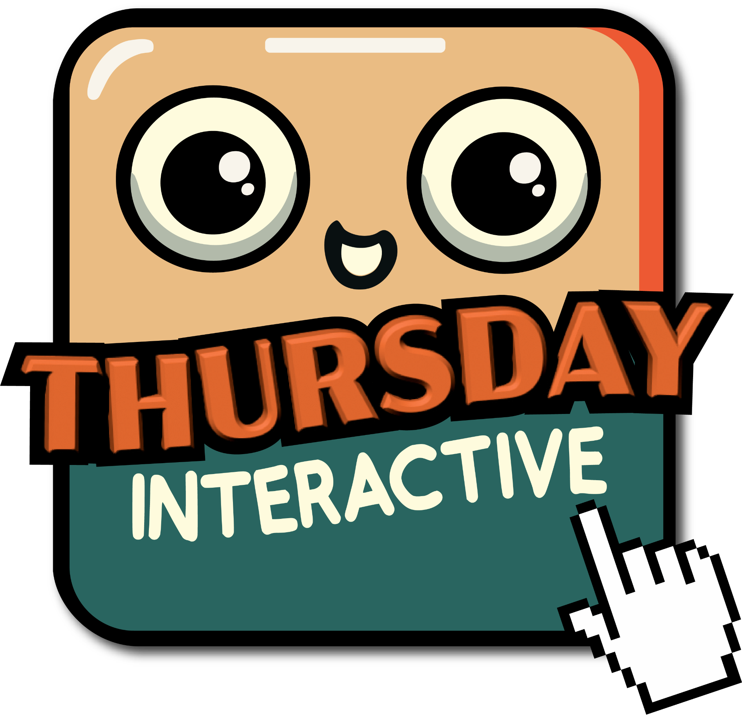
COURSE DESIGN
USING GAME THEORY
Design the Course They Don’t Want to Miss
1 NARRATIVE ARC: YOUR COURSE OBJECTIVE
What’s your course objective?

Is the student the hero, or just the person completing it?

2 CHALLENGE CALIBRATION: MAP YOUR COURSE
What are the skills that build toward the real challenge? What’s the final boss?
● What are the small skills that build toward the real challenge?

● What is the small project that integrates each set of skills?

● Does each project expand on the last, or does it reset to zero every time?

● What is the final boss: the student-created challenge all of this is building toward?

3 FAILURE LOOP: WHERE THEY FAIL
What is one assessment where students fail and just don’t come back?

What would have to change for that failure to feel like a checkpoint instead of a verdict?

Course Design Using Game Theory · thursdayinteractive.com

