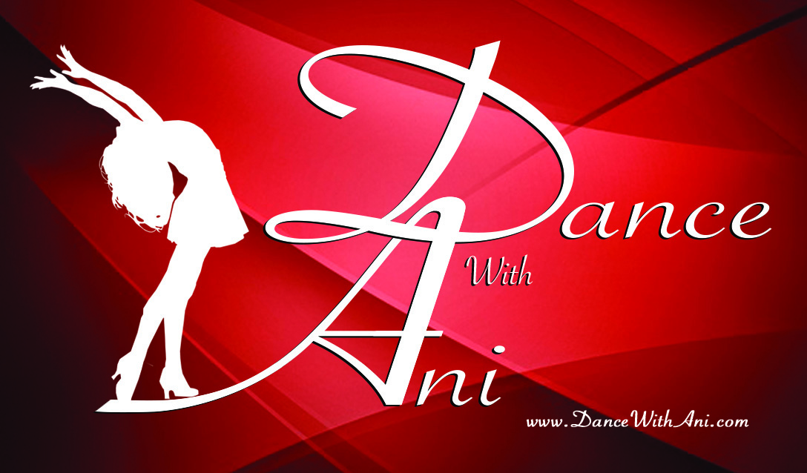

**Mat Pilates**

Mat Pilates provides simultaneous stretching and strengthening, using a series of exercises that focus on the abdominals and other muscles that create the body's "powerhouse". Working with the basic principles of control, breath, precision and centering, the Pilates method lengthens the spine, builds muscle tone, increases body awareness and flexibility. Mat Pilates is a great way to sculpt your body and to strength and tone your core. Pilates involves performing all the exercises on the floor. The main fitness goal of a Pilates program include: Improved flexibility, muscle tone, body balance, spinal support, low back health, sports performance, and body-mind awareness.

**ZUMBA**

Zumba Fitness is a Latin-inspired, dance-fitness class that incorporates international music with dance movements creating a dynamic and exciting/effective fitness system! Zumba integrates some of the basic principles of aerobic, intermittent & resistance training to maximize calorie output, cardiovascular benefits and total body toning and sculpting. The cardio-based dance movements will be easy steps to learn. Dancers & non-dancers alike immediately master a Zumba class because they do not have to know how to dance to succeed at Zumba. Zumba will give you a Healthy Heart, Stronger Muscles & Bones, Greater Mobility, help you to Lose Weight, relieve your stress, and most of all you will get to interact and share the same passion with everyone in the same room. Zumba creates a party like atmosphere that provides a non-intimidating opportunity for non-dancers, new exercisers and those who have hesitated to participate in a group class. All levels are welcome to join.

**SALSA**

Learn to Salsa like a star in this fun and energizing class! Salsa is in and it's hot! Ani will teach you the basic steps, as well as styling and great patterns of this sassy Latin dance. No partner needed. Learn basic Salsa terminology, proper alignment, gain strength, coordination, and rhythmic ability to master Salsa Dancing. Through movement this Salsa class will help you be a better partner: A good Leader and a Follower, to master partnering skills. You will also learn various Salsa footwork (shines), styling, patterns, which will help you be a better dancer on the dance floor.

**STRONG30**

No excuses! Maximize your fitness level in 2020 and get energized in a fun class that focuses on strength and toning, calorie burning, core training, agility, balance and more. High Intense total body workout, using your own body weight as resistance. STRONG 30 combines body weight, resistance style, muscle conditioning, cardio and plyometric training movements synced to customized music like no other fitness program ever. This program provides a challenging yet safe way to increase your fitness level with science-based, cutting edge, high intensity, full body training methods synced to music! Challenge yourself in this dynamic new class and be amazed at the results!

**ZUMBA GOLD**

Zumba Gold is a lower-intensity version of the typical **Zumba** class and is designed to meet the anatomical, physiological and psychological needs of seniors and students who are new to Zumba. Zumba Gold takes the popular Latin-dance inspired workout of Zumba and makes it accessible for seniors, beginners or others needing modifications in their exercise routine. Zumba Gold builds cardiovascular health by challenging the heart and working the muscles of the hips, legs and arms with dance moves.

**HIP-HOP**

Get your kids dancing, ages 5+. Inspiring kids to live happier, healthier, fuller lives through movement, and fun. Dance with Ani is an expert Kids Hip Hop Instructor and will help your kids develop physical fitness & healthy habits, confidence, expression, connection, growth & leadership skills. A great way to learn various hip-hop combinations and encourage creativity

*Great for beginners. All levels welcome

**ARMENIAN DANCE**

Get your kids dancing Ages 5+. Learn the fundamentals of Armenian dancing. Master various leg movements, hand styling/gestures, correct posture and build strength and stamina. Adapt the basics of group dancing, solo work, and duets. This class will help the students understand the different types of Armenian Dances, through various formation changes. Students will also be able to master technique, discipline, and the ability to work as a team. With the different tempos of the music students will be able to role-play and become artistic dancers.

**CLASSICAL BALLET**

Classical Ballet Barre for ages 5+. Inspiring kids to live happier, healthier, fuller lives through movement, and fun. Dancer will learn various ballet barre exercises, positions of the feet, arms, and body to strengthen and stretch the entire body; while helping the dancers to gain flexibility, great posture and placement. Practicing various jump combinations at the center and doing multiple traveling turns/spins and leaps across the dance floor.