
Wright Family Ministry

Fall 2021 Update
Dear friends and supporters, we are delighted to share with you good news. Despite the feeling—at times this year—of walking up hill. As we look back despite the setbacks, we have met many goals that we set at the first of the year. Goal #1 was to increase church attendance with new families. Goal #2
was to increase the financial income of the church. Goal #3 was to refinance the church mortgage with AGCU. Goal #4 was a personal goal and that was to publish my next book. Goal #5 was to start seeing Baptismal services and as you see the figure on the right this was accomplished in October.

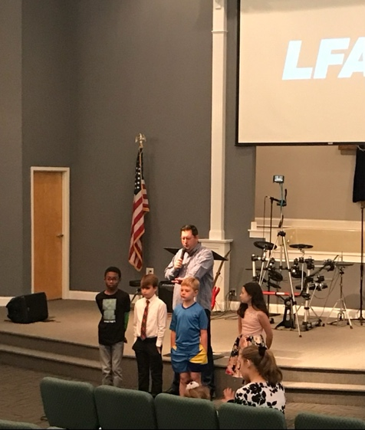
Dustin with Baptismal Candidates
We want to say a big thank you to all who have stayed with us as we transitioned into Church Mobilization. Your giving has made a huge impact for the growth and health of Loris First Assembly of God. As we continue to see rapid migration into Horry County. We are truly better together.
Announcements
- We now have a personal ministry website: www.thewrightperspective.life. This website was created to share truth digitally in alternate ways. Much of the material: the blog, podcast, and You Tube channel work seamlessly with the church website or app.
- My new book,10 Cs of Jesus Exemplified is available everywhere books are sold. By the way God provided every dime for this to be possible.
Prayer Requests
- Pray for God to provide volunteer Pastoral staff.
- Pray for increased financial support for our ministry.
- Pray for a Revival of the Holy Spirit to be experienced in the church.
- Pray for outreach inspiration.

