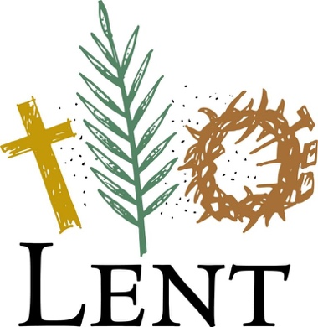
Crescent Hill Presbyterian Church
Lenten Weekly Devotional

No Paradise
Rick Roderick

Genesis 2:15-17, 3:1-7
The Lord God took the man and put him in the garden of Eden to till it and keep it. ¹⁶ And the Lord God commanded the man, “You may freely eat of every tree of the garden, ¹⁷ but of the tree of the knowledge of good and evil you shall not eat, for in the day that you eat of it you shall die.”
Now the serpent was more crafty than any other wild animal that the Lord God had made. The serpent said to the woman, “Did God say, ‘You shall not eat from any tree in the garden’?” ² The woman said to the serpent, “We may eat of the fruit of the trees in the garden, ³ but God said, ‘You shall not eat of the fruit of the tree that is in the middle of the garden, nor shall you touch it, or you shall die.’ ” ⁴ But the serpent said to the woman, “You will not die, ⁵ for God knows that when you eat of it your eyes will be opened, and you will be like God, knowing good and evil.” ⁶ So when the woman saw that the tree was good for food and that it was a delight to the eyes and that the tree was to be desired to make one wise, she took of its fruit and ate, and she also gave some to her husband, who was with her, and he ate.⁷ Then the eyes of both were opened, and they knew that they were naked, and they sewed fig leaves together and made loincloths for themselves.

If we take the story of Adam and Eve literally, we can come to the conclusion that they introduced original sin into the world, and God punished them for it. Another way of looking it is that humanity had a realization that the paradise that they sought is unattainable.
Sometimes, life seems to be going very well. Then sickness and death occur, a conflict occurs with others, or a natural disaster destroys well-laid plans. Often, when people attain what they view as paradise, it will be gained because of the sacrifice of others.
This situation causes many of us to throw up our hands in despair. However, this is not what God intends or what Jesus taught. The Lord's prayer says, "Thy kingdom come, thy will be done on earth as it is in Heaven." This is a request to God, but not a passive one. We are empowered by the Holy Spirit to work for a better world in small and large ways. It may be in simple acts of helping others or in participating in movements to promote social change.
Our Earth Care Team works for environmental justice in our congregation and throughout the larger church and community. They keep us informed and engaged about initiatives to make the world a better place.
We cannot bring about Heaven on earth, but we can work toward a better quality of life for all of us. May we spread the love of God in everything we do.

Prayer: Gracious God, we pray that your realm may come to earth. Help us to spread your love and work for a better world. Amen.

