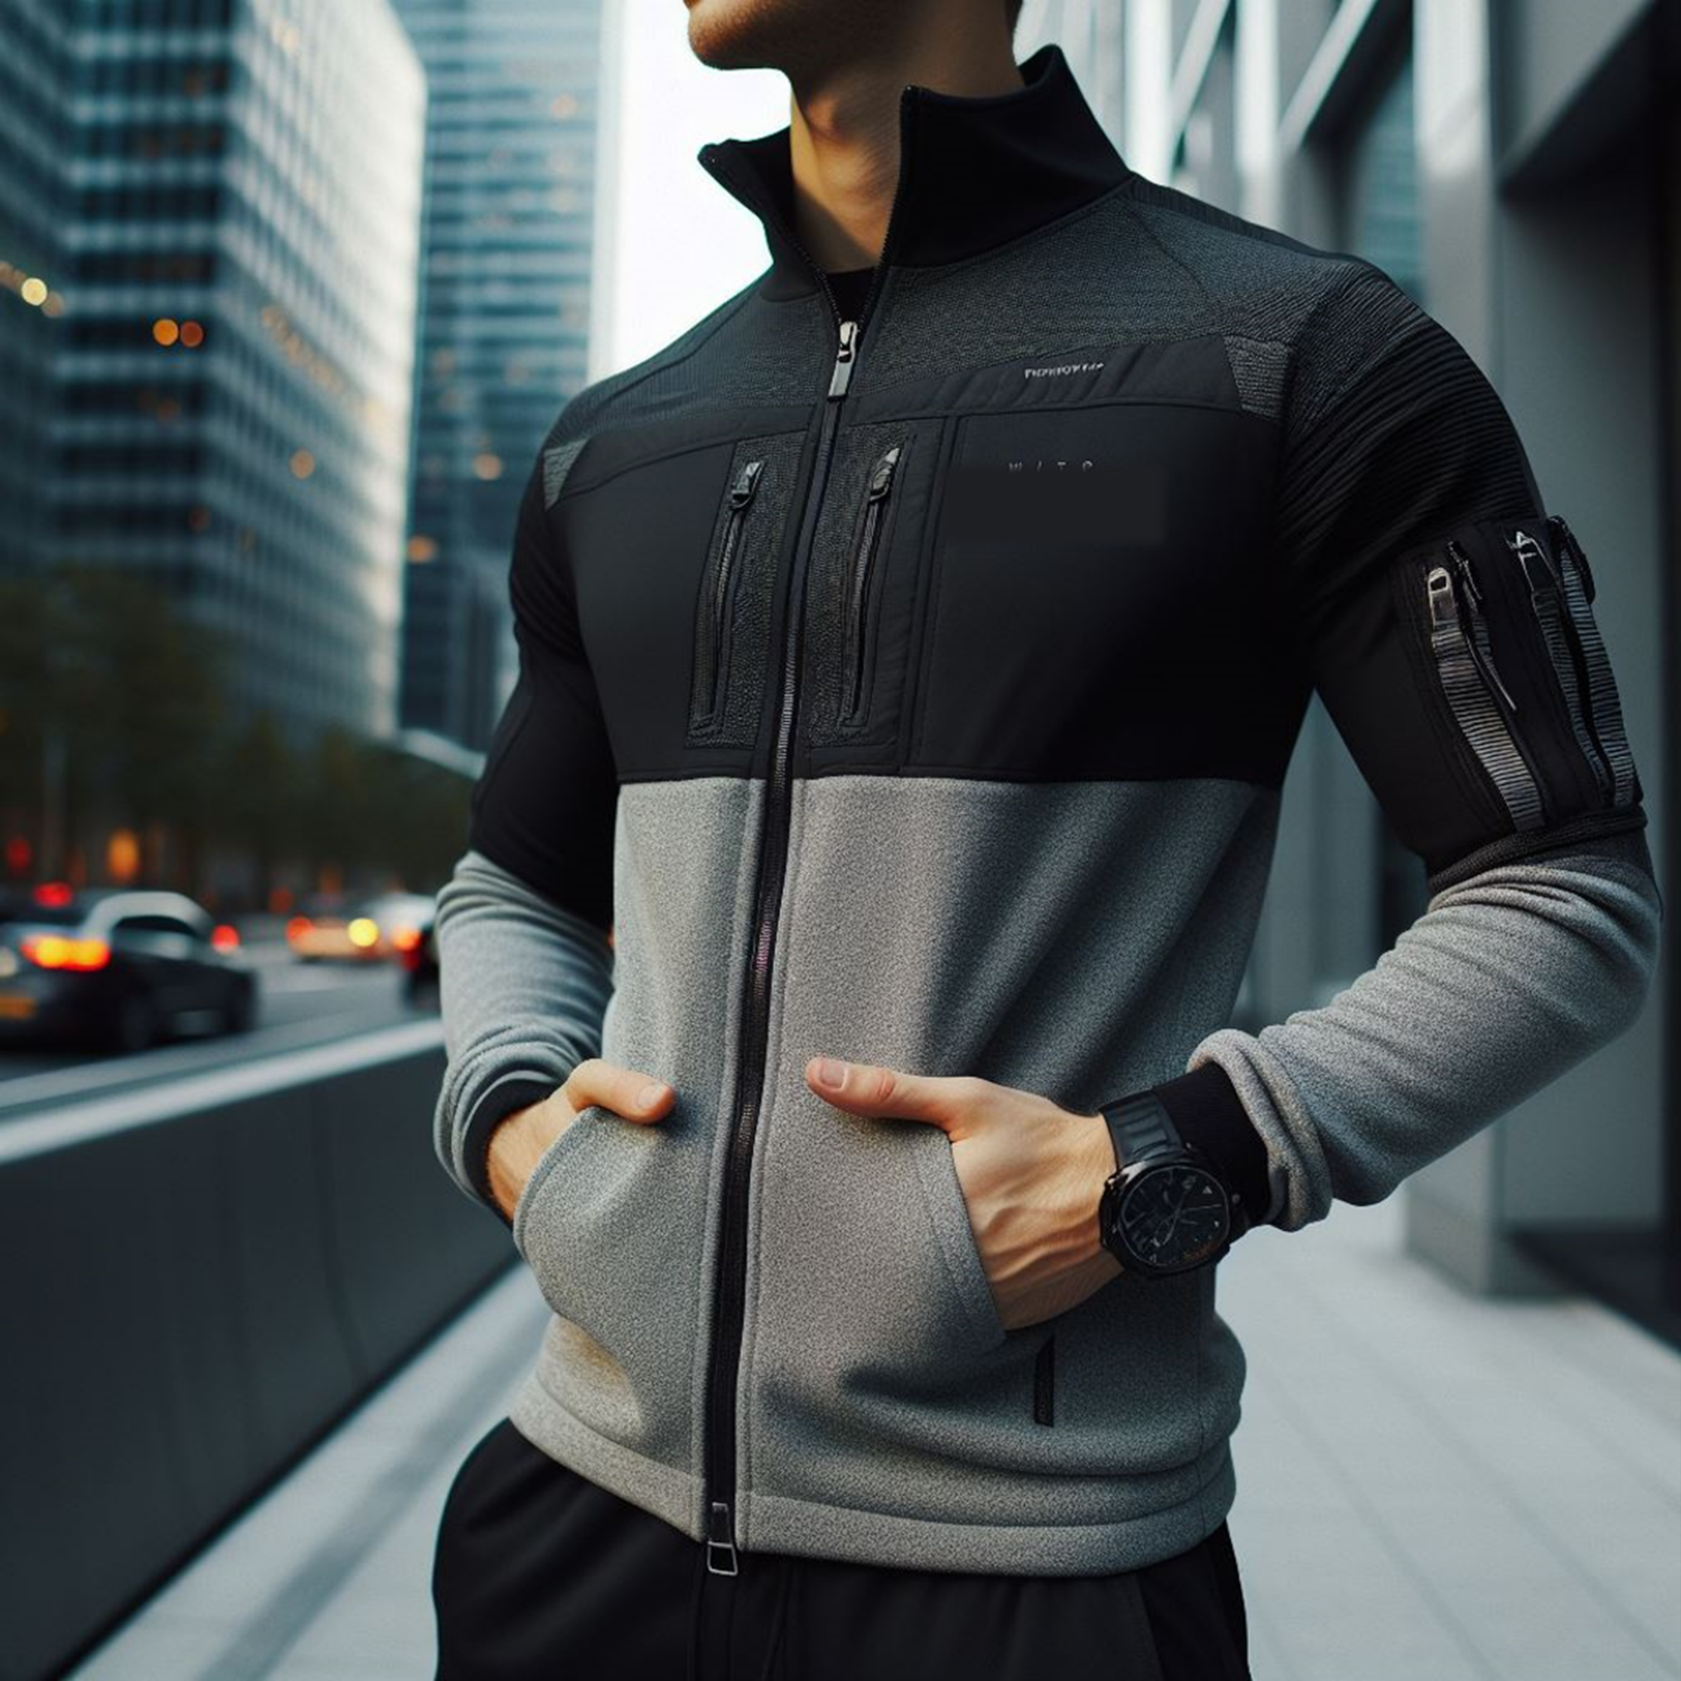
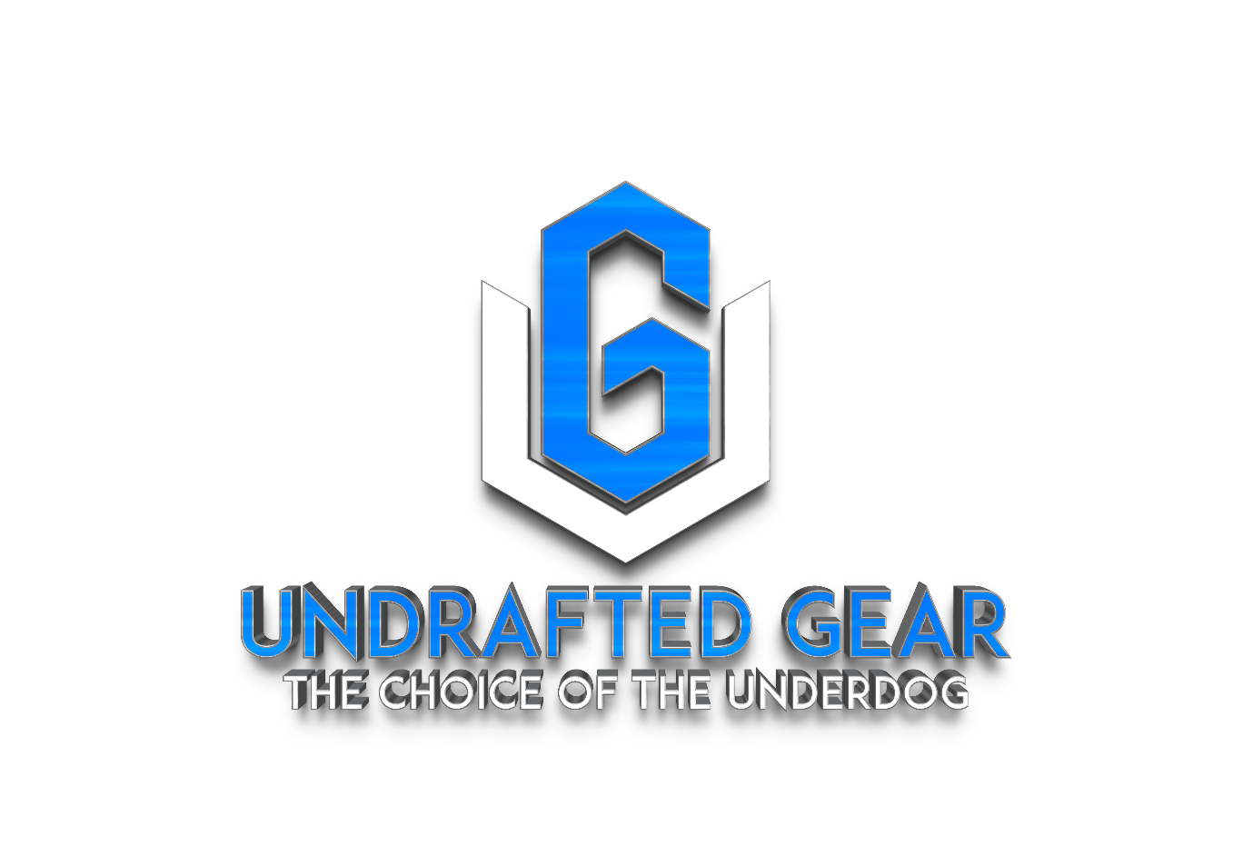

Prepared: February 2024

Web: www.undraftedgear.com
Phone: 1+ (951) 807-1382 USA
E-Mail: undraftedgear@gmail.com
BUSINESS PLAN
Confidentiality Agreement
The undersigned reader acknowledges that the information provided by ………………………………………. in this business plan is confidential; therefore, the reader agrees not to disclose it without the express written permission of …………………………………………………………………

It is acknowledged by the reader that information to be furnished in this business plan is in all respects confidential in nature, other than information which is in the public domain through other means and that any disclosure or use of same by the reader, may cause serious harm or damage to ……………………………………….

Upon request, this document is to be immediately returned to …………………….

___________________
Signature

___________________
Name (typed or printed)

___________________
Date

This is a business plan. It does not imply an offering of securities.

Contents
1. Executive Summary 6
1.1 Brand Concept and Identity 6
1.2 Product Development 7
1.3 Keys to Success 8
1.4 Financial Highlights 9
2. Company Overview 11
2.1 Our Story 11
2.2 Legal Structure 11
2.3 Location of Undrafted Gear 12
2.4 Management Team of Undrafted Gear 13
2.5 Mission Statement 13
2.6 Core Values 14
2.7 Future Goal 14
3. Our Offerings 15
3.1 Introduction to Our Offerings 15
3.2 Our Products 16
3.3 Special Features of Undrafted Gear 18
3.4 Risk Analysis 18
4. Industry Overview 20
5. Marketing Plan 36
5.1 Marketing Objectives 36
5.2 Target Market 37
5.3 Brand Positioning Strategy 37
5.4 Pricing Strategy 38
5.5 Marketing & Promotion Strategy 38
5.6 Competitive Advantage 41
5.7 SWOT Analysis 41
6. Operation and Management 44
6.1 Operation Plan 44
6.2 Business Management Structure 45
6.3 Human Resource Management Plan 46
7. Development Plan 48
8. Financial Plan 51
8.1 Financial Need 51
8.2 Underlying Assumptions 52
8.3 Sensitivity Analysis 52
8.4 Financial Forecasts 52
Disclaimer 59

Introduction to the Business Plan
This business plan is designed to provide a comprehensive overview of the business activities, goals, and strategies of Undrafted Gear Inc. Its primary purpose is to establish a clear and actionable roadmap for achieving sustainable success and building fruitful business partnerships. The plan also outlines our commitment to generating consistent returns on our chosen business model. It is important to note that this document contains confidential information and is exclusively intended for the company's management. We expect that this information will be held in strict confidence and not shared with third parties, except for the company's professional advisors.
Investing in any business involves a level of risk and the anticipation of returns. This business plan serves as a valuable source of information, offering insights into our business objectives and strategies. However, it should be emphasized that this document does not serve as a prospectus or an invitation for external parties to subscribe for shares in the company. Any forward-looking projections or statements provided in this plan are rooted in the experience and expertise of the compiler and are intended for illustrative purposes.
In summary, this business plan offers a glimpse into Undrafted Gear Inc.'s vision, mission, and objectives, providing a foundation for informed decision-making and effective collaboration with our partners. We are committed to executing our strategies, managing risks, and achieving our business goals in a rapidly evolving technology landscape.
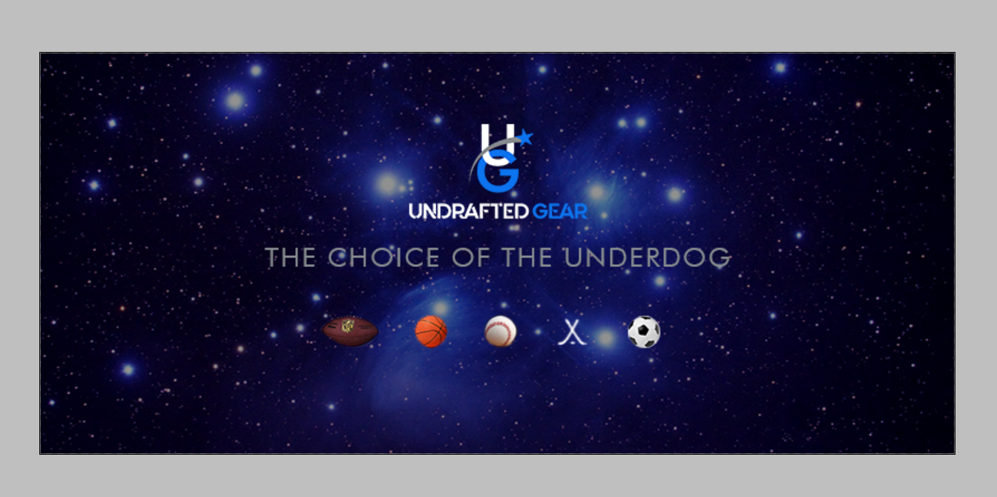

1. Executive Summary

1.1 Brand Concept and Identity
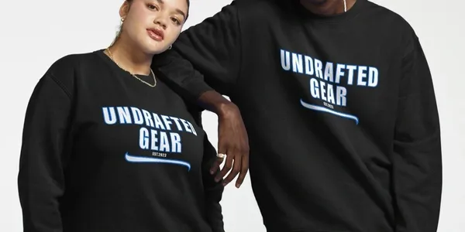

Undrafted Gear Inc. is a California-based development company focusing on a new, top-end line of sports apparel, coupled with a new crypto token (the UGCT “Undrafted Gear Crypto Token”) which will fuel transactions on a yet-to-be-determined blockchain. The token may also be used to purchase Undrafted Gear apparel and be invested with and traded in the cryptocurrency market. Undrafted Gear will start as an online sportswear company.
The proposed venture is banking on its superior brand name and revolutionary crypto token used within the sportswear industry to create a strong, global presence and interactive customer Base. Locating and hiring a recognized professional sports athlete as “the face” of the venture will immensely increase the chances of the venture’s long-term success.
The term “Undrafted” is a very popular vernacular in the sports world today. It has both positive and negative connotations. Undrafted (adj.) “Anyone who was not drafted by a professional sports team; deemed an average athlete or unworthy of elite status.” (Those are the negative connotations). (The positive connotations of “Undrafted”:) “Any athlete or regular person who has the desire and drive to greatly exceed their perceived expectations.” (and) “An individual who consistently hones their craft, then achieves unexpected greatness.” Undrafted Gear as a company will focus on the positive connotations of this term in marketing its variety of sports apparel merchandise. Our business will emphasize that Undrafted Gear is not just for athletes, but for anyone who wants to achieve greatness in their chosen walk of life.
The primary areas of development for this venture include selecting and creating a complete line of sportswear from tops to caps, to footwear and all merchandise that would encompass the lineup of a world-class sporting goods company. Comfortability, style, and affordability are also essential components of the proposed Undrafted Gear sportswear line. Undrafted Gear will also offer over 110 versions of T-shirt images that our artists from around the world have designed over the past three years. A secondary yet crucial area of development for the Undrafted Gear brand will be its creation and entrance into the cryptocurrency world with the proposed UGCT token (Undrafted Gear Crypto Token). Lastly, but just as important as the other needed areas of development - Undrafted Gear must decide and finalize its shipment and delivery of products system once a customer purchases merchandise from our online store. Cost efficiency points toward partnering with an already existing shipment and delivery system.
The UGCT will be an investment vehicle for our customers. It can also be used to purchase Undrafted Gear sportswear and is tradable within the cryptocurrency exchanges. A big factor of the UGCT is that it will allow our customer base to interact in a cryptocurrency community and social media arenas that strengthen customer involvement and retention. It will be the first known cryptocurrency directly related to a sportswear brand.
Another huge area of development for Undrafted Gear is the recruitment of a current or retired professional athlete to join our team as “the face” of Undrafted Gear. The Founder of this venture believes that if a well-recognized athlete were to join and endorse this endeavor, the chances of its success would be exponentially increased.

1.2 Product Development
Undrafted Gear sportswear solves the problem of providing world-class sportswear in line with the Web3 generation that specifically targets the underachiever in life. All other sportswear companies promote the “be like Mike” theory, that you may want to be like a certain sports hero. They also promote their brand names, hoping to get loyal customers on style and brand name differentiation. There will be a strong push by Undrafted Gear to garner a market of consumers who strive for greatness outside of the sports world. A huge market of people who just want to be seen as successful in their everyday endeavors in life.
Undrafted Gear will also solve the problem of any sportswear line not in tune with the forthcoming wave of decentralized currencies that will dominate the financial landscape in the coming years.
Undrafted Gear sportswear wants to attract a customer base that wants to invest in our new token with our same sportswear brand name. This is an unprecedented endeavor. Further, the social media discord surrounding the UGCT will enhance the brand’s popularity and social media community engagement.
Cryptocurrency Integration
In a groundbreaking move, Undrafted Gear transcends traditional sportswear boundaries by seamlessly integrating cryptocurrency into its innovative brand. As pioneers at the intersection of fashion and finance, Undrafted Gear introduces the Undrafted Gear Crypto Token (UGCT), redefining the consumer experience. This crypto token not only serves as a secure and efficient method of transaction within the Undrafted Gear ecosystem but also opens up unparalleled opportunities for our customers. Beyond mere purchases, UGCT becomes a gateway to investment, tradable assets, and active participation in the cryptocurrency community. Embracing the ethos of democratizing success, Undrafted Gear empowers its clientele not only through sportswear but also by introducing them to the world of decentralized finance, marking a visionary stride into the future of retail and cryptocurrency integration.

1.3 Keys to Success
- Clear Mission and Goals: At Undrafted Gear, we will champion the power of a clear mission and specific goals to steer our journey toward greatness. By envisioning our path and setting achievable objectives, we will pave the way for success in every endeavor.
- Resilience and Perseverance: Just as every underdog will rise from adversity, we at Undrafted Gear will embrace resilience and perseverance as essential traits on our path to victory. We will face challenges head-on, bounce back stronger, and never lose sight of our goals.
- Continuous Learning and Adaptability: The spirit of the underdog will mean always evolving, and always learning at Undrafted Gear. We will stay nimble, embracing new ideas, and adapting to change. By staying ahead of the game, we will ensure our success in an ever-evolving world.
- Effective Planning and Execution: Every victory will start with a game plan at Undrafted Gear. We will meticulously plan our strategy, break down our goals into actionable steps, and execute with precision. It will be this meticulous approach that propels us towards our dreams.
- Strong Work Ethic and Discipline: The undrafted will know the value of hard work and dedication at Undrafted Gear. We will embody this ethos, working tirelessly towards our goals with unwavering discipline. Our relentless pursuit of excellence will set us apart from the rest.
- Positive Mindset and Attitude: Positivity will fuel our journey at Undrafted Gear. With an unwavering belief in ourselves and our abilities, we will face challenges with optimism and determination. It will be this positive mindset that propels us forward, even in the face of adversity.
- Effective Communication and Collaboration: Teamwork will make the dream work at Undrafted Gear. Through open communication and collaboration, we will harness the collective strength of our team to achieve greatness. Together, we will be unstoppable.
- Adaptation to Feedback and Reflection: At Undrafted Gear, we welcome feedback as an opportunity for growth. Through reflection and adaptation, we will continuously refine our approach, learning from every experience to become better, stronger, and more resilient.
- Integrity and Ethical Conduct: Integrity will be the cornerstone of our success at Undrafted Gear. With honesty, integrity, and ethical conduct as our guiding principles, we will build trust, credibility, and long-lasting relationships with our community.

1.4 Financial Highlights
At Undrafted Gear, we've meticulously analyzed the financial landscape to ensure the success of our venture. Our projections are based on thorough market research, industry trends, and a keen understanding of our target audience. Here's a glimpse into our financial forecast:
- Revenue Growth: With a projected global sports apparel market size expected to reach USD 218 billion in 2024 and athletic apparel revenue forecasted to reach USD 315 billion, Undrafted Gear anticipates robust revenue growth in the coming years. Our innovative approach, coupled with the integration of cryptocurrency, positions us for significant market share and revenue expansion.
- Cost Management: We understand the importance of prudent cost management to maximize profitability. By carefully selecting suppliers, optimizing production processes, and leveraging economies of scale, Undrafted Gear aims to minimize costs without compromising quality or customer experience.
- Investment in Innovation: Undrafted Gear recognizes the value of innovation in driving long-term success. A portion of our revenue will be allocated towards research and development, allowing us to continuously innovate our product offerings, enhance customer engagement, and stay ahead of market trends.
- Partnership and Collaboration: Collaboration is key to our financial success at Undrafted Gear. We will seek strategic partnerships with complementary brands, distribution channels, and technology providers to expand our reach, enhance our product offerings, and drive revenue growth.
- Profitability and Sustainability: Ultimately, our goal at Undrafted Gear is not just profitability but sustainability. We're committed to building a resilient business model that withstands market fluctuations, adapts to changing consumer preferences, and delivers long-term value to our stakeholders.
 | 2024 | 2025 | 2026
Income | $ 2,180,000 | $ 2,834,000 | $ 4,109,300
Cost of Sales | $ 654,000 | $ 793,520 | $ 1,027,325
Gross Profit | $ 1,526,000 | $ 2,040,480 | $ 3,081,975
Total Expenses | $ 698,600 | $ 773,730 | $ 907,689
Profit Before Taxes | $ 827,400 | $ 1,266,750 | $ 2,174,287
Total Taxes | $ 73,142 | $ 111,981 | $ 192,207
Net Profit | $ 754,258 | $ 1,154,769 | $ 1,982,080
Net Profit Margin | 35% | 41% | 48%

2. Company Overview

2.1 Our Story
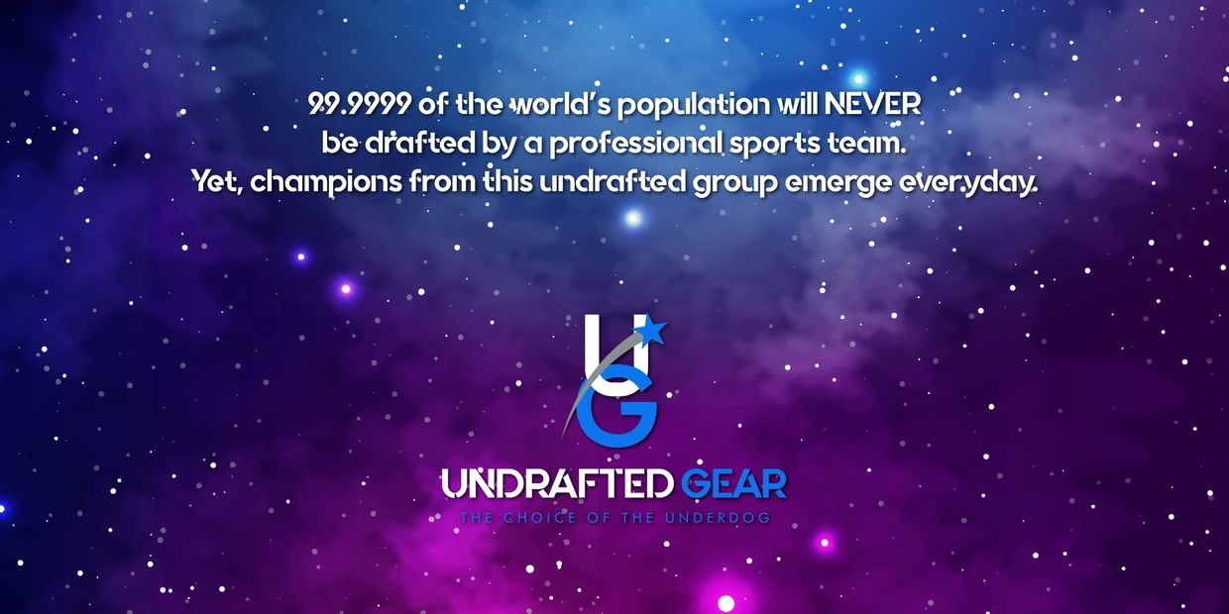
In the future, driven by the allure of the most compelling brand name in the sportswear industry, Undrafted Gear will be born. Our vision is to create a brand that not only embodies the spirit of determination and resilience but also fosters eventual ownership by a professional sports athlete looking to venture into the sportswear industry. Undrafted Gear presents the perfect career opportunity for active or retiring professional athletes seeking to transition into business endeavors after their playing days have concluded.
Undrafted Gear will also boast one of the most unique and bold T-shirt collection lines on the planet, showcasing designs that capture the essence of our brand's ethos. Each design will embody the spirit of the underdog, celebrating the journey of those who defy expectations and achieve greatness. With our commitment to quality, innovation, and inclusivity, Undrafted Gear will stand as a beacon of inspiration in the sportswear industry, empowering individuals to embrace their unique journey and excel both on and off the field.

2.2 Legal Structure
Undrafted Gear operates as a California-based corporation, adhering to the legal framework established by the state. As a corporation, we enjoy distinct legal status separate from our owners, providing liability protection and ensuring continuity of operations.
Key aspects of our legal structure include:
- Incorporation: Undrafted Gear is registered as a corporation in the state of California, with all necessary legal documentation filed with the appropriate authorities. This formal incorporation establishes us as a separate legal entity, distinct from our founders and shareholders.
- Limited Liability: One of the primary benefits of our corporate structure is limited liability. This means that our founders, shareholders, and officers are generally not personally liable for the debts and obligations of the company. This legal protection shields personal assets from business liabilities, mitigating financial risk for individuals involved in the company.
- Ownership and Governance: As a corporation, Undrafted Gear is owned by shareholders who hold shares of stock in the company. The shareholders elect a board of directors to oversee corporate affairs and make strategic decisions on behalf of the company. Officers, appointed by the board, manage day-to-day operations and execute corporate strategies.
- Compliance and Regulation: Operating as a corporation requires compliance with various legal and regulatory requirements at the state and federal levels. This includes annual filings, tax obligations, corporate governance standards, and adherence to industry-specific regulations. Undrafted Gear is committed to maintaining strict compliance with all applicable laws and regulations to ensure legal integrity and operational stability.
- Flexibility and Scalability: The corporate structure offers flexibility and scalability, allowing Undrafted Gear to attract investors, raise capital, and facilitate growth opportunities. This structure facilitates equity financing through the issuance of stock, providing a mechanism for raising funds to support expansion and innovation.


2.3 Location of Undrafted Gear
Nestled in the heart of Sacramento, California, Undrafted Gear will find its home amidst the vibrant energy of the West Coast. Our future headquarters at 173 Lightner Court will serve as the epicenter of our innovative endeavors, where creativity will meet ambition in every stitch of fabric and line of code. Located in a thriving metropolitan area known for its entrepreneurial spirit and diverse community, Undrafted Gear will draw inspiration from its dynamic surroundings, infusing our brand with the spirit of innovation and inclusivity. From this central hub, we will connect with customers and collaborators worldwide, leveraging the power of technology to transcend geographical boundaries and make an impact on a global scale. With our roots firmly planted in Sacramento, Undrafted Gear will embody the spirit of the underdog, rising from humble beginnings to conquer the world of sportswear with determination, resilience, and unwavering passion.

2.4 Management Team of Undrafted Gear
At Undrafted Gear, our management team is the driving force behind our mission of revolutionizing the sportswear industry. Led by founder Stephen (Steve) Butler, our team embodies a diverse range of skills, expertise, and passion for excellence. Here's an introduction to our key management personnel:

Stephen (Steve) Butler - Founder: With a background in law enforcement and a lifelong passion for sports, Steve Butler is the visionary leader behind Undrafted Gear. His entrepreneurial spirit, strategic vision, and unwavering commitment to excellence set the tone for our entire organization.

Co-Founder: Undrafted Gear is actively seeking a co-founder to join our team and contribute their expertise to our mission. This individual will play a crucial role in shaping the direction of our company, bringing valuable insights and leadership to our organization.

Professional Athlete: As part of our strategic vision, Undrafted Gear is in the process of recruiting a professional athlete to serve as the face of our brand. This individual will lend their credibility, influence, and expertise to elevate Undrafted Gear's visibility and appeal within the sports community.

Management Team (to be appointed): In addition to our founder, co-founder, and professional athlete, Undrafted Gear will assemble a dedicated management team to oversee various aspects of our operations. This team will include executives with expertise in areas such as marketing, finance, operations, and product development, ensuring that we have the talent and leadership needed to drive our success.

2.5 Mission Statement
“Undrafted Gear, the choice of the underdog.”
To provide the sportswear industry with the first investable clothing line within the cryptocurrency realm, while marketing an undeniably catchy, attractive, and comfortable brand of sportswear.

2.6 Core Values


- Innovation: Undrafted Gear will continually push the boundaries of innovation, embracing cutting-edge technologies and forward-thinking approaches to redefine the sportswear industry.
- Empowerment: We will empower individuals to unleash their full potential, fostering a culture of confidence, resilience, and self-belief in every athlete and enthusiast we serve.
- Inclusivity: At Undrafted Gear, we will champion diversity and inclusivity, celebrating the unique talents, backgrounds, and perspectives of our global community.
- Quality: Our commitment to excellence will be unwavering. Undrafted Gear will uphold the highest standards of quality in every product we create, ensuring durability, comfort, and performance.
- Resilience: We will embrace challenges as opportunities for growth and resilience. In the face of adversity, we will persevere with determination, grit, and a never-say-die attitude, embodying the spirit of the underdog.
- Passion: Passion will drive everything we do at Undrafted Gear. We will approach our work with enthusiasm, energy, and a genuine love for what we do, infusing our brand with excitement and vitality.
- Excellence: We will pursue excellence relentlessly, striving for continuous improvement and setting the bar high for ourselves and our products. We will never settle for anything less than the best, always aiming to exceed expectations and deliver exceptional value to our customers.

2.7 Future Goal
In the future, Undrafted Gear aims to become the leading innovator in the intersection of sportswear and cryptocurrency, revolutionizing the industry with our groundbreaking approach. Our goal is to establish Undrafted Gear as a globally recognized brand synonymous with empowerment, inclusivity, and excellence.

3. Our Offerings

3.1 Introduction to Our Offerings
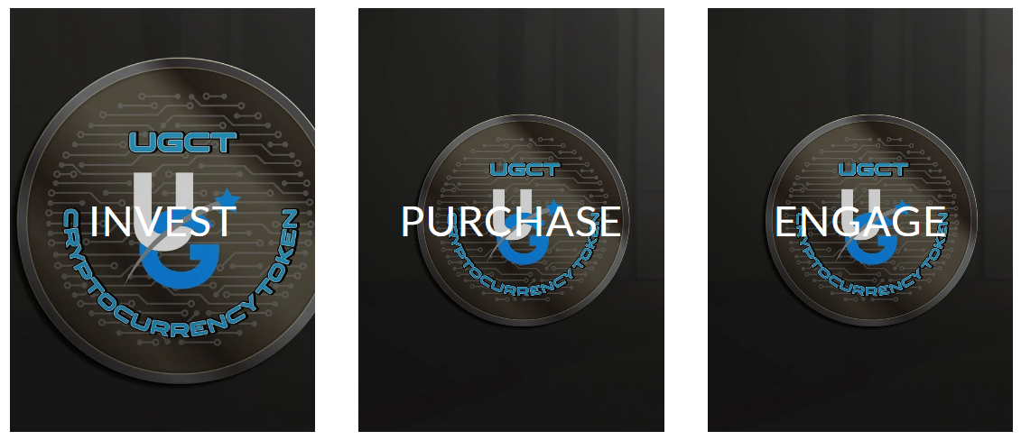
Undrafted Gear will not only be a sportswear brand; it will be a testament to the undying spirit of determination and resilience. Undrafted Gear will embody the ethos of pushing beyond perceived limitations to achieve greatness in every aspect of life.
Undrafted Gear will offer a comprehensive range of premium sportswear and athleisure products designed to elevate performance, style, and comfort for athletes, fitness enthusiasts, and individuals leading active lifestyles. Our product lineup will encompass a diverse array of apparel and gear, meticulously crafted using the finest materials and cutting-edge technologies to meet the demands of modern athletes.
From performance-enhancing activewear to stylish athleisure pieces, Undrafted Gear's product offerings will cater to every aspect of our customers' active lives. Our apparel collection will feature moisture-wicking fabrics, breathable constructions, and ergonomic designs to ensure maximum comfort and mobility during workouts and training sessions.
Moreover, Undrafted Gear will prioritize versatility and functionality, with products that seamlessly transition from the gym to the streets. Whether it's high-performance compression leggings, lightweight training tops, or durable running shoes, our products will empower individuals to push their boundaries and perform at their best, whatever the challenge.
In addition to apparel, Undrafted Gear will offer a range of accessories and gear designed to complement our customers' active lifestyles. From performance-enhancing accessories such as compression sleeves and sweat-wicking headbands to stylish gym bags and water bottles, our products will enhance both performance and convenience for our customers.
Furthermore, Undrafted Gear will be proud to introduce an innovative integration of cryptocurrency technology, allowing customers to engage with our brand in exciting new ways. Through our unique cryptocurrency token, customers will have the opportunity to invest, make purchases, and participate in our vibrant community, adding a new dimension of interaction and value to our products.
With our unwavering commitment to quality, innovation, and customer satisfaction, Undrafted Gear will be more than just a sportswear brand—it will be a symbol of empowerment, resilience, and excellence, inspiring individuals to embrace their unique journey and achieve greatness in every aspect of their lives.

3.2 Our Products
All of our products at Undrafted Gear will be meticulously designed with the active individual in mind. We will utilize only the finest materials and cutting-edge technology to craft sportswear that is not only comfortable and durable but also stylish and performance-driven. From premium workout leggings engineered for flexibility and support to high-performance sports bras designed for maximum comfort and control, Undrafted Gear will offer a comprehensive range of products to elevate your fitness experience and help you reach your goals. Whether you're hitting the gym, hitting the trails, or hitting the pavement, you can trust Undrafted Gear to provide the quality and performance you need to take your fitness to the next level.
- Sportswear Apparel: Our core offerings will include a comprehensive line of sportswear apparel, meticulously crafted to enhance performance and comfort. From moisture-wicking tops and breathable leggings to supportive sports bras and lightweight jackets, our apparel will be designed to withstand the rigors of training while keeping you comfortable and stylish.
- Footwear: Undrafted Gear will also offer a range of athletic footwear designed to support your active lifestyle. Whether you're hitting the gym, pounding the pavement, or conquering the trails, our shoes will provide the stability, cushioning, and traction you need to excel in any activity.
- Accessories: In addition to apparel and footwear, Undrafted Gear will provide a selection of accessories to complement your athletic endeavors. From moisture-wicking socks and supportive compression sleeves to durable water bottles and versatile gym bags, our accessories will enhance your performance and convenience.
- UGCT Integration: As pioneers in the integration of cryptocurrency, Undrafted Gear will introduce the Undrafted Gear Crypto Token (UGCT) as a revolutionary addition to our offerings. The UGCT will serve as both a transactional currency within our ecosystem and an investment vehicle for our customers, empowering them to participate in the cryptocurrency market while enjoying exclusive benefits and rewards.
- Limited Edition Collections: To keep our offerings fresh and exciting, Undrafted Gear will periodically release limited edition collections inspired by the latest trends, events, and collaborations. These exclusive collections will offer unique designs, premium materials, and limited availability, allowing our customers to stand out from the crowd with one-of-a-kind apparel and accessories.
Our Product Testing
Before we release any product at UNDRAFTED GEAR, we will subject it to rigorous testing to ensure that it meets our high standards for quality and performance. We will work with athletes and fitness enthusiasts to put our products to the test in real-world conditions and use their feedback to make improvements. This attention to detail is what sets us apart from other sportswear brands. UNDRAFTED GEAR will be the first sportswear line to offer an interactive cryptocurrency token that you may invest with, purchase gear with, and become a member of its engaging community
Our Distribution
Undrafted Gear will employ a multi-faceted distribution strategy to ensure its products reach customers effectively and efficiently. Initially, the primary distribution channel will be an online platform, allowing customers worldwide to browse and purchase Undrafted Gear's sportswear products conveniently from the comfort of their homes. This e-commerce approach enables the company to reach a broader audience and capitalize on the global reach of the internet. Additionally, Undrafted Gear may explore partnerships with select retail outlets and sporting goods stores to expand its physical presence and reach customers who prefer in-store shopping experiences. By leveraging both online and offline channels, Undrafted Gear aims to maximize its market penetration and accessibility, ensuring that its high-quality sportswear products are readily available to consumers across various demographics and geographical locations.

3.3 Special Features of Undrafted Gear
- Cutting-Edge Materials: Undrafted Gear will utilize state-of-the-art materials engineered for performance, durability, and comfort. From moisture-wicking fabrics that keep you dry during intense workouts to breathable materials that enhance airflow and regulate temperature, our sportswear will be designed to optimize your performance and maximize your comfort.
- Advanced Technology Integration: We will incorporate advanced technology into our products to enhance functionality and convenience. This may include features such as built-in compression for targeted support, seamless construction for reduced chafing and irritation, and smart fabrics that adapt to your body's needs for optimal performance.
- Innovative Design Elements: Undrafted Gear will feature innovative design elements that combine style with functionality. This may include strategic mesh panels for ventilation, reflective accents for enhanced visibility in low-light conditions, and adjustable straps and closures for a customizable fit.
- Customization Options: We will offer customization options to allow you to personalize your sportswear to suit your preferences and needs. Whether it's choosing your favorite colors, adding personalized embroidery or graphics, or selecting specific features for a custom fit, Undrafted Gear will empower you to create sportswear that truly reflects your unique style and personality.
- Integration with UGCT: As pioneers in the integration of cryptocurrency, Undrafted Gear will offer unique benefits and rewards to customers who use the Undrafted Gear Crypto Token (UGCT) for their purchases. This may include exclusive discounts, access to limited edition products, and participation in special events and promotions.

3.4 Risk Analysis
Risk | Mitigation Strategy
Market Competition | - Conduct thorough market research to identify niche opportunities and differentiate products.  - Build brand loyalty through unique value propositions, such as superior quality, innovative designs, and customer engagement.
Economic Downturn | - Diversify revenue streams by exploring alternative sales channels, such as partnerships with fitness influencers or specialty retailers.  - Maintain a lean operating model to mitigate the impact of reduced consumer spending during economic downturns.
Shifting Consumer Preferences | - Stay abreast of industry trends and consumer preferences through regular market analysis and customer feedback.  - Continuously innovate product offerings to align with evolving trends and cater to changing consumer demands.
Cryptocurrency Volatility | - Implement risk management strategies, such as hedging techniques or setting reserves, to mitigate the impact of price fluctuations.  - Educate customers about the benefits and risks of cryptocurrency investment to manage expectations and minimize volatility effects.
Supply Chain Disruptions | - Establish robust supplier relationships and maintain open communication to address potential issues proactively.  - Diversify sourcing options and maintain buffer stock levels to mitigate the impact of disruptions in the supply chain.
Technology Risks | - Invest in robust cybersecurity measures, such as encryption protocols and regular security audits, to protect customer data and assets.  - Implement redundancy and backup systems to ensure continuity of operations in the event of technology failures or system breaches.
Quality Control | - Implement stringent quality control processes throughout the manufacturing and distribution chain to maintain consistent product quality.  - Regularly monitor product feedback and conduct quality assurance checks to identify and address any issues promptly.
Regulatory Compliance | - Stay updated on regulations for product safety and consumer protection, ensuring full compliance.  - Invest in legal counsel or regulatory experts to navigate complex requirements and mitigate legal risks efficiently.

4. Industry Overview
The Global Sportswear Industry
MARKET OUTLOOK
The global sportswear market was valued at USD 425.37 billion in 2022 and is expected to reach USD 635.69 billion by 2028, growing at a CAGR of 6.93%. Increasing participation of athletes in sports activities, awareness of fitness & and wellness, and athleisure trends all contribute to the adoption of sportswear. Moreover, the growth of the manufacturing industry also contributes to the expansion of the sportswear market. Facilities owners concentrate on producing and delivering products to their clients at a faster, cheaper, and higher quality rate and for efficient production cycles, which minimizes operational costs and waste. Hence, increased adoption of sportswear among the end-users is expected to drive the market demand for sportswear during the forecast period.
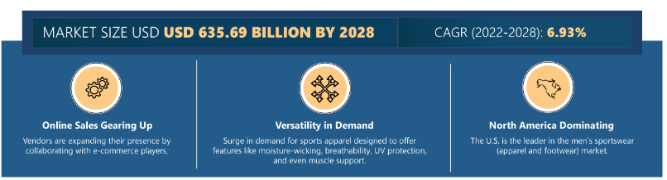
Sportswear is usually preferred in various sports and fitness activities for its comfort, functionality, and performance-enhancing features among various individuals. It encompasses various products, such as athletic apparel, footwear, and accessories. Serval factors, such as fitness, wellness, and athleisure, drive the intense surge in demand for sportswear. The rise in participation of individuals in various sports activities and the adaption of innovative technologies are expected to drive high demand for sportswear products in the sportswear market. Moreover, major vendors are inclined towards adopting online distribution channels along with their in-store or offline distribution channels to expand their customer base in the market.

RISK FACTORS IN THE MARKET
Foreign exchange policy is the biggest risk factor the sportswear market faces and will continue to face. These policies can include actions taken by a government to control its currency exchange rate, such as imposing capital controls, implementing currency controls, or introducing restrictions on foreign currency transactions. Changes in foreign exchange policies can lead to increased volatility in currency exchange rates. This is happening because of increased demand and restricted supply.
Supply chain management risk is a critical concern for sportswear companies as it can impact their supply chain, product quality, delivery timelines, and overall business operations. Sportswear companies often face fluctuating demand due to seasonal trends, fashion preferences, and changing consumer behavior. This uncertainty can result in challenges in forecasting demand accurately, leading to either excess inventory or stockouts. Further, counterfeit sportswear can dilute legitimate companies' brand image and reputation. If counterfeit products are of poor quality or fail to meet customer expectations, it reflects negatively on the genuine brand.
MARKET TRENDS & OPPORTUNITIES
- Rising Popularity of Athleisure Wear: The surging popularity of athleisure wear among Gen Z and millennials can be attributed to the increased focus on fitness and wellness, the convenience of remote work, celebrity endorsements, high-quality standards, versatility for various occasions, and the potential for innovation and sustainability. Rising demand for athleisure products among athletes, celebrities, health-conscious people, gyms, etc. Polyester, cotton, etc., is the fabric used to absorb sweat-wicking. Comfortable to wear during exercise also creates demand in the global sportswear market. Women's participation also raises the need for this athleisure.
- Government Initiatives Supporting Demand for Sportswear: The government organizes various sports programs within their respective countries to promote sports engagement. For instance, programs such as the National Football League, the National Hockey League, Major League Baseball, and the National Basketball Association showcase the government's commitment to sports in the United States. Similarly, in India, programs like Khelo India, Fit India Movement, and Special Area Game Scheme have been introduced to encourage youth participation in sports. These initiatives are pivotal in motivating individuals to engage in physical activities, as they recognize the importance of sports for overall health and well-being.
INDUSTRY RESTRAINTS
Raw Material Price Fluctuation: Price fluctuation depends on the demand and supply of the market. The organization buys raw materials such as textiles and handlooms to manufacture the product. The price of the raw material affects various things, such as production cost, price for the consumer, profitability, etc. Sportswear companies buy cotton and polyester material in huge quantities due to manufacturing apparel and footwear.
SEGMENTATION INSIGHTS
- INSIGHTS BY PRODUCTS: The apparel products segment dominated the global sportswear market share in 2022. There is a high demand for sportswear apparel such as t-shirts, tops & and shirts, and shorts. People increasingly wear sportswear for workouts and everyday casual wear, which has led to a surge in demand for stylish and versatile sportswear options. Advances in fabric technology have led to the development of performance-enhancing materials. These fabrics are designed to offer features like moisture-wicking, breathability, UV protection, and even muscle support, making sportswear more functional and appealing to consumers.
- INSIGHTS BY ACTIVITY TYPE: The global sportswear market by activity type has been broadly classified into sports, training & and activewear, swimming, and others. In terms of revenue, the sports segment dominated the activity-type market, generating over USD 232 billion in 2022. The sports segment experienced significant growth, emerging as the leading segment during the forecast period. This rise in industry share can be attributed to the increasing involvement of individuals in various sports activities, including baseball, basketball, soccer, and many other sports. The growing interest and participation in these sports have fueled the demand for related products and services, consequently driving the market's expansion.

- Moreover, the surge in people's engagement with fitness activities such as gym workouts, cycling, running, yoga, and other forms of exercise has further contributed to the growth of the training and activewear segment. As individuals prioritize their physical well-being and adopt healthier lifestyles, the global sportswear market for high-quality training apparel and activewear has grown substantially. Swimming is a versatile and effective exercise that offers a full-body workout while being gentle on the joints. As individuals place greater importance on maintaining an active lifestyle, swimming gains popularity due to its numerous benefits and adaptability. The increased awareness, accessibility, and sustainability contribute to the expanding global sportswear market.
- INSIGHTS BY END-USER: The global sportswear market by end-user has been broadly classified into male, female, and children. The male segment has dominated the industry. The demand for sportswear has been higher among males due to factors like participation in sports activities, gym workouts, and outdoor pursuits. Other factors influencing sportswear demand in the male segment are high disposable income, health consciousness, carer opportunity, athleisure wear, emerging trends, premium products, etc. Many sportswear companies target the men's segment and offer various products, such as Nike, which offers sports shoes, T-shirts, Shorts, tracksuits, jackets, hoodies, etc. Furthermore, the U.S. is the leader in the men’s sportswear (apparel and footwear) market. Men aged 21–38 are the major contributors to sportswear sales, followed by 39–54 years.
- INSIGHTS BY DISTRIBUTION CHANNEL: The global sportswear market has numerous products under the offline segment. Most vendors prefer to do brick-and-mortar forms of business with a business outlet with either one or more than one physical location. At present, many customers prefer to opt for these stores rather than online sales channels. Furthermore, the demand for sportswear through online channels is increasing due to the rising internet penetration worldwide. Moreover, the number of smartphone users is rapidly growing, contributing to the success of online sportswear sales. Various vendors are expanding their presence in other countries by collaborating with e-commerce players or through their proprietary websites.
- GEOGRAPHICAL ANALYSIS: North America accounted for the highest share of the global sportswear market, accounting for over 37% share in 2022. North America dominates the demand for sportswear in the global market owing to the huge potential of innovative products as well as the high disposable income of consumers. Moreover, since the majority of the population in North America lives in urban areas and holds good education, awareness of fitness and wellness is also high in the region. With the rise in disposable income, the personal spending of an individual also increases. This has mainly driven the demand for sportswear products in the country. The region is the largest market for sportswear due to the kind of lifestyle that the population in this region enjoys and the kind of culture they have.
- The APAC region has significantly grown in the sportswear market over the past decade. Factors such as increasing disposable income, urbanization, changing lifestyles, and a growing emphasis on health and fitness have contributed to the rising demand for sportswear in countries like China, India, Japan, South Korea, and Australia. Furthermore, European countries generating considerable demand for sportswear include Germany, France, Italy, the UK, Spain, Poland, Netherlands, Belgium, Hungary, and others. Most European countries have structured physical education programs in schools, which include regular sports activities and encourage students to participate in various sports.
COMPETITIVE LANDSCAPE
The global sportswear market is highly fragmented, with many local and international players. Some key leading vendors in the global sportswear market are Nike, adidas, ANTA Sports Goods, ASICS Corporation, lululemon athletica, Puma, Under Armour V.F. Corporation, and others. The competition among these players is intense. The rapidly changing technological environment could adversely affect vendors as customers expect continual innovations and upgrades in sportswear. The present scenario forces vendors to refine their unique value proposition to achieve a strong industry presence.
Source:https://www.arizton.com/market-reports/sportswear-market-size-analysis#:~:text=MARKET%20OUTLOOK,at%20a%20CAGR%20of%206.93%25
SPORTSWEAR MARKET
The global sportswear market size was valued at nearly USD 182.22 Billion in 2022 and is anticipated to reach USD 323.90 Billion by 2031, expanding at a CAGR of 6.6% during the forecast period, 2023–2031. Sportswear refers to a broad category of fashion-oriented, comfortable apparel that is loosely based on clothing designed for participation in sports.
Sportswear refers to shoes, clothing, and accessories that are specifically designed for athletic apparel use. To suit different sports, it offers benefits such as specified functions, good thermal qualities, sustainability, comfort, specific fabric weight, and many other properties.
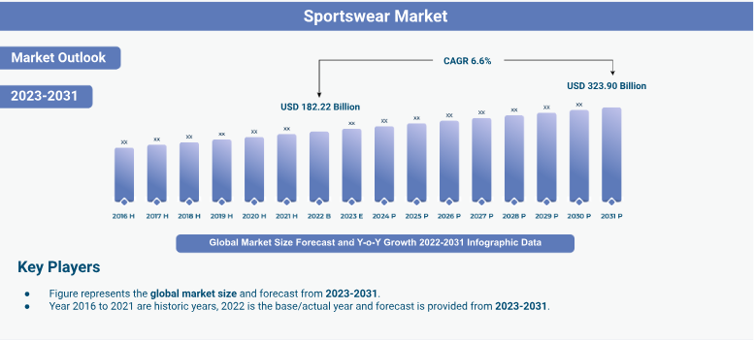
Swimwear can be made of a variety of materials and many of these clothing items are mostly water-resistant. Some advanced features are fixed with the clothing to allow them to flex with the body, while others have thermal properties to keep the athlete's body warm in cold weather and cool in hot weather.
Sportswear Market Trends, Drivers, Restraints, and Opportunities
- Improving products' ability to provide breathability and sweat-wicking as well as enhancements to physical activity are expected to boost the market growth.
- Growing number of women participating in multiple sports sectors acts as a key driver of the market growth.
- Consumers' growing health consciousness and growing need for comfortable yet fashionable clothes are propelling the market expansion.
- Rapidly changing fashion trends, advancements in sportswear manufacturing technologies, as well as the increased global desire for premium sportswear are driving the market growth.
- The rising number of counterfeit products in clothes, footwear, leather goods, and other categories along with the high prices of products are major challenges that can hamper the market growth.
- Increasing usage of smart sportswear for improving workout routines as these clothing provide real-time feedback and monitor performance presenting immense opportunities for the market.
Sportswear Market Segment Insights
- Product Type Segment Analysis
Based on product type, the sportswear industry is segregated into apparel, footwear, and wearables. The apparel segment is projected to hold a significant market share, owing to the high demand for products for a variety of sports such as basketball, football, tennis, and others.
Similarly, the growing popularity of using athletic apparel as fitness wear contributes to the rising consumption rate. The number of Gen Z and millennials going to the gym has increased dramatically, which is helping to boost sales of gym apparel like t-shirts and tops.
In addition, the production of high-quality materials to improve performance is moving the segment forward. Increased sports activities worldwide as well as growing knowledge of various fitness programs are driving the segment growth. Technological improvements such as fast-drying fabrics and t-shirts that can measure heart rate present another key driver of the segment.
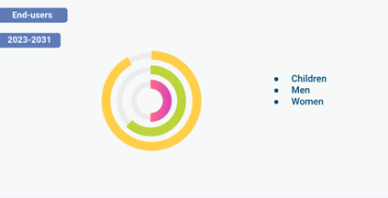
- End-user Segment Analysis
Based on end-users, the market is segmented into children, men, and women. The men segment is anticipated to account for a substantial share of the market, due to increased male engagement in sports. A huge percentage of men normally participate in outdoor activities such as rock climbing, cycling, trekking, and other similar hobbies.
On the other hand, the women segment is expected to expand at a robust pace shortly. The increased engagement of women in domestic professional sports and their growing concerns for fitness activities are key factors further driving the segment's growth.
The growing crossover between fashion and sports has increased in the presence of fashionable athletic apparel, which is projected to further increase women's interest in sportswear.
- Distribution Channel Segment
In terms of distribution channels, the sportswear market is bifurcated into retail stores and e-commerce stores. The retail stores segment is anticipated to register a substantial growth rate during the forecast period, owing to the growing number of popular athletic companies around the world.
Moreover, the number of retail stores is expanding due to the presence of a huge number of consumers who want to prevent shipping delays, mismatches, and hassles with returns and replacements.
Retail stores offer a diverse range of products and brands to expand consumers’ choices. Furthermore, such stores provide support from sales executives, which contributes to the segment's growth.
- Regional Analysis
In terms of region, the sportswear market is classified as Asia Pacific, North America, Europe, Latin America, and Middle East & and Africa. North America is expected to dominate the market, due to the presence of important industry actors such as Adidas and Nike, which have a large share of the North American sports apparel market in terms of sales.
The popularity of sports such as soccer and basketball as well as the increased health consciousness of a large number of the regional population present another key factor driving the market expansion. Moreover, improved living conditions and cheap manufacturing costs are driving regional market growth.

Competitive Landscape
Key players in the global sportswear market are Adidas AG; Puma SE, Inc.; and Nike, Inc.; Under Armour, Inc.; Lululemon Athletica Inc.; Anta Sports Products Limited; Columbia Sportswear Company; Fila Holdings Corp.; Umbro Ltd.; and Li Ning Company Limited. These players have actively engaged in several market development activities including collaborations, agreements, mergers & and acquisitions, production capacity expansion, new product launches, and partnerships to increase their market share.
Source:https://growthmarketreports.com/report/sportswear-market-global-industry-analysis

THE Global Cryptocurrency Market
The global cryptocurrency market size was valued at USD 4.67 billion in 2022 and is expected to expand at a compound annual growth rate (CAGR) of 12.5% from 2023 to 2030. The global cryptocurrency market cap was valued at over USD 800 billion in 2022. Cryptocurrency, also known as virtual currency, exists digitally and has no regulatory authority. Cryptocurrency uses distributed ledger technology such as blockchain to validate transactions. The increasing adoption of distributed ledger technology is anticipated to propel the cryptocurrency market growth during the forecast period. Moreover, increasing usage of cryptocurrencies for cross-border remittances is expected to fuel market expansion due to the reduction in consumer fees and exchange charges.
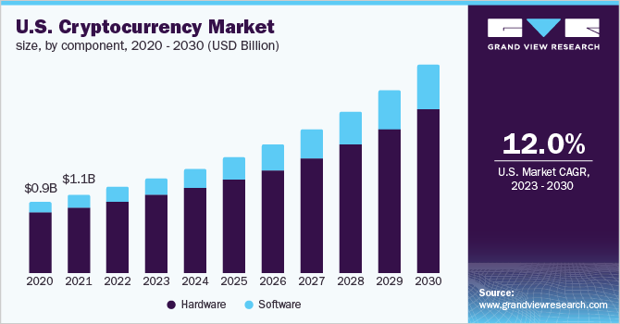
Recent developments in Artificial Intelligence (AI) are expected to have a huge impact on the cryptocurrency market. The rising popularity of AI-based cryptocurrency platforms has inspired several businesses to focus on the development of AI technology. For instance, in August 2021, researchers at Los Alamos National Laboratory developed an artificial intelligence program to identify unlawful cryptocurrency miners who use research computers for cryptocurrency mining.
Moreover, the rise of cryptocurrency as a decentralized asset class has attracted investments by private venture companies in the market. For instance, the U.S. cryptocurrency market witnessed investments worth USD 6.1 billion in 2021 across 106 deals. The growth is further supported by the increased demand for cryptocurrency as an alternative form of tender across emerging economies, such as Iran, Argentina, and Zimbabwe, plagued with devalued currencies.
One of the key elements influencing the growth of digital currency is the growing number of businesses that now accept cryptocurrency as an official payment method. Additionally, the adoption of digital currency by major corporations such as Tesla Inc. and MasterCard Inc. is anticipated to boost industry expansion. For instance, in November 2021, MasterCard Inc., a financial services company, allowed its network partners to enable their customers to purchase, trade, and hold digital currency using a digital wallet. Moreover, the business offered digital currency as a reward for the clients who participated in loyalty programs.
Government bodies across the globe are focusing on devising laws to regulate cryptocurrencies European Union developed the Markets in Crypto Assets (MiCA) law to create a legal framework designed for the market of crypto assets. Additionally, in February 2022, the Indian government made its move towards making cryptocurrency legal by announcing a 30.0% tax on any income generated by the transfer of digital currencies. Cryptocurrencies such as Bitcoin have been gaining traction in high-inflation countries, including Argentina, Zimbabwe, and Brazil, as their local currency devalues.
Even though Bitcoin is cutting-edge financial technology, its growth is expected to be constrained by the lack of regulations and a unified standard for exchanging digital currency. Regulators from all over the world are worried about the use of cryptocurrencies for unlawful purposes, which is a significant barrier to the market's expansion. However, law enforcement agencies are making efforts to seize illegally acquired cryptocurrency which bodes well for the market growth. For instance, in November 2021, IRS Criminal Investigation seized approximately USD 3.5 billion worth of cryptocurrency.
COVID-19 Impact Analysis
The COVID-19 pandemic halted global economic activity, although it is projected to positively affect the cryptocurrency market. The impact of the COVID-19 outbreak on the world economy has heightened uncertainty, which has drawn more attention to cryptocurrencies such as Ethereum, Bitcoin, and others. The banks started creating digital currencies backed by blockchain to enable Business-to-Business (B2B) crypto payments. In October 2020, the first Central Bank Digital Currency (CBDC) was launched by the Central Bank of Bahamas, named Sand Dollar. This launch of CBDC aimed to improve financial inclusion and strengthen security.
Component Insights
The hardware segment dominated the market in 2022 and accounted for more than 82.0% of the global revenue. Factors such as higher processing speed and reduced power consumption of cryptocurrency miners are expected to drive the growth of the hardware segment. The shifting consumer expectations have led many businesses to develop Bitcoin mining hardware. Hardware such as graphics processing units, which are swift, effective, and stable, is needed to create mining devices. Such factors are projected to generate considerable growth prospects for the industry during the forecast period.
The software segment is anticipated to expand at the highest CAGR throughout the forecast period. The growth can be attributed to the increasing demand for software designed for the exchange and mining of cryptocurrencies. The development of software, to manage the massive volume of data generated by cryptocurrencies is expected to support the segment's growth. Furthermore, the growing demand for cryptocurrencies around the globe has increased the demand for crypto wallets and crypto exchange software, which is expected to augment the segment growth.
Hardware Insights
The application-specific integrated circuit segment dominated the market in 2022 and accounted for more than 43.0% of the global revenue. Application-Specific Integrated Circuits (ASICs) are electronic circuits designed explicitly for mining virtual currencies such as Bitcoin, Litecoin, and Ethereum. Several companies are adopting ASIC miners to mine cryptocurrency, with the growing need for low-energy consumption devices for mining crypto. Additionally, ASIC requires less maintenance and enables efficient use of energy, which is expected to support the growth of the segment.
The Graphics Processing Unit (GPU) segment is anticipated to expand at a promising CAGR throughout the forecast period. This growth is attributable to the growing demand for GPU for crypto mining as it offers high processing speed and consumes less power. Several crypto miners are encouraged to consider GPU for crypto mining. According to Jon Peddie Research Inc., a statistics and trends provider in the computer industry, 25.0% of GPUs were sold to crypto miners in the first quarter of 2021.

Software Insights
The exchange software segment dominated the market in 2022 and accounted for more than 32.0% of the global revenue. The use of exchange software is essential for completing cryptocurrency transactions since it facilitates the conversion of cryptocurrency coins to fiat currencies and vice versa. The growing development of crypto exchange software to provide seamless trading of cryptocurrency is anticipated to aid the segment growth.
For instance, in March 2021, Open Ware Inc., a Fintech software company, launched a crypto-exchange software platform with Exchange Liquidity Network (ELN) named OpenDAX3. It is designed to offer better exchange services to facilitate the trading of cryptocurrencies, assets, and security tokens.
The wallet segment is anticipated to expand at a higher CAGR during the forecast period. The growth of the segment can be attributed to the increased usage of cryptocurrency wallets since they offer consumers online tools for securely managing and storing blockchain assets and cryptocurrencies ability to store and exchange various cryptocurrencies including Bitcoin, Litecoin, and Ethereum is made possible via various multi-asset cryptocurrency wallets.
Additionally, several companies that offer cryptocurrency wallet services are concentrating on creating crypto wallets that let users send or receive cryptocurrencies through mobile applications. For instance, in January 2022, Robin Hood, a cryptocurrency wallet service provider, launched its upcoming beta version of cryptocurrency wallets. The wallet is created to allow its customers to trade, send, and receive cryptocurrencies using the Robin Hood application.
Process Insights
The mining segment dominated the market in 2022 and accounted for more than 74.0% of the global revenue. Blockchain transactions are validated and verified as a part of the mining process. New coins are inserted into the current supply chain by mining activities. To provide cryptocurrency miners with a better mining experience, many businesses around the world are concentrating on implementing and building crypto miners' farms.
These crypto miner farms are in an excellent position to run their mining operations as they receive electricity from the public grid. For instance, in August 2020, Enegix, a mining facility operator, announced opening its 180-megawatt Bitcoin mining facility in Kazakhstan, which can accommodate up to 50,000 mining rigs.
The transaction segment is anticipated to expand at the fastest CAGR during the forecast period. The need for high-performance transaction services among organizations is rising, as a result of the quick development of technological advancements such as digitization and automation. As a result, many players worldwide are concentrating on creating Wallet as a Service (WaaS) to offer safe digital wallet choices for businesses to carry out their transactions effectively to meet the demand for high-performance transactions.
For instance, in November 2021, Crypto APIs, a blockchain development company, launched Wallet as a Service (WaaS) in partnership with Sepior, a Fintech company. The WaaS was created to provide small & and medium businesses, institutions, and enterprises with secure and reliable multicurrency digital wallets to carry out cryptographic transactions.
Type Insights
The bitcoin segment dominated the market in 2022 and accounted for more than 36.0% of the global revenue. The segment is anticipated to develop at the fastest growth rate during the forecast period. Bitcoin is a virtual currency operating as a decentralized alternative payment method. The emergence of Bitcoin Exchange Traded Funds (ETFs) is anticipated to surge the volume of global Bitcoin trades during the forecast period. For instance, in May 2022, Purpose Bitcoin ETF in Canada witnessed the biggest inflow of USD 207 million.
The Ethereum segment is anticipated to grow significantly through the projection period. Ethereum is an open software platform that allows users to build a range of decentralized applications. Due to the proliferation of new projects using the Ethereum network, there has been a considerable uptick in network traffic, which is directly related to the expansion of the Ethereum market.
Smart contracts were initially applied to algorithm-based financial transactions with Ethereum. On the blockchain network, smart contracts are written instructions for carrying out transactions. As Ethereum upgrades to Ethereum 2.0, which requires less energy and is less expensive to mine, the first-mover advantage is anticipated to support the growth of the cryptocurrency during the forecast period.
End-use Insights
The trading segment dominated the market in 2022 and accounted for more than 28.0% of the global revenue. Trading in cryptocurrencies enables users to purchase, sell, and examine asset balances and get deposit addresses. Several browser technology providers are concentrating on forming alliances with blockchain technology firms to enable their clients to trade cryptocurrency easily.
For instance, in March 2020, Brave Software, Inc., a browser technology company, entered into a partnership with Binance, a blockchain technology company, to enable its users to seamlessly trade cryptocurrency assets through Binance. Such factors bode well for the growth of the segment.
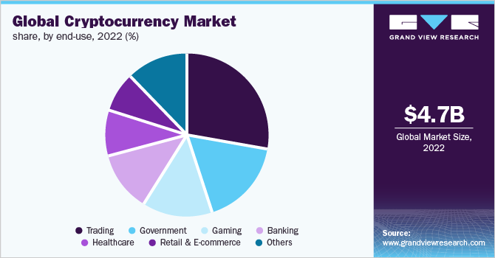
The retail & and e-commerce segment is anticipated to expand at a promising CAGR during the forecast period. The rising number of retail & and e-commerce companies that are accepting cryptocurrencies as an official payment method is one of the major factors driving the segment growth. Several cryptocurrency payment processors are entering into strategic partnerships with e-commerce companies to increase the acceptance of digital currencies for payments.
For instance, in May 2020, Coin Payments, a cryptocurrency payment processor, entered into a strategic partnership with Shopify, an e-commerce company, to offer a cryptocurrency payment platform to all Shopify merchants.
Regional Insights
Asia Pacific dominated the cryptocurrency market in 2022 and accounted for a share of above 30.0% of the global revenue. The dominance is attributable to the acceptance of cryptocurrencies in countries such as South Korea, Japan, and India. Moreover, the presence of cryptocurrency mining companies such as Ebang International Holdings, Inc., Bitmain Technologies Limited., Canaan, Inc. and others are expected to support the market growth in the region.
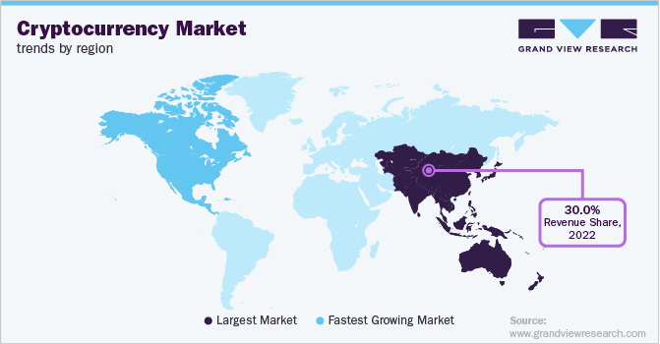
Furthermore, leading players in the region are entering into partnerships to address the competitive market. For instance, in February 2020, Canaan Inc., a China-based crypto mining hardware manufacturer partnered with Northern Data AG, a blockchain infrastructure firm, to pool together their technological and operational resources.
North American regional market is expected to grow significantly during the forecast period. The use of cryptocurrencies in NFTs in the region and the rising acceptance of cryptocurrencies as a form of value storage is driving the regional market's expansion. Moreover, the region is witnessing heavy investments in companies developing blockchain technology and cutting-edge solutions for cryptocurrency mining systems that have higher hash rates and better power efficiency.
For instance, In February 2022, Intel Corporation announced to contribute to the development of blockchain technology with a roadmap of energy-efficient accelerators. The company stated that its blockchain accelerator chip will ship later in the year. Argo Blockchain, Block & Grid Infrastructure is among their first customers for this upcoming product.
Key Companies & Market Share Insights
The cryptocurrency market can be described as a moderately fragmented market characterized by the presence of prominent players. Some of the key vendors in the cryptocurrency market are NVIDIA Corporation; Advanced Micro Devices, Inc.; Intel Corporation; Binance; and Xilinx, Inc. Market leaders are driving the competition in the market by pursuing several strategies aimed at long-term sustenance, thereby making it challenging for new players to enter the market. The strategies followed by these companies include product innovations, a strong focus on R&D activities, geographical expansions, strategic partnership agreements, and joint ventures.
Key players are seeking strategic collaborations and partnerships to expand their offerings. For instance, In November 2021, Ripple partnered with the Republic of Palau to explore the country's first national digital currency and its use cases with the XRP Ledger. This partnership aimed to develop cross-border payments and USD-backed digital currency for Palau. Strategic partnerships and collaborations are allowing businesses to develop innovative products and expand their sales across different geographies. Some of the leading players in the global cryptocurrency market include:
- Advanced Micro Devices, Inc.
- Binance
- Bit fury Group Limited
- Bit Go, Inc.
- Bit Main Technologies Holding Company
- Intel Corporation
- NVIDIA Corporation
- Ripple
- Xapo Holdings Limited
- Xilinx, Inc.
Source:https://www.grandviewresearch.com/industry-analysis/cryptocurrency-market-report
UNDRAFTED GEAR’S COMPETITION IN THE CRYPTOCURRENCY SECTOR
The Cryptocurrency arena is speculative, high-risk, and ever-changing. The top market cap Cryptocurrencies (2023) are:
- BITCOIN
- ETHER
- TETHER (USDT)
- BINANCE COIN (BNB)
- USD COIN (USDC)
- BINANCE USD (BUSD)
- XRP DOGECOIN (DOGE)
- CARDANO (ADA)
- POLYGO

5. Marketing Plan

5.1 Marketing Objectives
Increase Brand Awareness:
- Establish Undrafted Gear as a recognizable brand in the sportswear industry through targeted marketing campaigns.
- Expand brand visibility through social media, influencer partnerships, and brand ambassadors.
Drive Customer Engagement:
- Foster a strong sense of community among customers through interactive marketing initiatives, such as social media challenges, user-generated content campaigns, and online forums.
- Encourage customer feedback and participation to build brand loyalty and enhance the customer experience.
Promote Product Differentiation:
- Highlight the unique features and benefits of Undrafted Gear products, emphasizing factors such as comfort, durability, and style.
- Showcase the integration of cryptocurrency and innovative technologies to differentiate Undrafted Gear from competitors.
Expand Market Reach:
- Explore new distribution channels to reach a broader audience, including online marketplaces, specialty retailers, and international markets.
- Target niche segments within the sportswear market, such as fitness enthusiasts, outdoor adventurers, and athleisure consumers.
Drive Sales Growth:
- Implement promotional strategies to drive sales and increase conversion rates, such as limited-time offers, bundle deals, and loyalty programs.
- Optimize pricing strategies to balance profitability with competitive pricing to attract price-sensitive consumers.
Enhance Customer Experience:
- Improve the online shopping experience through a user-friendly website, intuitive navigation, and secure payment options.
- Provide exceptional customer service through responsive communication channels, easy returns and exchanges, and personalized recommendations.
Educate Consumers about Cryptocurrency Integration:
- Educate consumers about the benefits and opportunities associated with the Undrafted Gear Crypto Token (UGCT) through informative content and tutorials.
- Demonstrate the seamless integration of cryptocurrency into the shopping experience and highlight the advantages of using UGCT for transactions.
Build Strategic Partnerships:
- Collaborate with complementary brands, fitness influencers, and sports organizations to extend brand reach and credibility.
- Leverage partnerships for co-branded campaigns, exclusive product launches, and cross-promotional opportunities.


5.2 Target Market
Undrafted Gear will target a dynamic audience composed of individuals who epitomize determination and resilience in their pursuits. Our focus will be on athletes, fitness enthusiasts, and everyday individuals who prioritize both style and functionality in their sportswear choices. They will seek apparel that not only enhances their performance but also reflects their unique identity and mindset. Our brand will resonate deeply with this audience, offering a diverse range of products designed to cater to their active lifestyles. By prioritizing quality, comfort, and sustainability, Undrafted Gear will inspire our target market to push their boundaries and strive for greatness in all aspects of their lives.


5.3 Brand Positioning Strategy
Undrafted Gear's positioning strategy centers on innovation, authenticity, and empowerment in the sportswear market. Through a unique blend of comfort, style, and cutting-edge technology, we aim to redefine sportswear excellence. Our brand will resonate with athletes, fitness enthusiasts, and individuals striving for greatness, offering more than just apparel but a lifestyle movement. By fostering inclusivity and authenticity, Undrafted Gear will inspire individuals to exceed expectations and unleash their full potential.

5.4 Pricing Strategy
In the future, Undrafted Gear will implement a pricing strategy that balances affordability with the perceived value of our premium sportswear offerings. We will aim to position our products competitively within the market while maintaining margins that support sustainable growth and investment in innovation. We will adopt a tiered pricing model, offering entry-level options for budget-conscious consumers alongside premium collections featuring advanced materials and innovative designs. Additionally, we will leverage dynamic pricing techniques to adjust prices based on factors such as demand, seasonality, and promotional events. By providing transparent pricing and value-driven propositions, Undrafted Gear will ensure accessibility without compromising on quality, ultimately driving customer satisfaction and loyalty.

5.5 Marketing & Promotion Strategy
- Website Marketing Strategy: Undrafted Gear will implement a comprehensive website marketing strategy to establish a strong online presence and drive engagement and conversions on its website. The company will invest in search engine optimization (SEO) to improve its visibility in search engine results and attract organic traffic. It will create valuable and engaging content, including blog posts, videos, and guides, to educate and inspire its audience and position itself as a trusted authority in the sports and fitness industry. Undrafted Gear will integrate social media functionality into its website to encourage sharing and engagement and will leverage email marketing campaigns to nurture leads and drive repeat visits. The company will prioritize user experience optimization and conversion rate optimization to ensure a seamless and intuitive browsing experience that maximizes the likelihood of visitors converting into customers. Through continuous monitoring, analysis, and optimization, Undrafted Gear aims to create a dynamic and engaging online platform that drives business growth and fosters a loyal customer base.
- Influencer Partnerships: Undrafted Gear will carefully select influencers who embody our brand values and have a genuine connection with our target audience. We will collaborate with athletes, fitness trainers, and lifestyle influencers who inspire and motivate their followers to lead active and healthy lifestyles. Through partnerships with these influential figures, we will showcase our products in a relatable and aspirational manner, driving awareness and engagement among their followers.
- Social Media Campaigns: Our social media campaigns will be dynamic and captivating, designed to capture the attention of our audience and encourage them to engage with our brand. We will leverage visually appealing content, such as high-quality images and videos, to showcase our products in action and highlight their features and benefits. By creating shareable and interactive content, we will foster a sense of community and encourage user-generated content to further amplify our reach.
- Content Marketing: Undrafted Gear's content marketing strategy will focus on providing valuable and relevant content that resonates with our audience's interests and aspirations. We will create a mix of educational, inspirational, and entertaining content that addresses topics such as fitness tips, workout routines, nutrition advice, athlete interviews, and behind-the-scenes glimpses into our brand. By consistently delivering valuable content across various channels, we will position ourselves as a trusted authority in the sportswear industry and build credibility with our audience.
- Product Launch Events: Our product launch events will be carefully curated experiences designed to generate excitement and anticipation among our audience. We will host exclusive events in key locations, inviting select media, influencers, and VIP customers to be among the first to experience our latest product innovations. These events will feature interactive product demonstrations, live performances, and opportunities for attendees to engage with our brand ambassadors and team members. By creating memorable and immersive experiences, we will create buzz around our new releases and drive excitement for our brand.
- Loyalty Programs: Undrafted Gear's loyalty program will offer a range of benefits and rewards designed to incentivize repeat purchases and foster customer loyalty. Members of our loyalty program will enjoy exclusive perks such as early access to sales and promotions, special discounts, birthday rewards, and VIP customer service. We will also implement a tiered rewards system that offers progressively greater benefits as customers move up in membership levels based on their purchase activity and engagement with our brand. By offering personalized rewards and incentives, we will strengthen our relationships with our most loyal customers and encourage them to continue supporting our brand.
- Sponsorship and Events: Undrafted Gear will actively engage with the sports and fitness community by sponsoring and participating in a variety of events, including local races, fitness expos, and sporting competitions. We will seek out opportunities to align ourselves with events that resonate with our brand values and target audience, such as marathons, triathlons, and charity walks. As a sponsor, we will have the opportunity to showcase our products, interact with attendees, and demonstrate our commitment to supporting active and healthy lifestyles. By participating in events that are meaningful to our audience, we will increase brand visibility, build trust, and forge connections with potential customers.
- Email Marketing: Our email marketing campaigns will be carefully crafted to deliver relevant and engaging content directly to our subscribers' inboxes. We will segment our email list based on factors such as purchase history, demographics, and engagement level to ensure that each subscriber receives content that is tailored to their interests and preferences. Our emails will feature a mix of product updates, promotions, educational content, and customer testimonials, designed to provide value and foster engagement with our brand. We will also leverage automation and personalization techniques to deliver targeted messages at the right time, maximizing the effectiveness of our email marketing efforts and driving conversions.
- Community Engagement: Building a strong sense of community will be a cornerstone of Undrafted Gear's marketing strategy. We will create dedicated online communities where our customers can connect, share their experiences, and support one another on their fitness journeys. These communities will serve as hubs for discussion, inspiration, and collaboration, fostering a sense of belonging and camaraderie among our customers. We will actively participate in these communities, engaging with our customers, responding to their questions and feedback, and providing valuable content and resources to support their goals. By nurturing a vibrant and supportive community, we will strengthen our brand advocacy and loyalty, turning customers into brand ambassadors who actively promote and advocate for our brand.
- Referral Program: Our referral program will be designed to incentivize and reward customers for sharing Undrafted Gear with their friends and family. We will offer a variety of rewards for successful referrals, such as discounts, exclusive access to products or events, and even cash rewards or gift cards. We will provide customers with personalized referral links or codes that they can share with their networks, making it easy for them to track their referrals and claim their rewards. By harnessing the power of word-of-mouth marketing, we will tap into the existing networks and communities of our customers, leveraging their influence and trust to attract new customers and drive sales.
- Cause Marketing: Undrafted Gear will use cause marketing initiatives to make a positive impact on the world and align our brand with meaningful causes that resonate with our audience. We will partner with charitable organizations and non-profits that support causes related to sports, wellness, and community development, such as youth sports programs, health and fitness education initiatives, and environmental conservation efforts. Through cause marketing campaigns, we will raise awareness and funds for these causes, demonstrate our commitment to social responsibility, and engage our customers in making a difference. We will highlight our partnerships and initiatives through our marketing channels, including social media, email, and in-store signage, to inspire our audience to join us in giving back to the community. By incorporating cause marketing into our overall marketing strategy, we will not only create a positive social impact but also strengthen our brand identity, build trust with our customers, and differentiate ourselves from competitors.

5.6 Competitive Advantage
Undrafted Gear envisions carving out a distinctive competitive edge by weaving together two seemingly disparate worlds: sportswear and cryptocurrency. Our vision entails not just offering premium activewear but also providing customers with a gateway into the burgeoning realm of cryptocurrency investment through our proprietary Undrafted Gear Crypto Token (UGCT). This innovative approach sets us apart from traditional sportswear brands, as we transcend the boundaries of mere apparel to offer a multifaceted experience. Moreover, our strategic alliances with renowned professional athletes will not only lend credibility to our brand but also infuse it with an aura of authenticity and prestige. By seamlessly integrating these elements, Undrafted Gear aims to create a compelling narrative that resonates with our audience, presenting them with an unparalleled value proposition that extends beyond performance and style to include investment potential and aspirational lifestyle

5.7 SWOT Analysis
Undrafted Gear's SWOT analysis succinctly evaluates internal strengths and weaknesses, as well as external opportunities and threats. This strategic tool helps identify areas for growth and potential risks in the competitive sportswear market, guiding the company toward effective decision-making and sustainable success.

STRENGTHS | - Unique Value Proposition: Undrafted Gear offers a novel combination of high-quality sportswear and cryptocurrency integration, providing customers with a distinctive value proposition that sets it apart from traditional sportswear brands.  - Innovative Brand Concept: The integration of the Undrafted Gear Crypto Token (UGCT) offers customers the opportunity to invest in cryptocurrency while also enjoying premium activewear, catering to tech-savvy and financially minded consumers.  - Strategic Partnerships: Collaborations with professional athletes as brand ambassadors enhance Undrafted Gear's credibility and visibility in the sports industry, attracting a wider audience and strengthening brand authenticity.  - Focus on Customer Engagement: Undrafted Gear prioritizes community building and customer engagement through social media, events, and loyalty programs, fostering a loyal customer base and driving brand advocacy.
WEAKNESSES | - Brand Awareness: As a new entrant in the market, Undrafted Gear may face challenges in building brand awareness and gaining traction among consumers, particularly in a competitive industry dominated by established players.  - Cryptocurrency Volatility: The integration of cryptocurrency introduces potential risks associated with market volatility, which may deter some customers from investing in the Undrafted Gear Crypto Token (UGCT) or lead to fluctuations in token value.  - Limited Product Range: Initially focusing on sportswear and cryptocurrency, Undrafted Gear may have a limited product range compared to traditional sportswear brands, potentially limiting its appeal to a broader audience.
OPPORTUNITIES | - Expansion into New Markets: Undrafted Gear has the opportunity to expand its product offerings beyond sportswear and cryptocurrency, potentially diversifying into related categories such as fitness equipment, accessories, or lifestyle products.  - Global Market Reach: With an online-focused business model, Undrafted Gear can leverage digital channels to reach a global audience, tapping into emerging markets and expanding its customer base beyond geographical boundaries.  - Continued Cryptocurrency Adoption: As cryptocurrency becomes increasingly mainstream, Undrafted Gear can capitalize on growing consumer interest and adoption of digital currencies, further enhancing the appeal of its integrated brand concept.
THREATS | - Competitive Pressure: Undrafted Gear faces intense competition from established sportswear brands and emerging players in both the sportswear and cryptocurrency industries, posing a threat to market share and profitability.  - Regulatory Uncertainty: Regulatory changes and government interventions in the cryptocurrency market could impact the legality, stability, and acceptance of the Undrafted Gear Crypto Token (UGCT), potentially undermining investor confidence and brand reputation.  - Economic Downturns: Economic downturns or financial instability may adversely affect consumer spending habits and investment behavior, leading to reduced demand for discretionary items such as premium sportswear and cryptocurrency investments.

6. Operation and Management

6.1 Operation Plan
Undrafted Gear will implement an operation plan designed to streamline its business processes and ensure the effective execution of its strategies. Product development will be a priority, with the company focusing on creating high-quality sportswear that meets the evolving demands of customers. Market research will guide the selection of materials and designs, and collaboration with manufacturers will ensure the timely production of innovative products. Undrafted Gear will also continue to refine its Undrafted Gear Crypto Token (UGCT), adapting to changes in the cryptocurrency market and investor preferences.
Supply chain management will be optimized, with Undrafted Gear establishing strong relationships with suppliers and manufacturers to guarantee the consistent availability of materials and timely delivery of products. The company will invest in advanced inventory management systems to optimize stock levels and minimize the risk of stockouts or overstocking.
The e-commerce platform will serve as the primary sales channel, with Undrafted Gear investing in website optimization, digital marketing strategies, and secure payment processing systems to enhance the online shopping experience. Customer service will remain a priority, with the company offering multiple channels for support and implementing a customer-friendly return policy.
Logistics and fulfillment will be streamlined through partnerships with reliable shipping providers, ensuring efficient and reliable delivery of orders to customers. Undrafted Gear will also prioritize regulatory compliance, staying informed about changes in regulations, and implementing measures to protect customer data and privacy.
Continuous improvement will be a key focus for Undrafted Gear, with the company regularly soliciting feedback from customers and stakeholders, analyzing market trends and performance metrics, and implementing strategic initiatives to drive growth and profitability. Employee training and development will be emphasized to ensure a skilled and motivated workforce capable of delivering exceptional results and contributing to the company's success.

6.2 Business Management Structure
The management structure of Undrafted Gear is currently led by Stephen (Steve) Butler, who serves as the Founder of Undrafted Gear Sportswear Inc. As the sole proprietor of the business, Mr. Butler holds exclusive rights to the venture and the innovative concept of integrating a crypto token with a sportswear company. With a background as a retired law enforcement officer and a fervent sports enthusiast, Mr. Butler brings a unique blend of passion and expertise to Undrafted Gear.
However, Undrafted Gear is actively seeking to expand its management team by appointing a Co-Founder and CEO who will play a pivotal role in shaping the future of the company. Viable candidates for this position include dynamic and committed leaders with a background in professional sports, particularly from leagues such as the NFL, NBA, MLB, NHL, or other sports organizations. The ideal candidate will possess a strong vision for the brand and the ability to command a world-class sportswear line. Additionally, individuals who share the vision of Undrafted Gear and have the resources to contribute to its success are also encouraged to express their interest in joining the team.
The management structure of Undrafted Gear is poised to evolve as the company continues to grow and expand its operations. With a focus on innovation, collaboration, and visionary leadership, Undrafted Gear is committed to building a diverse and dynamic management team that will drive the brand forward in the competitive sportswear industry.
This management structure provides a framework for the future growth and expansion of Undrafted Gear, with each role-playing a critical part in driving the company's success in the competitive sportswear industry. Below is a potential future management structure for Undrafted Gear:

6.3 Human Resource Management Plan
- Recruitment and Selection: Undrafted Gear will develop a comprehensive recruitment strategy aimed at attracting top talent across various roles, including professional athletes, designers, marketers, and other key positions. Utilizing multiple channels such as online job boards, professional networks, and industry events, the company will actively source candidates who align with its values and mission. A thorough selection process, including resume screening, interviews, and skills assessments, will be implemented to ensure that the best candidates are selected for each role. Undrafted Gear will prioritize diversity and inclusion in its recruitment efforts to build a workforce that reflects the diverse backgrounds and perspectives of its customer base.
- Onboarding and Training: Undrafted Gear will design an onboarding program to introduce new employees to the company culture, values, and policies. Comprehensive training will be provided to ensure that new hires have the necessary skills and knowledge to excel in their roles. Mentors or buddy systems will be assigned to support new employees during the onboarding process and facilitate their integration into the team. Ongoing training and development opportunities will be offered to help employees grow and advance within the company, ensuring that they are equipped to meet the evolving demands of their roles.
- Performance Management: Undrafted Gear will implement a performance management system designed to set clear expectations, goals, and objectives for employees. Regular performance reviews will be conducted to assess employee performance, provide feedback, and identify areas for improvement. Top performers will be recognized and rewarded to incentivize excellence and motivate employees to achieve their best. For employees who may be struggling to meet performance expectations, coaching and support will be provided, along with access to resources for improvement.
- Employee Engagement and Retention: Undrafted Gear will foster a positive work environment that promotes employee engagement, collaboration, and well-being. Initiatives such as team-building activities, wellness programs, and employee recognition events will be implemented to enhance morale and satisfaction. Feedback from employees will be actively solicited through surveys, focus groups, and one-on-one meetings to identify areas for improvement and address concerns. Retention strategies, including competitive compensation and benefits packages, opportunities for career growth, and a supportive work culture, will be developed to minimize turnover and retain top talent.
- Compliance and Legal Requirements: Undrafted Gear will ensure compliance with all relevant employment laws, regulations, and industry standards. Accurate and up-to-date employee records will be maintained, including employment contracts, performance evaluations, and training documentation. Managers and supervisors will receive training on legal requirements related to hiring, discrimination, harassment, and workplace safety. Policies and procedures will be implemented to address issues such as diversity and inclusion, harassment prevention, and conflict resolution.
- Succession Planning: Undrafted Gear will identify key roles and positions within the organization that are critical to its success and develop succession plans to ensure continuity and smooth transitions in leadership and key roles. High-potential employees will be identified and provided with opportunities for development and advancement within the company. Cross-training initiatives will be implemented to build depth and resilience in the organization and reduce dependency on individual employees.


7. Development Plan

Phase I: Development Plan
Phase I of Undrafted Gear's development plan focuses on establishing a strong foundation for the business and launching its initial operations. Key objectives include:
- Establishing Legal Structure:
- Registering the business entity and obtaining any necessary licenses or permits.
- Drafting and finalizing legal documents such as operating agreements, employment contracts, and intellectual property protections.
- Product Development:
- Conducting market research to identify target customer preferences and trends in the sportswear industry.
- Designing and developing the first line of Undrafted Gear sportswear products, including tops, bottoms, and accessories.
- Testing prototypes for quality, comfort, and performance to ensure they meet customer expectations.
- Recruitment and Team Building:
- Identifying key roles and positions needed to support the business operations, such as marketing, design, and operations.
- Recruiting talented individuals to join the team, including professional athletes, designers, marketers, and operations staff.
- Establishing clear roles, responsibilities, and reporting structures within the team.
- Brand Development and Marketing:
- Creating the Undrafted Gear brand identity, including logo, color scheme, and brand messaging.
- Developing a marketing strategy to build brand awareness and attract customers, utilizing both online and offline channels.
- Launching a website and social media presence to showcase the brand and engage with customers.
- Supply Chain and Logistics:
- Establishing relationships with suppliers and manufacturers to source materials and produce sportswear products.
- Developing a supply chain management system to track inventory, orders, and shipments.
- Implementing efficient logistics and distribution processes to deliver products to customers.
Phase II: Expansion and Growth
Phase II of Undrafted Gear's development plan focuses on scaling the business and expanding its reach in the market. Key objectives include:
- Product Diversification:
- Expanding the product line to include a wider range of sportswear products, such as footwear, outerwear, and specialized gear for different sports and activities.
- Introducing limited edition collections, collaborations with athletes, and customizable options to appeal to a broader customer base.
- Market Expansion:
- Identifying new target markets and demographics to expand the customer base beyond the initial target audience.
- Exploring opportunities for international expansion through online sales, distribution partnerships, and retail partnerships in key markets.
- E-commerce Optimization:
- Enhancing the online shopping experience through website optimization, mobile responsiveness, and streamlined checkout processes.
- Implementing digital marketing strategies such as search engine optimization (SEO), social media advertising, and email marketing to drive traffic and sales.
- Brand Partnerships and Sponsorships:
- Collaborating with professional athletes, sports teams, and influencers to increase brand visibility and credibility.
- Exploring sponsorship opportunities for sports events, competitions, and community initiatives to further establish Undrafted Gear as a leading brand in the sportswear industry.
- Innovation and Technology:
- Investing in research and development to innovate new materials, technologies, and features for sportswear products.
- Leveraging technology such as augmented reality (AR) for virtual try-on experiences and personalized recommendations to enhance the customer shopping experience.
By executing these strategic initiatives in Phase I and Phase II, Undrafted Gear will position itself for sustainable growth and success in the competitive sportswear market.

8. Financial Plan

8.1 Financial Need
Undrafted Gear recognizes the importance of securing adequate financial resources to successfully launch its debut line of sportswear and accompanying initiatives. To achieve this, the company estimates a total projected startup cost ranging from $120,000 to $150,000. These funds will be allocated towards various critical aspects of the business, including:
- Product Development: A significant portion of the budget will be dedicated to finalizing the debut line of sportswear, which involves selecting the right fabrics and materials to ensure quality, comfort, and performance.
- Recruitment and Management: Funds will be allocated towards recruiting and hiring key members of the management team, including a professional athlete to serve as the face of the brand. This investment is crucial for leveraging their expertise and influence to drive the venture's success.
- Cryptocurrency Integration: Undrafted Gear plans to create its crypto token to revolutionize transactions within the sportswear industry. Developing and launching the token will require financial resources for technological development, legal compliance, and marketing efforts.
The cost to create the Undrafted Gear Crypto Token (UGCT) alone will range from $8k to $10k. This includes the development of the token itself. Additionally, if a mobile app for Android and iOS platforms is required to support the token wallet, the total cost for both the token and app development will remain within the range of $8k to $10k. However, if a premium ICO dashboard script is needed in addition to the token and app, the total cost will range from $12k to $14k.
- Website Development: Establishing an online presence is essential for reaching customers and conducting e-commerce transactions. Financial resources will be allocated towards creating a professional and user-friendly website that showcases the brand and facilitates online sales.
- Shipment and Delivery: Partnering with an existing shipment and delivery system is a cost-effective solution for fulfilling customer orders efficiently. Funds will be allocated towards establishing these partnerships and covering associated expenses.
- Marketing and Promotion: Launching a new venture requires significant investment in marketing and promotional activities to generate brand awareness and attract customers. Financial resources will be allocated towards executing marketing campaigns across various channels, including digital advertising, social media, and influencer partnerships.

8.2 Underlying Assumptions
- The financial plan depends on important assumptions, most of which are shown in the following table as annual figures. The key underlying assumptions are:
- We assume a slow-growth economy, without a major recession.
- We assume that there are no unforeseen changes in the expectancy of the popularity of the area.
- We assume access to investments and financing is sufficient to maintain and fulfill our financial plan as shown in the tables.
- The business will seek funds from third parties.

8.3 Sensitivity Analysis
Undrafted Gear's income is subject to fluctuations based on the overall economic conditions within the industry. During periods of economic downturn, the company may experience challenges in generating top-line income due to reduced consumer spending. However, diversifying its product offerings with a range of sportswear items including tops, bottoms, accessories, footwear, and specialized gear for various sports and activities mitigates these risks. By offering a comprehensive selection, Undrafted Gear can adapt to changing consumer preferences and market conditions, thereby reducing its vulnerability to economic fluctuations.

8.4 Financial Forecasts
Forecasted Income Statement

INCOME
 | 2024 | 2025 | 2026
Income | $2,180,000 | $2,834,000 | $4,109,300
Total income | $2,180,000 | $2,834,000 | $4,109,300
Direct Cost | $654,000 | $793,520 | $1,027,325
Cost of Service Rendered | $654,000 | $793,520 | $1,027,325
Gross Profit | $1,526,000 | $2,040,480 | $3,081,975
EXPENSES
 | 2024 | 2025 | 2026
Salaries | $436,000 | $479,600 | $575,520
Sales and Marketing Expenses | $72,000 | $75,600 | $79,380
Security Measures | $15,000 | $17,250 | $18,113
Customer Support | $12,000 | $13,800 | $14,490
Research and Development | $18,000 | $20,700 | $21,735
Legal & Consultancy | $24,000 | $27,600 | $28,980
Insurance | $15,000 | $15,750 | $16,538
Website/ App Maintenance | $18,000 | $18,900 | $19,845
Delivery | $43,600 | $56,680 | $82,186
Internet & Communication | $15,000 | $15,750 | $16,538
Utilities | $18,000 | $18,900 | $19,845
Other | $12,000 | $13,200 | $14,520
Total Operating Expenses | $698,600 | $773,730 | $907,689
TOTAL EXPENSES | $698,600 | $773,730 | $907,689
PROFIT BEFORE TAXES | $827,400 | $1,266,750 | $2,174,287
TAXES - 8.84%
TOTAL TAXES | $73,142 | $111,981 | $192,207
NET PROFIT | $754,258 | $1,154,769 | $1,982,080
NET PROFIT MARGIN | 35% | 41% | 48%

NOTES
- Assumed Income for the 2024 year is $2,180,000.
  - Income is calculated as follows:
  - Market size for 2024: Dollars 218 billion
  - Assumed that our company can generate 0.00001 income from that.
- Salaries are no more than 20% of sales value.
- The salaries will increase by 10% in the second year and by 20% in the third year.
- Taxation is around 8.84% in California.
- Source: https://taxfoundation.org/data/all/state/state-corporate-income-tax-rates-brackets-2024/.
- Assumed that monthly marketing expenses are $ 6000 per month.
- Assumed that delivery charges are 2% of the sales value.
- Assumed that the startup cost is $ 150,000
- Assumed growth rates for the 2nd year – 30%, and 3rd year – 45%

Forecasted Cash Flow
OPERATING ACTIVITIES | 2024 | 2025 | 2026
Total income | $ 2,180,000 | $ 2,834,000 | $ 4,109,300
Accounts receivable | $ - | $ - | $ -
Inventories | $ - | $ - | $ -
Accounts payable | $ - | $ - | $ -
Depreciation | $ - | $ - | $ -
Cost of Service Rendered | $ (654,000) | $ (793,520) | $ (1,027,325)
Operating Expenses | $ (698,600) | $ (773,730) | $ (907,689)
Taxes | $ (73,142) | $ (111,981) | $ (192,207)
Total Operating Activities | $ 754,258 | $ 1,154,769 | $ 1,982,080
INVESTING ACTIVITIES | 2024 | 2025 | 2026
Startup Cost | $ (150,000) | $ - | $ -
Capital Improvement | $ - | $ - | $ -
Co-Founder Investment | $ 150,000 | $ - | $ -
Acquisition of business | $ - | $ - | $ -
Long Term - Asset | $ - | $ - | $ -
Total Investing Activities | $ - | $ - | $ -
FINANCING ACTIVITIES | 2024 | 2025 | 2026
Funding - Loan | $ - | $ - | $ -
Loan Installment | $ - | $ - | $ -
Total cash dividends paid | $ - | $ - | $ -
Common stock | $ - | $ - | $ -
Other financing cash flow items | $ - | $ - | $ -
Total Financing Activities | $ - | $ - | $ -
CUMULATIVE CASH FLOW | $ 754,258 | $ 1,154,769 | $ 1,982,080
BEGINNING CASH BALANCE | $ - | $ 754,258 | $ 1,909,027
ENDING CASH BALANCE | $ 754,258 | $ 1,909,027 | $ 3,891,107

Forecasted Balance Sheet

ASSETS
Current Assets | 2024 | 2025 | 2026
Cash | $ 754,258 | $ 1,909,027 | $ 3,891,107
Accounts Receivable | $ 0 | $ 0 | $ 0
Supplements/food/liquors in stock | $ 0 | $ 0 | $ 0
Prepaid Expenses | $ 0 | $ 0 | $ 0
Other Initial Costs | $ 0 | $ 0 | $ 0
Total Current Assets | $ 754,258 | $ 1,909,027 | $ 3,891,107
Fixed Assets | 2024 | 2025 | 2026
Startup Cost | $ 150,000 | $ 150,000 | $ 150,000
Computer and Office Equipment | $ 0 | $ 0 | $ 0
Furniture and Fittings | $ 0 | $ 0 | $ 0
Vehicles | $ 0 | $ 0 | $ 0
Total Fixed Assets | $ 150,000 | $ 150,000 | $ 150,000
(Less Accumulated Depreciation) | $ 0 | $ 0 | $ 0
TOTAL ASSETS | $ 904,258 | $ 2,059,027 | $ 4,041,107
LIABILITIES
Current Liabilities | 2024 | 2025 | 2026
Accounts payable | $ 0 | $ 0 | $ 0
Accrued expenses | $ 0 | $ 0 | $ 0
Notes payable/short-term debt | $ 0 | $ 0 | $ 0
Capital leases | $ 0 | $ 0 | $ 0
Other current liabilities | $ 0 | $ 0 | $ 0
Total Current Liabilities | $ 0 | $ 0 | $ 0
Debt | 2024 | 2025 | 2026
Long-term debt/loan | $ 0 | $ 0 | $ 0
Other long-term debt | $ 0 | $ 0 | $ 0
Total Debt | $ 0 | $ 0 | $ 0
Other Liabilities | 2024 | 2025 | 2026
Other liabilities (specify) | $ 0 | $ 0 | $ 0
Other liabilities (specify) | $ 0 | $ 0 | $ 0
Total Other Liabilities | $ 0 | $ 0 | $ 0
TOTAL LIABILITIES | $ 0 | $ 0 | $ 0
EQUITY
 | 2024 | 2025 | 2026
Owner equity-in capital | $ 150,000 | $ 150,000 | $ 150,000
Preferred Equity | $ 0 | $ 0 | $ 0
Retained earnings | $ 754,258 | $ 1,909,027 | $ 3,891,107
TOTAL EQUITY | $ 904,258 | $ 2,059,027 | $ 4,041,107
TOTAL LIABILITIES AND EQUITY | $ 904,258 | $ 2,059,027 | $ 4,041,107

Forecasted Break-Even Analysis
 | Break-Even Sales Value Calculation
 |  | Sales | $ 2,180,000 |  | 100%
 |  | Cost of Sales | $ 654,000 |  | 30%
 |  | Expenses / Fixed Costs | $ 607,000 |  | 28%
 |  | Gross Profit | $ 1,526,000 |  | 70%
 |  | Net Profit | $ 919,000 |  | 42%
 |  | Break Even Sales Value | $ 867,143

Graphical Representations

Disclaimer
While all care has been taken in preparing this business plan, all businesses are subject to risks, uncertainties, and assumptions that could cause actual events or results to differ materially from the estimates or expectations implied by any statements provided previously. The Recipient acknowledges that these forward-looking statements may be based on assumptions that may not be correct.

The Recipient acknowledges that no representation is made that any forecast or projection as to future events will be achieved and the Recipient should make their independent review of the relevant assumptions upon which the forecasts and projections are based.

The Recipient should not rely on any projections as to future events or other forward-looking statements as a statement, warranty, or representation of fact but should satisfy itself as to its correctness by such independent investigation, analysis, or due diligence as it or its advisers think fit.

