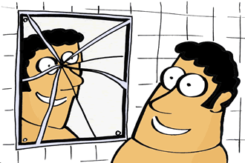


GOOD LUCK SUPERSTITIONS

1.- If you right hand itches, you will earn money.
2.- If you find a four-leaf clover, you will be lucky.
3.- If you step on your shadow, it brings you good luck.
4.- If a girl drinks salt water then goes to sleep, she will see her future husband in her dream.
5.- If the first butterfly you see in the year is white, it will bring you good luck all year.
6.- If you blow all the candles on your birthday cake in one blow, you will have whatever you want.
7.- If you put a mirror just across the door, you will have good luck.
8.- If you put the sugar into the cup first, before the tea, you will have good luck.
9.- You can hang garlic in your house for good luck.
BAD LUCK SUPERSTITIONS

1.- If your left hand itches, you will lose money.
2.- If you start a trip on Friday, you will meet misfortune.
3.- If you walk under a ladder, you will have bad luck.
4.- When a cat sneezes three times indoors, it will rain in 24 hours.
5.- If you dream about a dog, you will have a lot of enemies.
6.- If you break a mirror, it will be bring you seven years of bad luck.
7.- If you sleep with your feet towards the door, a nightwalker will steal your soul.
8.- If you open an umbrella, it brings you bad luck.
9.- If a dog howls at night, death is near.
10.- Don’t chase anyone with a broom.
