**A North American Christmas – An Inside Look for ESL Students…**

Posted By: Alisha

***North American Christmas Traditions***

[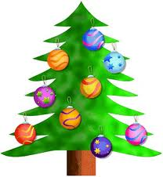](http://46dtbf3k4dl51vghpj6qqocj-wpengine.netdna-ssl.com/wp-content/uploads/2012/12/images2.jpg)

– Erin Casper (ILAC Teacher)

“This is the most wonderful time of the year.” Some of you might recognize this famous line from one of the many Christmas carols that are played on the radio and television this time of year. Christmas is a time to celebrate the holidays and spend quality time with friends and family. It’s a popular holiday in North America and we have our own Christmas traditions. Whether you celebrate Christmas or not, its fun to take part in some of the many activities and traditions Christmas has to offer.

**[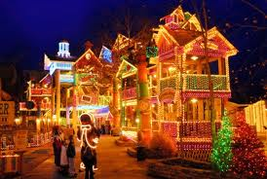](http://46dtbf3k4dl51vghpj6qqocj-wpengine.netdna-ssl.com/wp-content/uploads/2012/12/images6.jpg)Decorating the tree/house –** One of my favourite memories of Christmas was going to a tree farm last year. I don’t remember the name of the farm; however you can easily search the internet for tree farms in Ontario. Once I arrived at the farm, I got to walk around looking at the many trees and decide which one I wanted to cut down. The farm supplies you with an axe, so it made it easy to cut down a tree. Once I had my tree, I sat by the outdoor fire and roasted marshmallows and drank hot chocolate. I also had a snowball fight with my friends.

If driving to a tree farm is difficult to get to, you can purchase a Christmas tree at Canadian Tire or many other stores across Toronto. The biggest difference between purchasing a real Christmas tree versus a fake Christmas tree is the smell. There is nothing better than the fresh aroma of a real tree in your house. Once you have your tree, it is custom to decorate it with lights and ornaments, which can also be purchased at Canadian Tire or any department store. You can also see Christmas trees in front of City Hall and many other locations downtown. Along with decorating a Christmas tree, some people decorate their houses as well. I enjoy taking a walk around Rosedale neighbourhoods this time of year. The houses are very well decorated and beautiful to look at, especially at night.

**Presents! –**  Probably the best part of Christmas is the presents. Whether you are giving or receiving presents, it’s a great feeling making someone smile and surprising loved ones with things you know they will like. Christmas can be an expensive time of year, so my [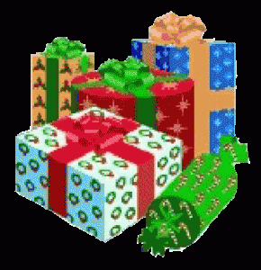](http://46dtbf3k4dl51vghpj6qqocj-wpengine.netdna-ssl.com/wp-content/uploads/2012/12/1christmaspresent.gif)advice is to give meaningful presents that cost very little, rather than big ticket items. Once you buy your presents, its custom to wrap them and place the presents under the tree. You usually open presents on Christmas morning. Along with presents, stocking stuffers are also popular. Stocking stuffers are small items like chocolate or candy that are placed in a stocking. A stocking is an empty (large) sock that is hung on Christmas Eve. Children usually believe that their stocking stuffers and other presents are given to them by Santa Claus. In order to prepare for Santa’s arrival, children put out milk and cookies for Santa to eat.

**[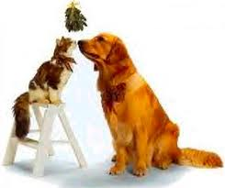](http://46dtbf3k4dl51vghpj6qqocj-wpengine.netdna-ssl.com/wp-content/uploads/2012/12/images5.jpg)[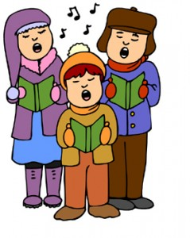](http://46dtbf3k4dl51vghpj6qqocj-wpengine.netdna-ssl.com/wp-content/uploads/2012/12/christmas-carolers.jpg) Christmas Carols** – As I mentioned before, you can hear Christmas carols everywhere this time of year. These popular songs get us into the Christmas spirit and many artists put out their own Christmas versions. This year I am going to a Christmas carolling party. I will receive a book when I get there with popular Christmas carols and for an hour everyone at the party will come together and sing these songs. There will also be food and drinks. The people that are hosting the event have been throwing this party for the last 25 years. I am excited to participate in this event. This is an example of the many Christmas parties that are hosted across North America.

**Mistletoe –** Mistletoe is a plant that grows on apples, oak and other broadleaf trees. Hanging mistletoe over a doorway during the holiday season is a popular tradition all over the world. This tradition derived from European folklore. It was believed that kissing under the Mistletoe would lead to marriage.  Nowadays, people usually partake in this activity for fun.

**[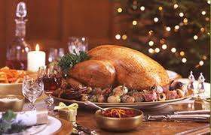](http://46dtbf3k4dl51vghpj6qqocj-wpengine.netdna-ssl.com/wp-content/uploads/2012/12/images4.jpg)Food –** There is nothing better than having a big delicious meal that you can enjoy with your friends and family. Both on Christmas Eve and Christmas Day, many North Americans have Turkey, duck, ham or any other roast meat to celebrate the occasion. There are many other types of food that are eaten often depending on the culture and traditions of the family. Accompanying the meal, there are a large selection of sweets such as gingerbread cookies and Christmas shortbread cookies.