**American Football: what´s up with that??**

American football is a favorite pass time of many Americans, especially in the fall of each year. On the field, there can be eleven players from each team in play. American football is a fairly young sport, starting around the 1890`s as a professional sport. It is played on a field marked by yards. There are 100 yards to each football field, and it looks like the picture below:

[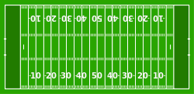](http://en.wikipedia.org/wiki/File:AmFBfield.svg)

To score, there are many things that each team must do. The teams are divided into offense and defense. The offense is responsible for moving the football down the field, towards the other team´s end zone. The offense must move the ball at least ten yards in order to continue, and we call this a First Down. The offense has four tries to earn a first down, and if they cannot do so, the other team takes control of the ball and must try to move it down the field in the other direction. Players can pass the ball, or tackle the ball from the other players to take control of the ball. The defense can also intercept the play, by taking the ball out of the air during a pass to another offensive player.

**How to score points:**

* Once players have earned a first down, the offense can try to make a touchdown. This is where they run the ball into the end zone. It is worth 6 points. After each touchdown scored, the kicker of the team has the opportunity to try for an extra point if they successfully kick the ball over the goal posts.
* A field goal is worth only 3 points, and this is earned when the offense scores with a kick over the goal posts.
* Very rare is the safety, which is worth only 2 points. This can happen when the ball is taken from the team in possession in their own end zone.

[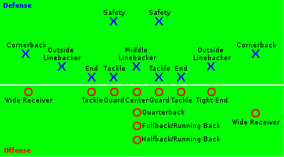](http://en.wikipedia.org/wiki/File:American_Football_Positions.svg)

The players:

**Defense:** Typical player positions consist of: defensive tackle, defensive end, middle linebacker, outside linebackers, cornerback, safety, nickelback or dimeback.

**Offense:** Quarterback, running back, wide receiver, tight end.

**Different levels:**  There are different levels in American football. There is the NFL (National Football League), Division I, Division II, and Division III. There are different rules for each division that require the universities to have so many students and so many athletes in order to be considered part of each division. Some popular division I universities are: University of Michigan (U of M), Michigan State University, Ohio State University, Pennsylvania State University (PennState), Purdue University, University of Notre Dame, Stanford University, UNLA, University of California.

Some popular division II universities are: Grand Valley State University (my university!), Ferris State University, Ashland University, Northwest Missouri State University, Wayne State University (my sister´s university!), Sagninaw Valley State University, Georgetown University, University of North Alabama, Michigan Tech, Simon Fraser University (located in British Colombia, in Canada, it is the first non-US Division II university).