*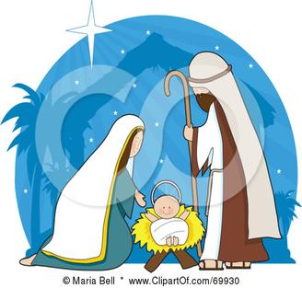*

*Christmas Songs and The Christmas Story*