ESL Easter Lesson
by www.elcivics.com
Easter is celebrated on a Sunday between March 22 and April 25. In 2015, it is on Sunday, April 5. On Easter, people color eggs, have an Easter egg hunt, wear new clothes, watch parades, and eat dinner with their family and friends. Some people go to church.
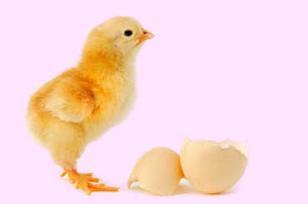 |  | What day of the week is Easter on?  - It is on a Sunday.  - This year Easter is on Sunday, March 27, 2016. We say "Happy Easter!"
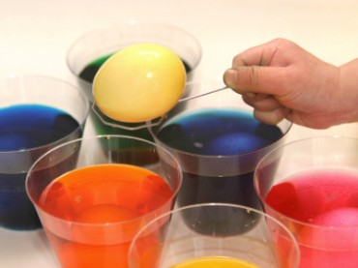 |  |  | What is the child in this picture doing?  - He is coloring hard boiled eggs for Easter.  - The dye is in plastic cups.  - Pink, yellow, blue, orange, and green are popular Easter colors.
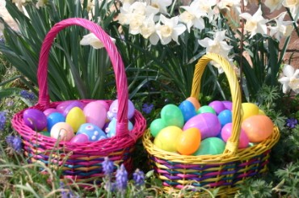 |  | What are these?  - They are Easter baskets.  - The Easter baskets are filled with colored eggs.
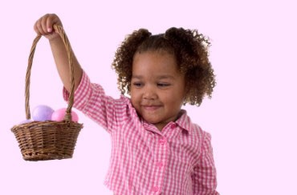 |  |  |  | Why is the girl smiling?  - She is smiling because she has a beautiful Easter basket.
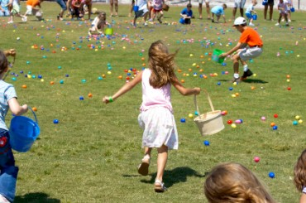 |  |  |  |  | What are these children doing?  - They are collecting plastic Easter eggs.  - They will put the eggs in their baskets.  - There is candy inside the eggs.
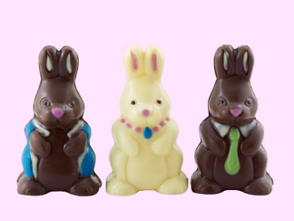 |  |  |  | What are these rabbits made of?  - They are made of chocolate.  - These chocolate rabbits are cute, and they taste delicious.
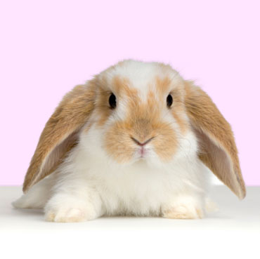 |  |  | What kind of animal is this?  - It is a rabbit.  - Children call baby rabbits bunnies, but they are really kits or kittens.  - Rabbits have long ears and short tails.  - Rabbits hop because their back legs are longer than their front legs.
 | What is this woman wearing on her head?  - She is wearing an Easter bonnet.  - An Easter bonnet is a fancy hat.  - This bonnet is pink, and it has flowers on it.

