Groundhog Day Lesson
by www.elcivics.com
February 2 is Groundhog Day. Groundhogs are small brown furry animals. They live in burrows in the ground, and they eat grass, berries, and other vegetation. Groundhog Day is based on folklore. The folklore is that if the groundhog comes out of its hole and sees its shadow then there will be six more weeks of winter weather. But if the groundhog comes out of its hole and doesn't see its shadow, then there will be an early spring.
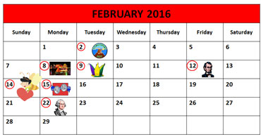 |  |  | When is Groundhog Day?  - It is on Thursday, February 2, 2017.  - If groundhog Phil does not see his shadow, there will be an early spring.  - If groundhog Phil sees his shadow, there will be six more weeks of winter.
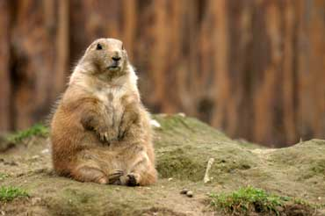 |  |  | What are groundhogs?  - They are small furry animals. Furry means their bodies are covered with hair.  - They have short ears, a short tail, and short legs.  - Groundhogs are common in the northeastern and central part of the United States.
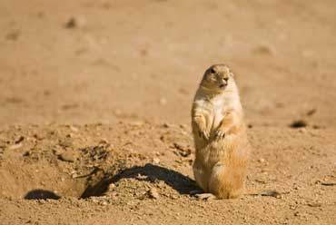 |  |  | What is the folklore of Groundhog Day?  - If the groundhog sees his shadow, there will be six more weeks of winter weather. If he does not see his shadow, there will be an early spring.  - The groundhog in this photo sees its shadow, so there will be six more weeks of winter weather.
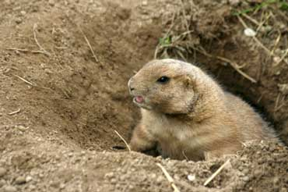 |  |  | Where do groundhogs live?  - They live in tunnels in the ground.  - They use their sharp claws to dig the tunnels.  - The tunnels are called burrows.
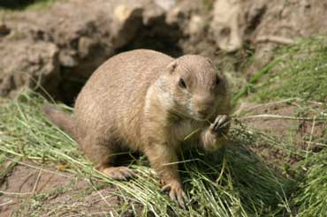 |  |  | What do groundhogs eat?  - They eat grass, berries, and other vegetation.
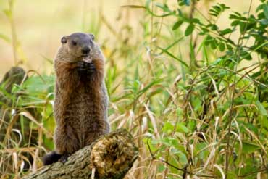 |  |  | How large are groundhogs?  - The average groundhog is 17 to 26 inches long with its tail and weighs from 4.5 to 9 pounds.  - Groundhogs gain weight before they go into hibernation for the winter. Hibernation is a deep coma.
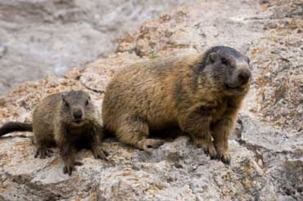 |  | What is a baby groundhog called?  - It is called a kit or a cub.  - Kits are born in mid-April or May, and they come in litters of 2 to 6 kits.  - Groundhogs live for 2 to 6 years.
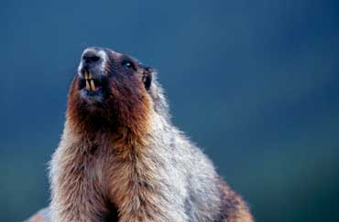 | What is this groundhog doing?  - It is whistling.  - Groundhogs whistle to warn other groundhogs about danger.  - They also whistle in the spring to attract mates.

