What is ESL ministry?  English as a Second Language ministry is a compassion ministry in which trained teachers help students learn English.  Students join our classes for many different reasons. Some want better jobs and some are seeking social connections. However, through the ministry of ESL we are able to teach English and make meaningful connections. These relationships allow us to offer them the most important and encouraging lesson we have – the gospel. |  | CHURCH LOGO | MY CHURCH ADDRESS  CITY, STATE, ZIP  PHONE  EMAIL  WEBSITE  ESL FACEBOOK |  | 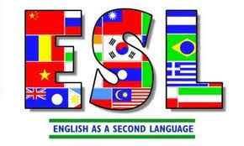  - Providing FREE English classes to our International friends who want to learn or strengthen their English speaking ability  (You may include one of the following here:  CHURCH MISSIONS STATEMENT  MATTHEW 28:19-20  ACTS 1:8)

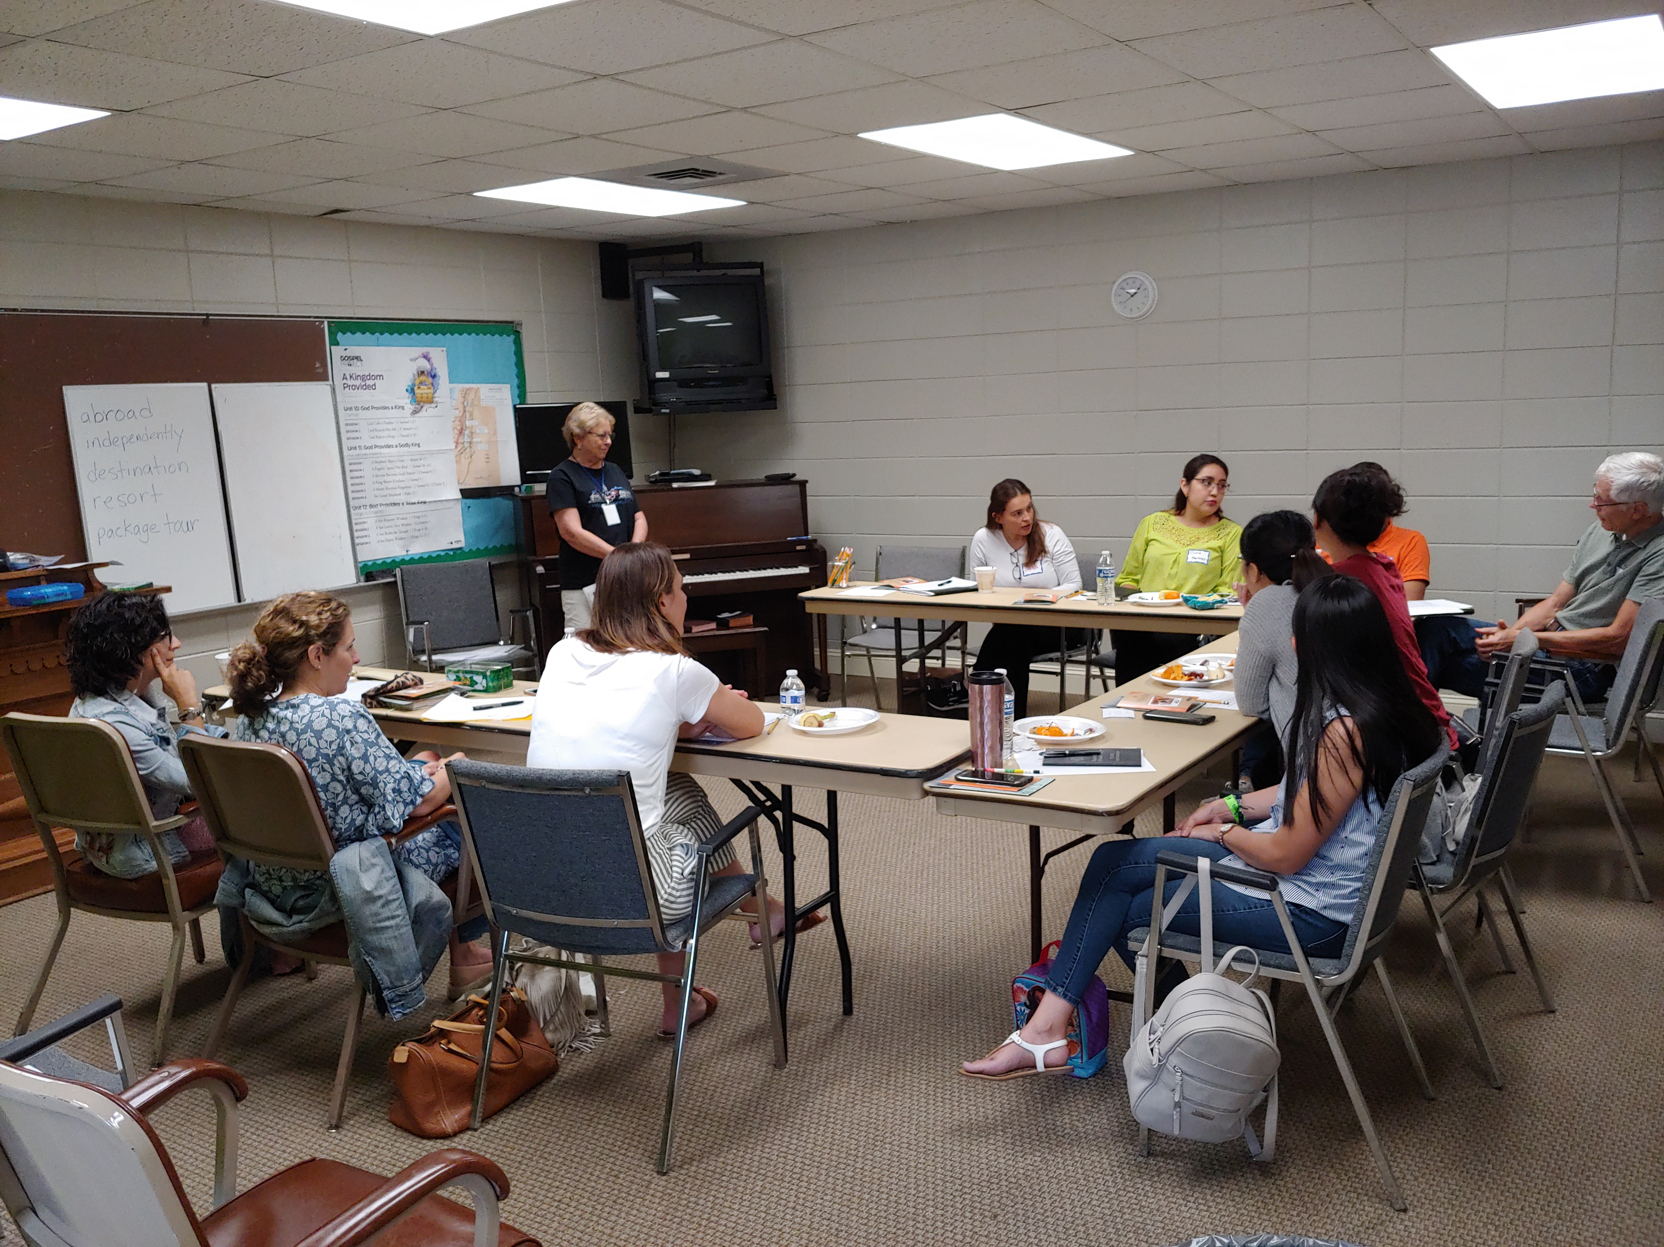  We have several opportunities each week for students to practice English.  CLASSES  ESL SUNDAY SCHOOL  Sunday School taught at an ESL level. The focus is on Bible learning, not English teaching but there are elements of both.  LEARN ENGLISH THROUGH THE BIBLE  Using the Bible as a textbook, students learn vocabulary, | If God has given you the desire to serve, we have a place for you in ESL ministry!  grammar, and practice conversational skills.  ALL ABOUT THE UNITED STATES  A combination of culture, history and government, this class introduces students to America. It is designed to introduce students to local customs, as well as prepare for citizenship interviews when appropriate.  ENGLISH CLASSES BY LEVELS  The largest portion of our ministry is our Thursday English classes. Students are divided into leveled classes. Class sizes are kept small to allow for meaningful connections. The goal is to have 2 teachers per class, or 1 teacher and 1 assistant. Conversational English is the focus and the goal is to help students improve their English-speaking abilities. | VOLUNTEER POSITIONS  There are many types of volunteers needed, not just teachers. Below are just some of the ways you can serve.  TEACHER  Teach a class. You DO NOT need to be able to speak a foreign language. Our emphasis is on speaking ENGLISH.  ASSISTANT TEACHER  Help a teacher during class time. If you can talk, you can assist!  HOSTESS  Help by greeting students, sending out cards, planning events and more.  CHILDCARE  Help our ministry by caring for the children of our students. You can teach the preschoolers some English while loving on these sweet babies.  CRAFT DAY  Help while our students enjoy making crafts together or your Sunday School class can provide lunch for the event.  PRAYER MINISTRY  Our most powerful weapon is prayer. Join the warriors that are praying for our students, their families, and our teachers.

