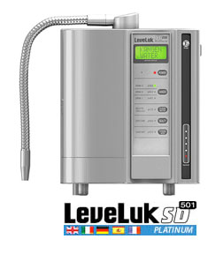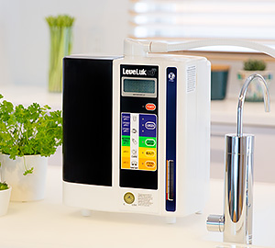

Awesome Videos

Change Your Water… Change Your Life!

These Videos will help You to better Understand This Amazing Water…

*KW in 20 Minutes [vimeo.com/61680206](https://vimeo.com/61680206)

*Pat Boone on KW [www.kangendemo.com](http://www.kangendemo.com)

*KW for Chiropractors [vimeo.com/61680211](https://vimeo.com/61680211)

*What Doctors say on KW [www.youtube.com/watch?v=p6I3ZGIf-do](http://www.youtube.com/watch?v=p6I3ZGIf-do)

*Dr. Oz on Antioxidants in KW [www.youtube.com/watch?v=LO6VCudb0qs](http://www.youtube.com/watch?v=LO6VCudb0qs)

*Dr. Michael Explains the KW <https://vimeo.com/83717898>

*Dr. Michael Explains the Competition [www.youtube.com/watch?v=TugKJW6USAw](http://www.youtube.com/watch?v=TugKJW6USAw)

*Alkline vs Alkalize w/Dr. Michael [www.youtube.com/watch?v=g83zxEmSC_o](http://www.youtube.com/watch?v=g83zxEmSC_o)

*Dr. Michael Explains this Business [www.youtube.com/watch?v=nkQS4QUnKaY](http://www.youtube.com/watch?v=nkQS4QUnKaY)

*Daniel Dimacale Dry Thirsty World [www.youtube.com/watch?v=o6K3KmQshEQ](http://www.youtube.com/watch?v=o6K3KmQshEQ)

*Dr. Corrine Allen Your Brain on Water [www.youtube.com/watch?v=a0gv4jApEu4](http://www.youtube.com/watch?v=a0gv4jApEu4)

*KW Effect on Your Blood <https://www.youtube.com/watch?v=Eay4EtVwDGc>

When Researching Kangen Water go to <http://scholar.google.com/> to Search or pubmed.gov. The technical term for Kangen water is Electrically Reduced Water (also known as ERW and Electrolyzed reduced)

For Our Enagic Website visit [www.Enagic.com](http://www.Enagic.com)

For a Kangen Water Personal Story on any health issue go to Youtube ..

Type in “Kangen” & Name of The Issue.

What’s Really Smart, Start Drinking this Water and Have a Testimony of Your own!