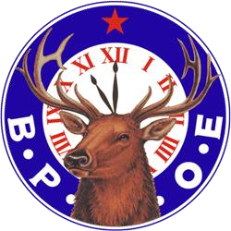
Portland Elks Lodge #188
1945 Congress Street
Portland, Maine 04102

Delinquent Member Information

We have members who have not paid their dues.
It is important for you to send in your dues to prevent being dropped from the roll of members of Elks Lodge #188.

Dues for 2026 were due on April 1, 2026

Dues for Members are $97.00

Dues for Life Members are $59.50

You can pay by

Cash, Check, Credit Card, or

Online at: https://secure.directbiller.com/db-payer-ui/#/login

IF YOU WANT YOUR CARD MAILED TO YOU, SEND
A SELF-ADDRESSED STAMPED ENVELOPE; OTHERWISE, YOUR CARD WILL BE AT THE BAR FOR YOU TO PICK UP.

