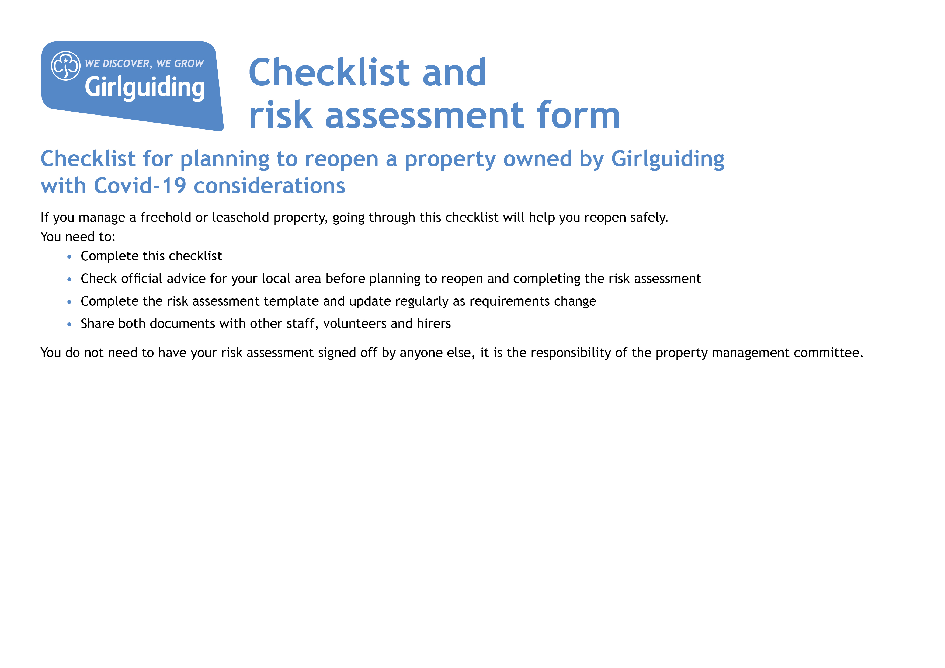



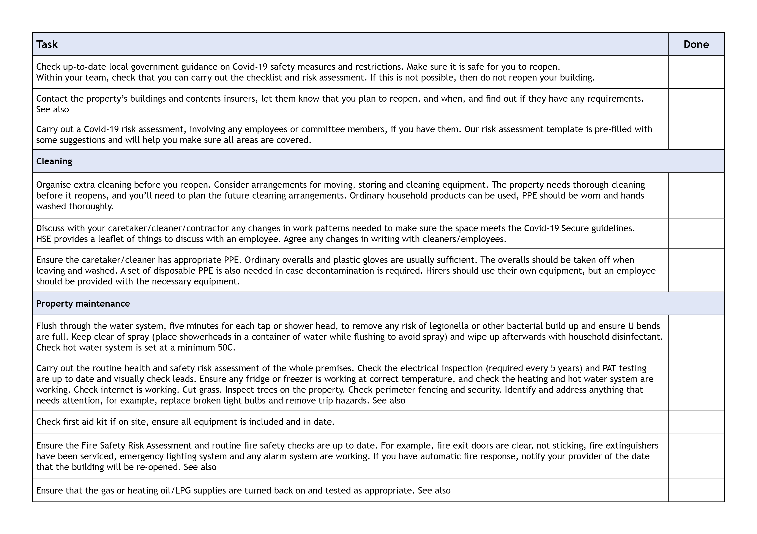

Be prepared: health and safety

Yes

Yes

Yes

Yes

Yes

Yes

Yes

Yes

Yes

Yes

Be prepared: health and safety

Fire Risk Assessment pdf

[Insurance issues for property managers](https://www.girlguiding.org.uk/making-guiding-happen/running-your-unit/finance-insurance-and-property/resources-for-property-managers/insurance-issues-for-property-managers/)

Yes

Yes

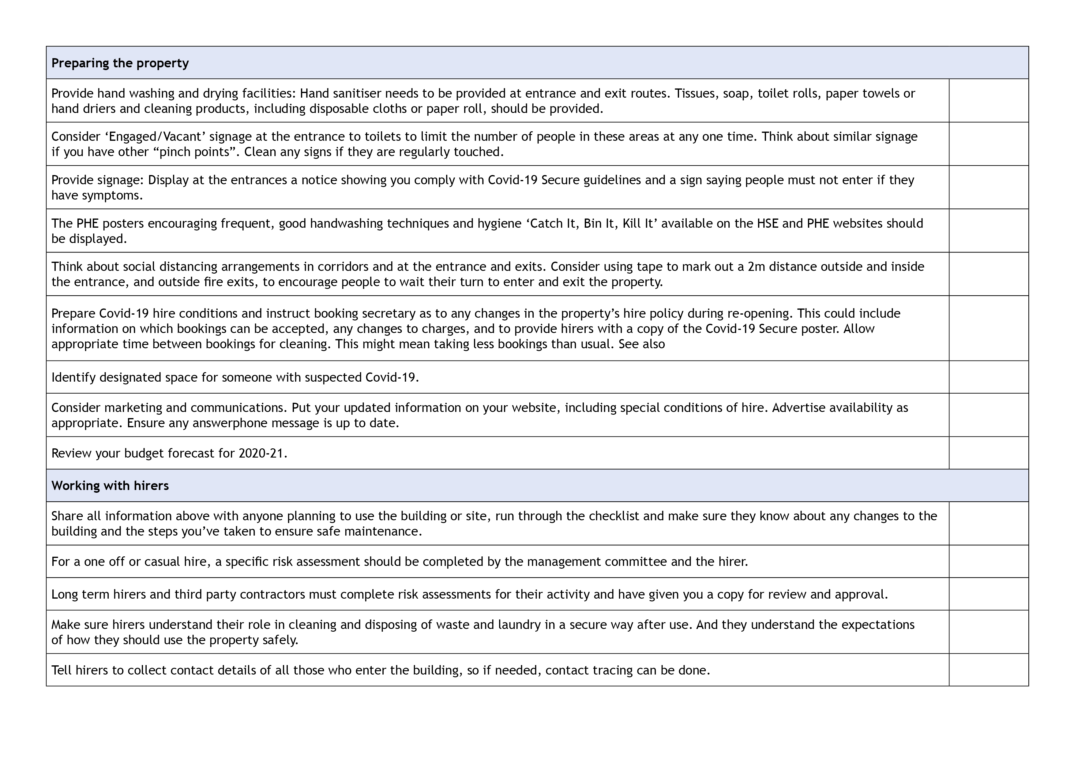

Yes

Yes

Yes

Yes

Yes

Yes

Yes

Yes

Yes

Yes

Yes

Yes

Yes

N/A

Hiring out your hall

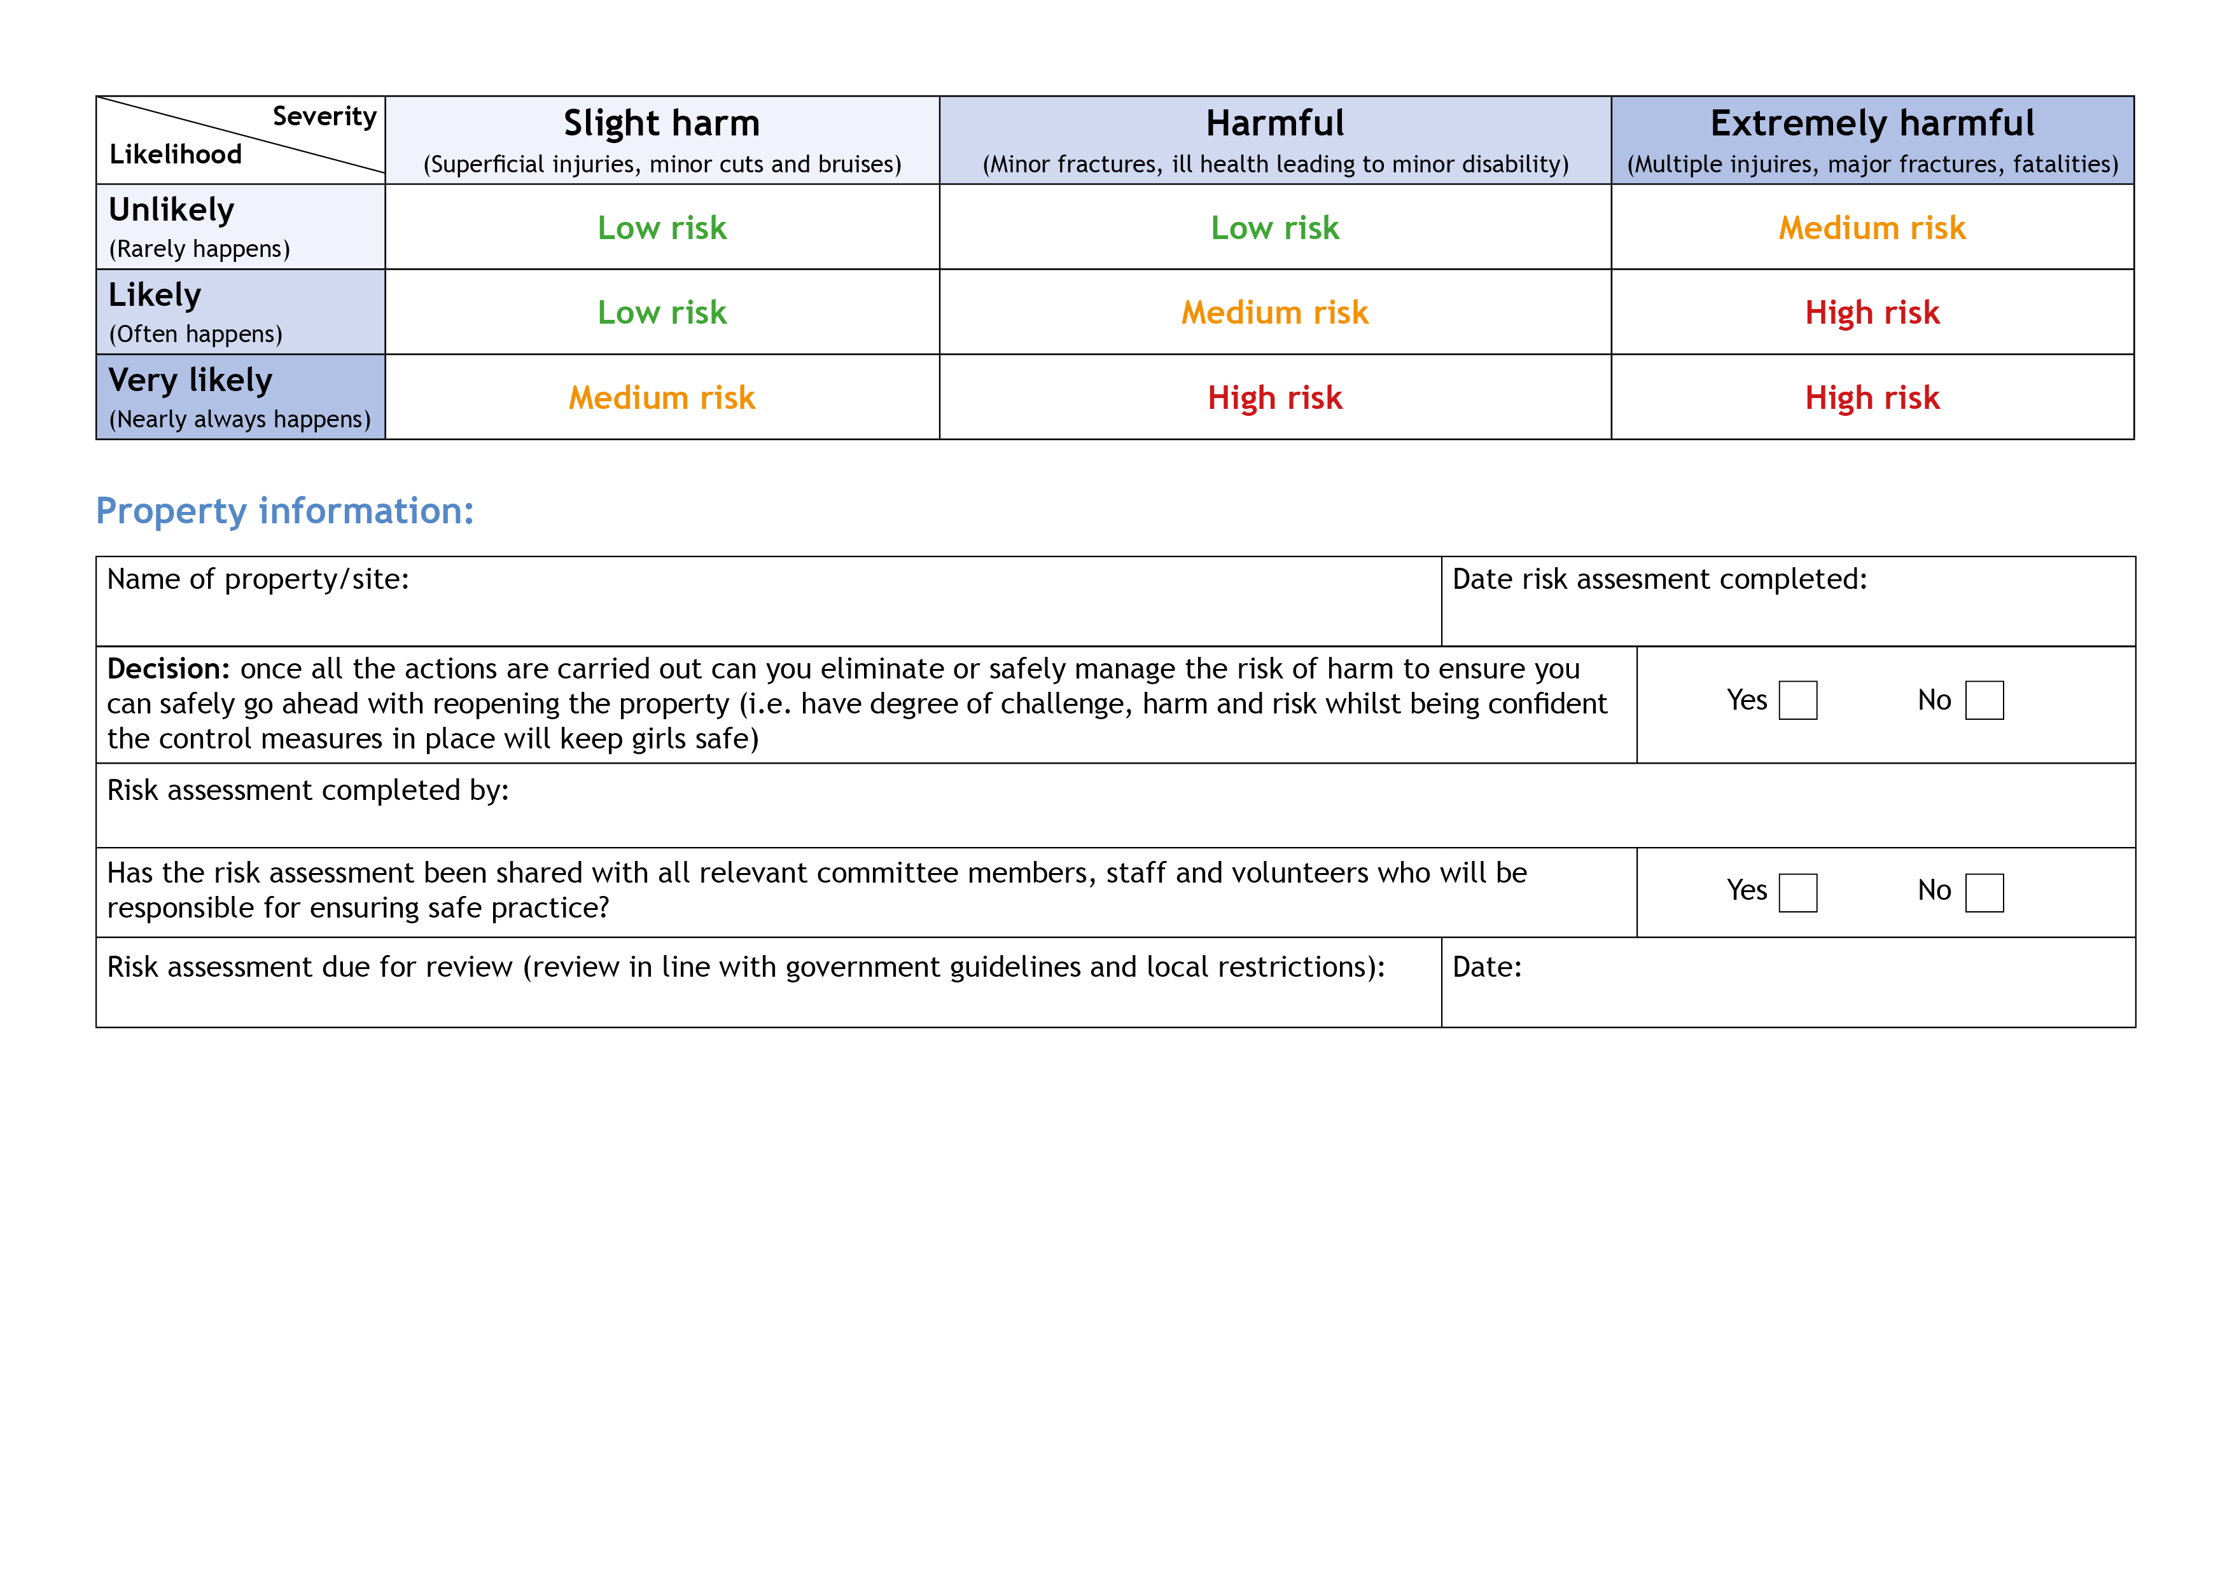

March 2021

X

X

Scarisbrick Guide Campsite. L40 9RQ

April 12th as step 2 of government pathway

begins

Scarisbrick Management Committee

| **Hazards**  What could cause harm or damage? | **Who or what is at risk of being affected and how?** | **What are you already doing?**  How have you reduced the risk already? | **Likelihood of risk occurring**  **(L/M/H)** | **Severity of risk**  **(L/M/H)** | **Are further controls necessary?**  What else needs to happen to reduce the risk to an acceptable level? | **Action by:**  name/date |
| --- | --- | --- | --- | --- | --- | --- |
| Long term closure means that systems may not have been working for an extended period.  This could mean that statutory compliance has not been maintained. | All users – may become ill or be put at greater risk because systems  are not working correctly. | Make sure that all systems are re-commissioned before any meetings take place.  This must include checks for fire and water systems and gas safety. Checks should also be performed on heating and ventilation systems and emergency lighting.  Perform deep clean prior to opening.  Complete checklist for reopening. | Medium | High | Consider employing specialists to carry out checks if not confident to do yourselves. Follow checklist to ensure that all relevant tests are carried out. | Estates Manager  (before March 30th & ongoing)  “  CA team  (before 1st users)  “ |
| Coronavirus infection risks below are in consideration of this risk and reducing it to an acceptable level. | All people using the facility from spread of virus through close contact. |  | Low | High |  |  |
| Staff, volunteers, contractors and users. | All could be at risk of exposure to virus through their roles, likely to include those carrying out cleaning, caretaking or maintenance. | Discuss the situation with staff/volunteers in high risk groups to identify whether provision of protective clothing and cleaning surfaces is sufficient to mitigate their risks, or whether they should cease such work or volunteering for the time being. | Low | High | Request RA and procedure for Covid-19 from contractors and users and review them.  Staff training/ regular briefing of users.  PPE provision for staff/volunteers.  Cleaning regimes, all contact surfaces to be regularly cleaned.  Doors on automatic release to keep open on regular walk ways. Fire evacuation procedure to be updated if you have doors open to ensure doors closed when not  in use. | Contractors: Estates Manager  Users: Booking Secretary  CA team  CA team  CA team  Users / CA on duty – included in opening up & closing procedure |

| **Hazards**  What could cause harm or damage? | **Who or what is at risk of being affected and how?** | **What are you already doing?**  How have you reduced the risk already? | **Likelihood of risk occurring**  **(L/M/H)** | **Severity of risk**  **(L/M/H)** | **Are further controls necessary?**  What else needs to happen to reduce the risk to an acceptable level? | **Action by:**  name/date |
| --- | --- | --- | --- | --- | --- | --- |
| All areas. | Potential for cross contamination and passing infection, between users. | Set out a procedure on what cleaning is required and how regularly this should be done for each hirer, include  door handles, light switches, window catches, tables, chairs and other equipment used to be cleaned by hirers before use or by property cleaning staff. | Low | High | Detail chemical to be used for cleaning. Something with a bleach product – COSHH risk assessment required on product (assessment of working with hazardous materials). | CA team to inform CA’s before their 1st duty  Cleaning products available for hirers to us during the day |
| Entrance halls/lobby, in corridors.  - MPH  - Barn | Capacity for social distancing is reduced thereby increasing the risk to all users. | Check the number of users meeting at the venue at the same time.  Work with hirers to plan the numbers that can be accommodated.  Provide hand sanitiser at all entrances.  Put a one-way system in place if necessary – use one door for entrance and one for exit.  Provide signage. | Low | High | Reorganise booking times or change days and time in order to maximise capacity for all users and allow for cleaning in between.  Hand sanitiser needs to be checked daily.  Provide more bins, in entrance hall, each meeting room. Empty regularly. | Booking Secretary  CA on duty  CA Team  Users / CA on duty |

| **Hazards**  What could cause harm or damage? | **Who or what is at risk of being affected and how?** | **What are you already doing?**  How have you reduced the risk already? | **Likelihood of risk occurring**  **(L/M/H)** | **Severity of risk**  **(L/M/H)** | **Are further controls necessary?**  What else needs to happen to reduce the risk to an acceptable level? | **Action by:**  name/date |
| --- | --- | --- | --- | --- | --- | --- |
| Car parks/paths/patios/  exterior areas. | Start and end of meetings creates risk of breaching social distancing guidelines for property users and those dropping off or picking  up users. | Have a drop off and pick up process that is communicated to all users in advance.  Mark out two metre waiting area outside all potential entrances with tape to encourage care when queuing to enter. If space does not allow this state that masks must be worn.  Keep all external areas clear of contaminated rubbish. | Low | High | Encourage those picking up and dropping off from cars to remain in their cars.  Suggest to hirers that they limit drop off and pick up to one parent/carer/adult.  Consider staggered start and finish times for bookings.  Make sure that there is a 15-minute gap between hirers to ensure there can be no cross over between groups. | Booking Secretary to communicate the message to users & duty CA to reinforce to users on arrival.  “  “  “ |
| Main hall/meeting space.  - MPH | Capacity for social distancing is reduced thereby increasing the risk to all users. | Set a limit on numbers attending – check relevant government guidance for your local area.  Remove unnecessary items from the hall/space.  Social distance guidance to be observed by hirers in arranging their activities.  Remove soft furnishings and things that are hard to clean from venue. | Medium | High | Outdoors from March 29th: Guide & Scout units  Indoors from April 12th*:  Guide & Scout units 15 children + volunteers in a bubble  All adults to follow current public guidance on meeting up | Booking Secretary to monitor numbers on booking.  Management committee to remove unnecessary items before 1st use |
| Small meeting rooms and offices.  - Barn | Capacity for social distancing is reduced thereby increasing the risk  to all users. | Don’t use these rooms if social distancing cannot be observed. If use is required make sure that masks are worn if social distancing cannot be observed.  Have a one in one out system. | Medium | High | Consider using for adult trainings only with restricted numbers | Booking Secretary to monitor numbers in bookings |

| **Hazards**  What could cause harm or damage? | **Who or what is at risk of being affected and how?** | **What are you already doing?**  How have you reduced the risk already? | **Likelihood of risk occurring**  **(L/M/H)** | **Severity of risk**  **(L/M/H)** | **Are further controls necessary?**  What else needs to happen to reduce the risk to an acceptable level? | **Action by:**  name/date |
| --- | --- | --- | --- | --- | --- | --- |
| Kitchen. | Capacity for social distancing is reduced thereby increasing the risk to all users. | Ask hirers to control the numbers using the kitchen area so as to ensure social distancing.  Hirers to clean all areas likely to be used before use, wash, dry and stow crockery and cutlery after use.  Hirers to bring own tea towels.  Hand sanitiser to be provided.  Hirers to be encouraged to bring their own food and drink. | Low | High | Cleaning materials to be made available in clearly identified location, eg a box on one of the kitchen surfaces, regularly checked and re-stocked as necessary.  Consider closing kitchen if not required or restricting access.  Disposable crockery (paper plates) and plastic/wood cutlery. | Booking Secretary to communicate message to users on booking & duty CA to reinforce on arrival.  Hirers are asked to leave all areas tidy on departure.  Duty CA to clean on departure |
| Use of shared resources. | Leads to risk of increased transmission. | Do not allow different user groups to use the same resources unless you can make sure that there is a clear protocol in place for cleaning and quarantining resources before using  them again.  Consider types of activities that are appropriate and inform users of cleaning arrangements for resources ahead of use so that they can include in their risk assessment.  Ensure thorough cleaning between different groups if areas and resources are shared. | Low | High | Ask users to bring their own equipment.    As well as cleaning we can quarantine equipment before next use dependent on how long the virus can survive on surfaces:  In the air: 3 hours  Metal: 5 days  Wood: 2- 4 days  Plastics: 2-3 days  Stainless steel: 2-3 days  Glass & ceramics: 5 days  Aluminium: 2-8 hours  100% cotton: 24 hours  The virus lasts on outdoor surfaces for a shorter time period. | Booking Secretary to take bookings that enable cleaning / quarantine between users and avoid sharing of resources as much as possible.  Provide cleaning equipment for use during the day / session and a detailed list of what to clean |

| **Hazards**  What could cause harm or damage? | **Who or what is at risk of being affected and how?** | **What are you already doing?**  How have you reduced the risk already? | **Likelihood of risk occurring**  **(L/M/H)** | **Severity of risk**  **(L/M/H)** | **Are further controls necessary?**  What else needs to happen to reduce the risk to an acceptable level? | **Action by:**  name/date |
| --- | --- | --- | --- | --- | --- | --- |
| Toilets. | Social distancing difficult. | Hirer to control access to toilets with particular attention to more vulnerable users.  Hirer to clean all surfaces etc (basins, baby changing and other surfaces, toilet pans/seats) after use. | Medium | High | Ensure soap, paper towels, tissues and toilet paper are regularly replenished and hirer knows where to access for  re-stocking if needed. | CA on duty to check supplies before arrival & show hirer where to find extra supplies  CA on duty to clean toilets after use |
| Poor respiratory or handwashing hygiene on the part of meeting attendees. | Risk of increased transmission. | Ensure clear signage that reinforces cleaning and hygiene routine in line with Covid-19 Secure guidelines:  Minimise contact with individuals who are unwell.  Clean your hands often.  Avoid touching mouth, eyes and nose. Dispose of tissues in a bin. Display catch it,  kill it, bin it poster.  Ensure regular cleaning of surfaces that are touched frequently.  Maintain social distance where possible.  Make sure that where possible windows and doors are unlocked for users to open them during a meeting (remember to remind users not to prop open fire doors and be mindful of safeguarding considerations). | Medium | High | Display relevant posters. | CA on duty to check all posters and signage is in place  CA on duty to go through list of what is required of the user and how to open windows etc. |

| **Hazards**  What could cause harm or damage? | **Who or what is at risk of being affected and how?** | **What are you already doing?**  How have you reduced the risk already? | **Likelihood of risk occurring**  **(L/M/H)** | **Severity of risk**  **(L/M/H)** | **Are further controls necessary?**  What else needs to happen to reduce the risk to an acceptable level? | **Action by:**  name/date |
| --- | --- | --- | --- | --- | --- | --- |
| Someone becomes ill during the course of a meeting. | Others in contact with the individual | Set up a designated safe area that should be used if someone becomes ill.  Have a clear guidance on who users should inform and what they should do.  Make sure that appropriate and relevant cleaning arrangements can be implemented. | Low | High | Have a supply of PPE in on site first aid kit. | Booking Secretary to communicate this to users on booking.  CA to check on departure & report to Booking Secretary ASAP so that cleaning can be arranged and future bookings checked in case of disruption. |
| Property users do not adhere to guidelines. | Others in the group or on site at the same time  The next users of the site | Share the property risk assessment with the hirers in advance.  Make sure that an appropriate risk assessment for the group/activity that is meeting at the venue has been completed.  Long term hirers and third-party contractors must share these with you.  Make sure relevant information about contact tracing procedures has been included and that no one attends if they show any signs of being unwell. | Low | High | Put in place any Covid-19 secure conditions that can be added to usual and one-off hire agreements – this could include clear instructions about cleaning responsibilities, maintaining social distancing, maximum attendance numbers, disposal  of rubbish and appropriate activities.  Carry out a risk assessment with one off or casual hirers. | Booking Secretary to share risk assessment with confirmation of booking and other related information  Check QR code for NHS app is visible |