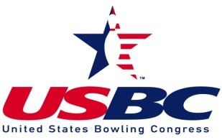

28th Annual Tucson Metro USBC Senior Masters

Certified by United States Bowling Congress
Entries paid by cash at time of bowling Prize Fund $75.00
Please enter at least 30 Minutes prior to start of squad Lineage/Expense Fee $25.00
All prize money returned 100% plus added money Total Entry Fee $100.00
Must be 50 years old by start of competition to compete
Pattern: Krypton
Sponsored by Park Avenue Jewelers and 643 SportsCards

SQUAD TIMES
Qualifying Saturday October 9, 2021 10:00AM and 2:00PM
Semi-Finals /Finals Sunday October 10, 2021 10:00AM

Host Center Tournament Director
Tucson Bowl Steve Harris 520 591-0622
. 7020 E. 21st Street
Tucson, AZ 85710
(520) 747-1363

This is a walk-in tournament. Bowlers must be members of Tucson Metro USBC (see Rules at Tucsonmetrousbc.com)

Name ________________________________________________ USBC Member # _______________

Address ____________________________________________________________________________

City _______________________________________ State ________________ Zip Code___________

Phone _____________________________________ Date of Birth _____________________________

Email______________________________________________________________________________

I have read and understand the rules for this tournament.

Signature ___________________________________________________________________________

Office Use
Entry Number _______________ Amount __________________________

