;.
,/J | ' .-. | .-

APut.JJreFoR
:
THE5JJOrf

ADULT LIFETIME 300 GAME AND
800 SERIES AWARDS

STEP 1: Choose Your Ring Style

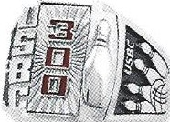
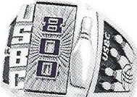
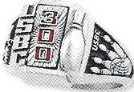
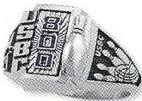
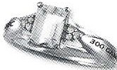
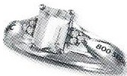
WOMEN'S PREMIER (Sizes 3 - 15)

......,. 300 GAME ......,. 800 SERIES

MEN'S PRESTIGE
- 3 00 GAME ,. 800 SERIES

.1 WOMEN'S PRESTIGE
--
- 300 GAME ......,. 800 SERIES

WOMEN'S PREMIER

-....-.... Siladium "" No Charge )ti

........

Siladium No Charge
........ Siladium No Charge

........ Golden Siladium $50.00
Siladium Two-Tone $200 .00
1 OK Yellow Gold $625.00 Siladium Two-Tone
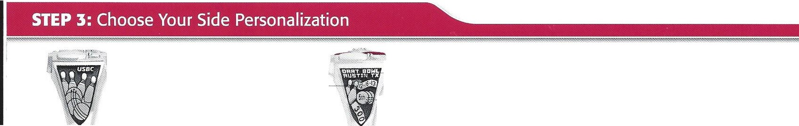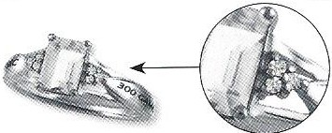14K Yellow Gold $875 .00 P r estige
- -
Date Bowled
,. No Personalization
(Standard)
No Charge
1,a .c.--
Two linesof text
(9 charactersper line)
Number of times score bowled
WOMEN'S PREMIER
-- Diamond Accent Stones $60.00
-- Personalized Design
$25.00
FJ.":' Standard &._ Lab-cre ated Ruby _a "'- Genuine Amethyst
No Charge i . me
: ries

........
Golden Siladium $50.00
Siladium Two-Tone $160.00
1 OK Yellow Gold $425.00
14K Yello w Gold $525.00
........ 1 OK Yellow Gold $315.00
........ 14K Yellow Gold $400.00

P RESTIGETOP PIN OPTIONS
: - Classic Pin
PRESTIGE PANEL / STONE OPTIONS
300 Game 80 0 Series
-

PAVE PANEL DESIGNS

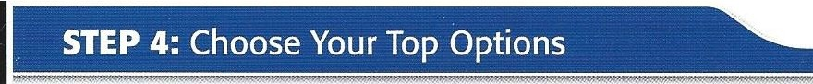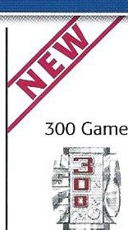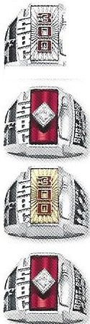(Standard )
No Charge
"' '
I'.S!
- Signet Panel
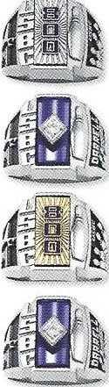
( Standard)

800 Series

-- --- NChar g e

- P a;,

Pa oel -

Diamond CZ
D •., .

- PersonalizedPin
(3 characters)
$10.00

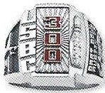
- Diamond­ Accent Pin
$60.00
- CZ Zenith -Set - Stone
$50.00

- l 0 K Yell ow - Go ld Pan el
$75.00

- Diamond - Zenith-Set Ston e
iqil_ll
55 - $60 55 - $40 • I
lO K - $100 l 0K - $60 -
Honor your multiple achievement with the 300 or 800 Multipl e Top
, -

Pave Panel - , _ ,
D iam on d CZ gJ2 J
j I
' 55 - $60 55 - $40 -
- l 0K - $100 lOK - $60 -

$150.00
_
Onceyour score has been certified, call Keepsake at 800-982-6515to placeyour upgradeorder.
:
To add this top panel to an existing Prestige ring, please contact Keepsake at 1-800-982 -6515 once your achievemenitsapproved.

CRYSTAL AWARDS AND PLAQUES

300 Game

C a l Aw acd
l&j\

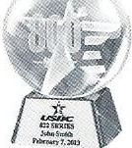
800 Series Crystal Award

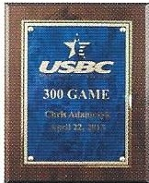
300 Game Plaque

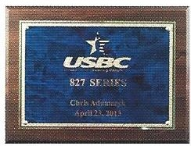
800 Series Plaqu e

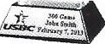Call USBC at 800 -514 -2695 to place your Crystal Awards and Plaques ord er.
- . .

Notify league processor within 48 hours of 300 game or 800 serie.sApplication must be submitted to league proce  USBC 2018-2019 ADULT HIGH SCORE APPLICATION: 300 Game and 800 Series.  ORDER CANNOT BE PROCESSED UNLESS ALL FIELDS ARE COMPLETE.  Center Name: _ _ _ _ _ _ _ _ _ _ _ _ _ Center#:  Center Address: _ _ _ _ _ _ _ _ _ _ _ _ _ _ _ _ _ _ _ _ _ _ _ _ _ _ _ _ _ _  Address City/State/Zip  Competition Name: Competition #:  Competition Official: _ _ _ _ _ _ _ _ _ _ _ _ _ _ _ _ _ _ _ _ _ _ _ _ _ _ _ _  Print Name Address City/State/Zip  Member Name:  Last Name · First Name M.I.  Member Address:  Street Address Apt. #  City State Zip  E-mail: Day Phone: ( ) _ _ _ _ _ _ _ _ _ _  Member Assn. Name: Assn. Number: |  |  |  |  |  |  | ssor within 20 days of score.  Competition Type (Check an e)  - League  □ Tournament  - Interschloastic  - Modified Format (scoresheetattached)  Note : See USBC Playing Rule 3 for modified competition formats.  _ Member ID#: _ Date of Birth: _  Gender: Bowled with:  - Female D Right hand  o Male □ Left hand
Date Bowled: _ _ _ _ _ _ | _ | _ | _ | _ _ _
MM DD |  |  |  | Year | Game I Game 2 | Game 3 | Average No. af Games
Serial Number on Ball: □ Yes □ No
Ball Manufacturer Ball Model Were all rules obseNed when score was bowled?
□ Yes □ No, (if no attach explanation)
Competition Official Signature: _X Was/were thegame(s) pre/post bowled?
□ Yes □ No
USBC LIFETIME ADULT ACHIEVEMENTS Approval can be found on bowl.com
Choose Your Award □ 300 Game □ 800 Series
Please note if this □ First adult lifetime achievement for this score. □Multiple achievements. (additiona l fees will apply)
achievement is: Please select award below. Do NOT select an award on this form. Please see NOTE* below.
□Men's Prestige Ring □ Women's Prestige Ring Crystal Awards/ Plaques: Donation Options:
Finger Size _ ._ (sizes 7-18 whole Finger Size _ ._ (sizes 3-15 whole □ 300 Game Crystal Award D Hall of Fame
and half sizes available) and half sizes available) □ Earl Anthony Fund
Men's Metal Choice {Choose one) Women's Metal Choice (Choose one) □ 800 Series Crystal Award O Bow lers to VeteransL in k ( BVL)
- Siladium No Charge □ Siladium No Charge
- Golden Siladium $50.00 □ Golden Siladiu m $50.00 □ 300 Game Plaque D Susan G. Kamen for the Cure
- Siladium Two-Tone $200.00 □ Siladium Two-Tone $ 160 .00 800 □ Youth Education Services
- l OK Yellow Gold $625 .00 D lOK Yellow Gold $425 .00 □ Ser ei s Pal qu e (YES Fu nd)
D 14K Yellow Gold $875 .00 D 14KYe l low Gold $525.00 _ _ _ _ _ _ _ _ _ _. _ _ _ _ _ _ _ _ _ _ _
D Women's Premier Ring in Si/odium with CZ stones
Prestige Side Personalization (Choose one) Finger Size _ ._ (sizes 3 -15 whole and half sizes available)
- Standard Side No Charge
- Custom S□ide □□$2□5.00 □□□□□ Upgrades Available:
  - l OK Yellow Gold $315.00
Text Line l: □□□□□□□□□(u p itno A9LcLhCaAraPSct)er s D 1 4 K Yellow Gold $400.00
  - Diamond Accents $60.00
Text Line 2: (u p itno A9LcLhCa rAa PcS)ter s □ Lab-createdRuby (300 Game) $25.00
  - Genuine Amethyst (800 Game) $25.00
Date Bowled: @] - [] [J - [J D □Multiple Design Pave Panel
* of Times Score Bowled: □ 300 □ 800
□ Bowling Ball Design or □ Number
Prestige Panel/Stone Choice Prestige Top Pin Cho ice □ Sterling Silverwith CZ $40
{Choose one) (Choose one) □ Sterling Silver with Diamond $60
- Signet Panel No Charge □ Classic Pin No Charge D 1OK Yellow Gold with CZ $60
- CZ Zenith Stone $50 .00 □ □Pers□ona□lized Pin $10 .00 □ l OK Yellow Gold with Diamonds $100
To add this top panel to an existing Prestige ring, please contact
- l OK Yellow Panel $75.00 (up to3 c harac te rs Keepsake at 1-800-982-6515 once your achievement is approved.
in ALL CAPS)
□ Diamond Zenith Stone $ 150.00 □ Diamond Accent Pin $60.00 □ No award requested for this achievement.
Please ship award to:
□ Directly to me at the above address.
Member Signature: _X_ _ _ _ _ _ _ _ _ _ _ _ _ _ _ _ _ _ _ _ _ _ □ Association
I verify that all information relative to the high score bowled is correct. □ League Official
*NOTE: Once your achievement is certified, additional awards may be purchased at □ Other:
Keepsakebowling.com, USBCBowlingAwards.com, or by calling 1-800-514-269 5
KS208-0518.27804

