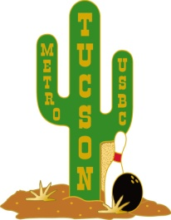 **Welcome Back Tournament**

**September 8, 2024 10am at Tucson Bowl**

**Sponsored by: TUCSON METRO USBC**

*Prize fees returned 100%*

**HANDICAP 9-PIN NO TAP TOURNAMENT**

**Three games singles**

**Handicap 90% of 220**

**$20.00**

**Entry Fee includes Lineage, Prize Fund, and** **Color Pins**

**10:00 am Sunday September 8, 2024**

**Check in starts at 9:00 am**

**Limited to 66 bowlers**

**Pre-register by email at**

[**am@TucsonMetroUSBC.com**](mailto:am@TucsonMetroUSBC.com)

**or Call Steve at (520) 591-0622**

**Pre-registered bowlers will be entered into a special raffle**

**Walk-ins Accepted (Space available)**

**Tucson Bowl**

**7020 E. 21st Street**

**Tucson, AZ 85710**

|  |  |
| --- | --- |
| **COST PER BOWLER PER EVENT •** |  |
| Prize fee $ 9.50 | **Payment by** |
| Lineage plus tax included $ 10.50 | **CASH ONLY** |
| Expenses $ 0 |  |
| **Total per person** **$ 20.00** |  |

**If you have any questions or to sign-up contact:**

**Steve Harris 591-0622** [**am@tucsonmetrousbc.com**](mailto:am@tucsonmetrousbc.com)