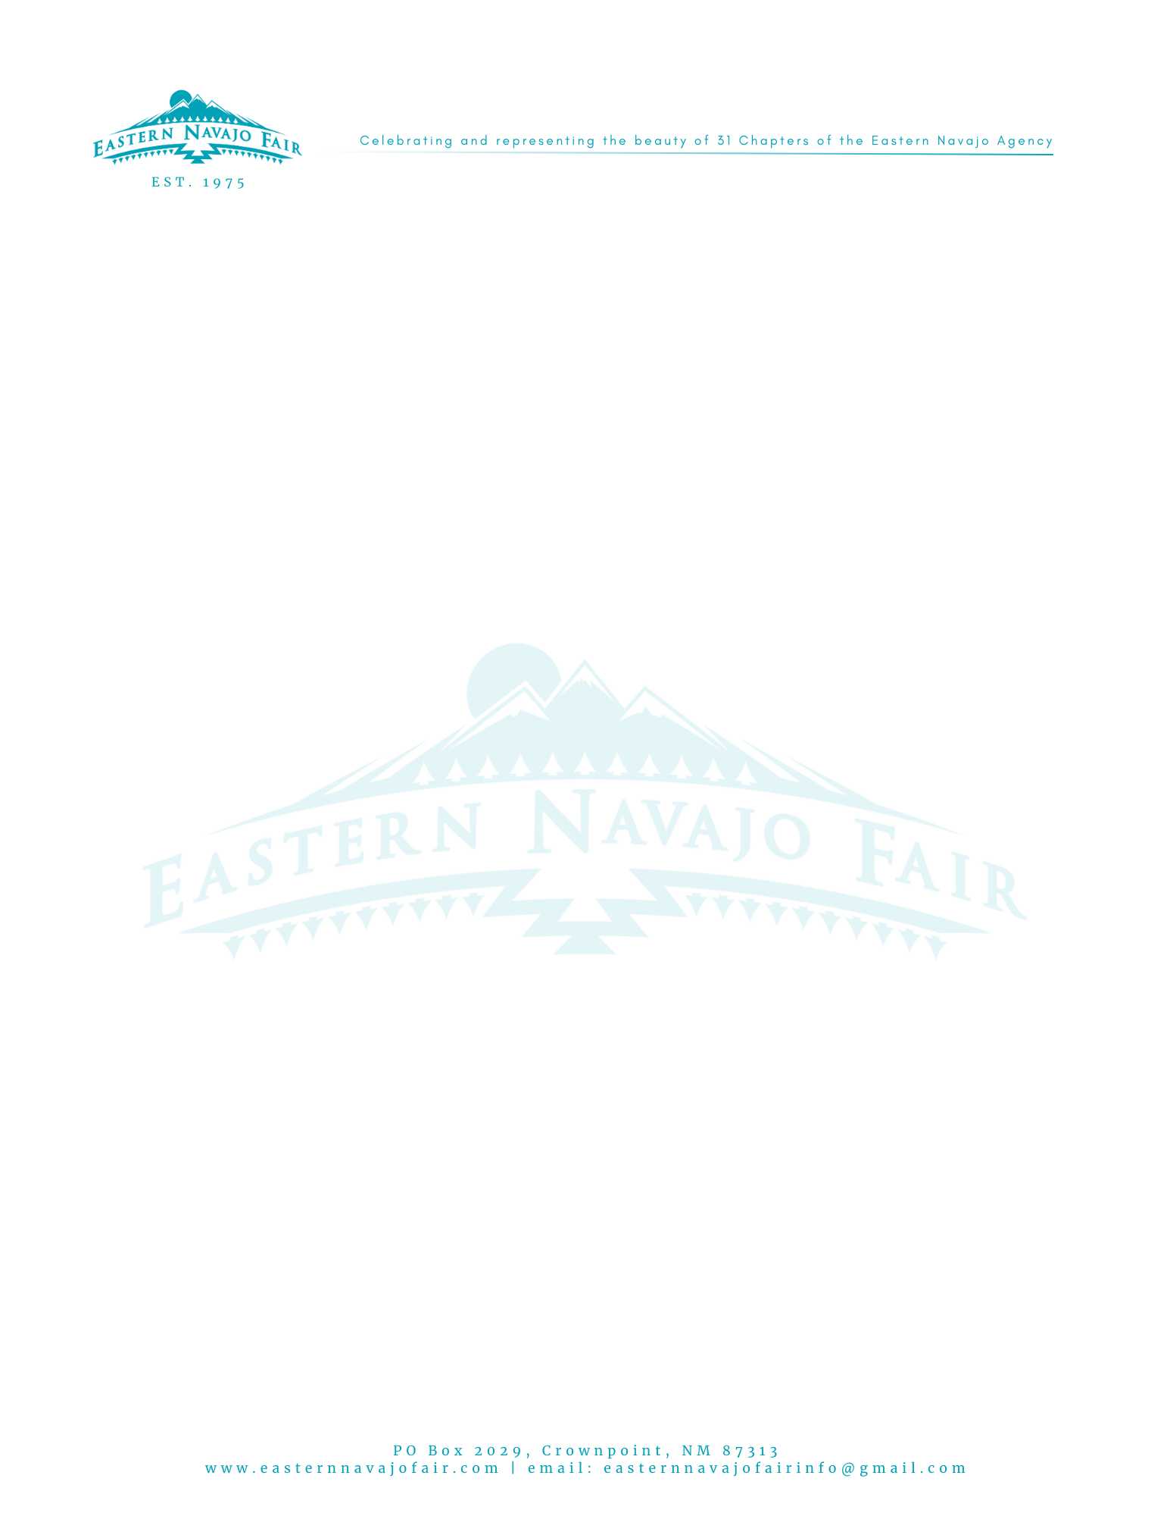 | INVOICE  INVOICE #: ENF47NN_______________  (MMDDYYYY)  Date: May 15, 2025
To:  Sean McCabe, Controller &  Division Representative:  ___________________________________________  Division Address:  Window Rock, AZ 86515 | Ship To:  Sean McCabe, Controller  The Navajo Nation  PO Box 3150  Window Rock, AZ 86515

Comments or special instructions:
Make all checks payable to:
Eastern Navajo Fair
EIN 83-2923069
PO Box 2029
Crownpoint, NM 87313
SALESPERSON | P.O. NUMBER | REQUISITIONER | SHIPPED VIA | F.O.B. POINT | TERMS
- | - | - | - | - | Due on receipt

QUANTITY | DESCRIPTION | UNIT PRICE | TOTAL
 |  | $ | $
SUBTOTAL | $
SALES TAX | 0.00
SHIPPING & HANDLING | 0.00
TOTAL DUE | $
Make all checks payable to:  Eastern Navajo Fair  EIN 83-2923069  PO Box 2029  Crownpoint, NM 87313 | If you have any questions concerning this invoice, contact:  Margaret Morgan-Benally, ENF Treasurer at 505-409-1009 or Douglas Capitan, ENF Comm. at 505-206-0784  Thank you for your support!

