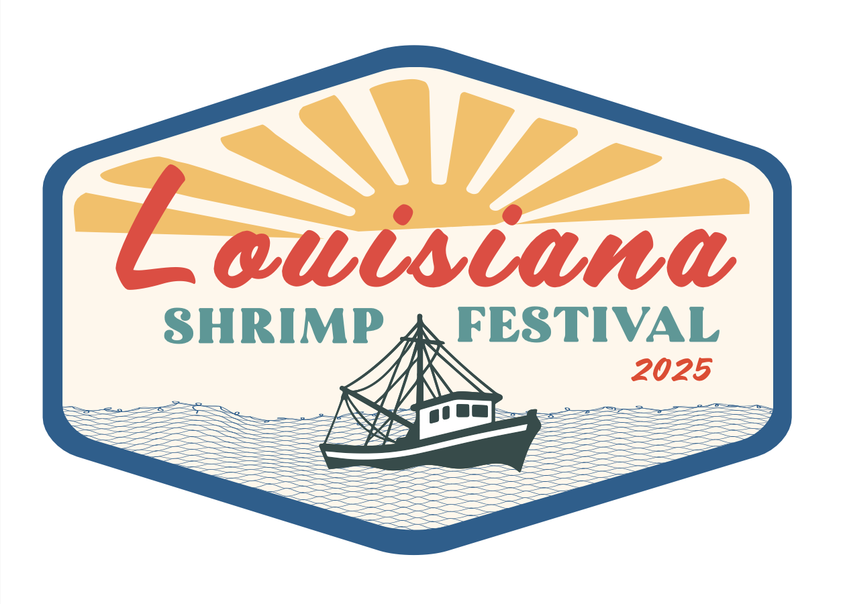

# **For Immediate Release**

**2025 Louisiana Shrimp Festival & Shrimp Aid** **Returning October 18–19, 2025 • New Orleans, LA** *A weekend of music, food, family fun — and a rallying call to: “SOS: Save Our Shrimpers.”*

**New Orleans, LA (Date)** – The Second Annual **Louisiana Shrimp Festival & Shrimp Aid** returns to The Broadside (600 N. Broad Street, Mid-City New Orleans) on **Saturday, October 18, and Sunday, October 19, 2025**, with doors opening at noon each day.

Following the success of its inaugural year, the festival once again blends **live music, food, and family-friendly activities** with a mission that matters: raising awareness of the urgent challenges facing Louisiana’s shrimping community and supporting the economic resilience of coastal fishing families.

### **Event Highlights**

* **Live Music:** Performances by award-winning artists and regional favorites, including *Honey Island Swamp Band, Kumasi Afrobeat, John Boutte, Sunpie & the Louisiana Sunspots, Trombone Shorty Academy, Sally Baby's Silver Dollars, Britti*, and more.
* **Food & Drink:** 10 Booths and pop-ups from top New Orleans restaurants, each serving **100% wild-caught Gulf shrimp**.
* **Youth & Family Activities:** Crafts, live entertainment, and hands-on fun for children.
* **Shrimp Peel & Eat Competition** – Sunday, up to 10 contestants.
* **The Little Shrimp and the Terrible Noise** – a puppet show on Saturday night.
* **Shrimp Aid Pavilion:** Cooking demos, panel discussions, and conversations with shrimpers, chefs, industry experts, and community leaders.
* **Meet your local shrimpers!** We offer free admission to the shrimping community with ample opportunities to connect with them.
* Wear your white boots and bring a cooler! Shrimpers will be selling shrimp outside!

### 

### 

### 

### **Why “SOS: Save Our Shrimpers”**

Louisiana’s shrimping industry faces a crisis: imported, farm-raised shrimp are flooding U.S. markets and driving dock prices to **as low as 45–65 cents per pound**. At these levels, many shrimpers cannot sustain operations—putting the 2025 and future seasons, and generations of coastal heritage, at risk. In 2000, Louisiana had **11,592 fishing vessels** landing shrimp at docks. Now we’re down to about **2,900**—a staggering **75% decline**.

### **Tickets & Admission**

* **General Admission:** $17, with “pay-what-you-can” options to ensure inclusivity.
* **Kids 10 & Under:** Free with a ticketed adult.
* **Shrimpers & Industry Members:** Free admission (registration required on our website).

### **Supporting a Cause**

The Louisiana Shrimp Festival & Shrimp Aid is a nonprofit event. Proceeds directly support local shrimpers and the U.S. wild-caught seafood industry through **advocacy, collaboration, public outreach, and education**.

### **About the Organizers**

Louisiana Shrimp Festival & Shrimp Aid is organized by **Shrimp Aid**, a nonprofit working in partnership with fishing industry members, educators, government agencies, and community organizations. Together, they aim to ensure the survival of local shrimpers and protect Louisiana’s cultural and coastal heritage.

### **Media Contact**

For interviews, press materials, or more information:  
 **LouisianaShrimpFestival.org** | **info@shrimpaid.org** | **Emma Reid: 612-817-8452**

Media Kit & Press Resources: [Download from the festival’s Media page]