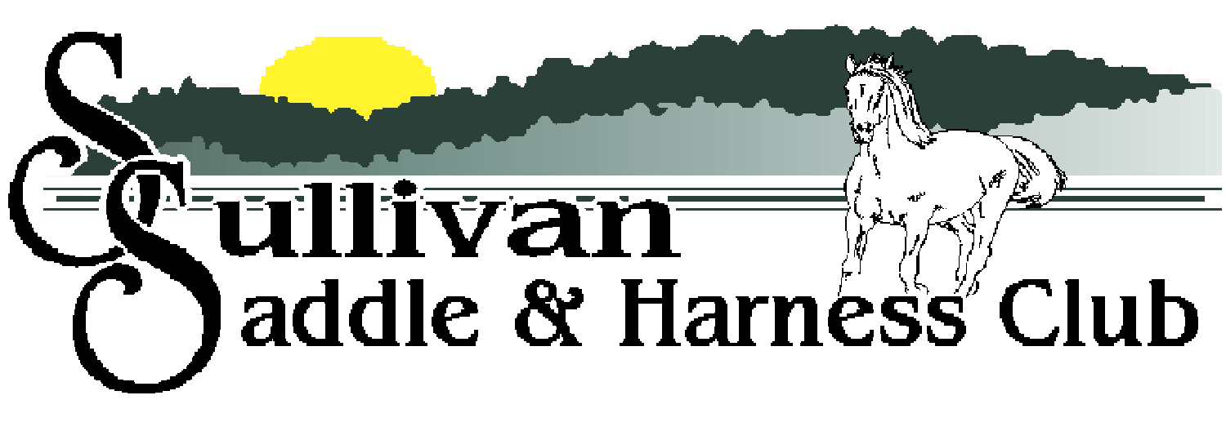

2022 FUN SHOWS

May 15th October 2nd
(Costume Class)

Start Time – 12 PM

- Driving | 12. Youth Barrels
- Tiny Tot Leadline | 13. Adult Barrels
- Egg & Spoon | 14. Speed & Action
- Plug Race | 15. Scurry Race
- Pick-Up Race | 16. Key Hole
- Ribbon Race | 17. Musical Sacks
- Catalog Race | 18. Ride A Buck
- Pee Wee Flag | 19. Pee Wee Poles
- Youth Flag | 20. Youth Poles
- Adult Flag | 21. Adult Poles
- Pee Wee Barrels
Ages as of January 1st
Tiny Tot: 7 & under Pee Wee: 10 & under Youth: 11-17 Adult: 18 & over

Gate Fee: $2.00 | Entry Fee: $8/Class or $15 Entire Show
(Members & those 7 & under: Free) | $5.00/additional rider
Address: 1090 Mattox Drive Sullivan, MO 63080
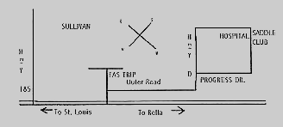

For more information call Mary Loomis at 573-732-4757 or Brenda Platt at 636-584-9996. You can also visit us online at www.sullivansaddleclubsite.com or on Facebook. Cancellations will be posted on www.mohorseshows.com.

