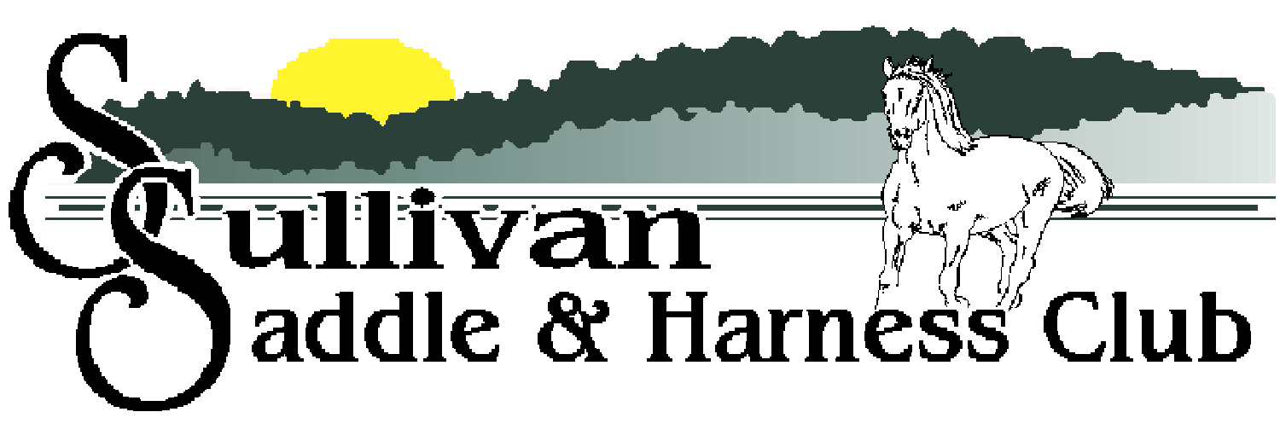

2022 OPEN SHOWS
May 7 June 4 July 2 August 6 September 3
Start Time – 12 PM

- Driving  - Pee Wee and Youth Halter | 17. Adult Western Pleasure  18. Novice Versatility
- Adult Mare Halter | 19. Open Versatility
- Adult Gelding Halter | 20. Novice Non-Blue
- Tiny Tot Halter | 21. Open Non-Blue
- Showmanship | 22. Trail (runs concurrent with speed classes)
- Tiny Tot Leadline | 23. Speed Jumping
- English Walk/Trot | 24. Pee Wee Flag
- English Pleasure | 25. Youth Flag
- Gaited Pleasure | 26. Adult Flag
- Country Pleasure | 27. Pee Wee Barrels
- Pee Wee Western Walk/Trot | 28. Youth Barrels
- Youth Western Walk/Trot | 29. Adult Barrels
- Adult Western Walk/Trot | 30. Pee Wee Poles
- Pee Wee Western Pleasure | 31. Youth Poles
- Youth Western Pleasure | 32. Adult Poles

Ages as of January 1st
Tiny Tot: 7 & under Pee Wee: 10 & under Youth: 11-17 Adult: 18 & over

Gate Fee: $2.00 | Entry Fee: $8/Class or $15 Entire Show
(Members & those 7 & under: Free) | $5.00/Additional rider

Address: 1090 Mattox Drive Sullivan, MO 63080
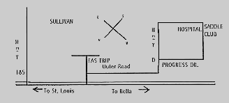

For more information call Mary Loomis at 573-732-4757 or Brenda Platt at 636-584-9996. You can also visit us online at www.sullivansaddleclubsite.com or on Facebook. Cancellations will be posted on www.mohorseshows.com.

