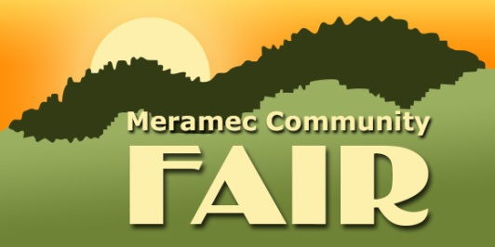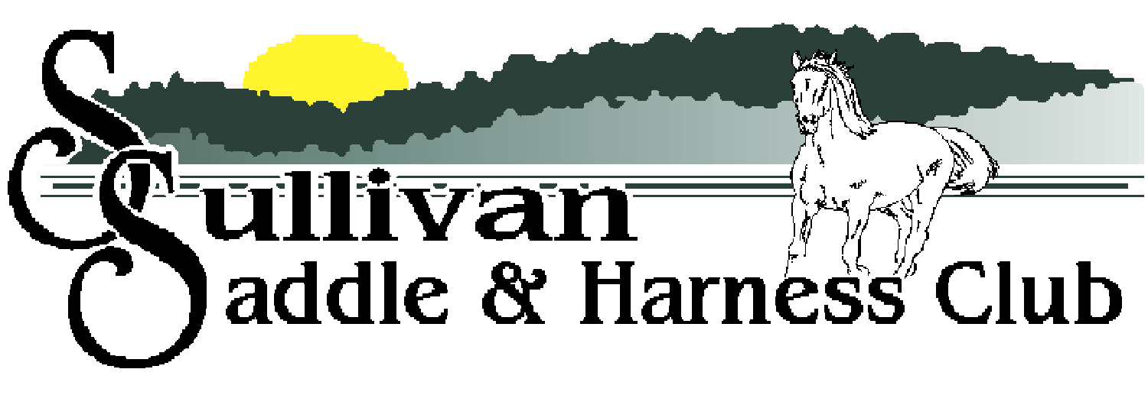
2023 ALL YOUTH SHOW
June 21, 2023
Start Time – 6:00 PM
Sign up no later than June 1, 2023
LIMITED TO 25 EXHIBITORS
NO ENTRY FEE in honor of the Sullivan Saddle Club’s 75th Anniversary
Enter through Track/Livestock Gate only

Rider age as of January 1, 2023
Youth - 11 & Under Junior - 12-18
1. Youth Ribbon Race 5. Youth Plug
2. Junior Ribbon Race 6. Junior Plug
3. Youth Figure 8 7. Youth Barrels
4. Junior Figure 8 8. Junior Barrels

No more than two horses per rider - Jeans and boots required
Negative Coggins required - No use of whips/bats/crops ahead of horse’s shoulder
No riding off club grounds - Inappropriate behavior is cause for expulsion
Tail ribbon for horses that kick - Chairperson’s decision is final
Meramec Community Fair and the Sullivan Saddle Club are not responsible for accidents, injuries, or losses to spectators, exhibitors or equine

For more information or to register contact
Mary Loomis at 573-732-4757 or Linda Schafer at 573-468-2066
Visit us online at www.sullivansaddleclubsite.com or Facebook.com/SullivanSaddleClub

!!!THANK YOU SPONSORS – YOU ARE WHY THIS EVENT IS FREE FOR THE KIDS!!! 