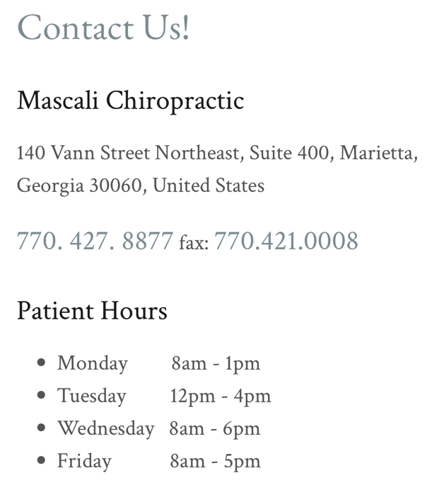

Ten Visit

Pre-Pay

Program

Ten Visit Pre-Pay Program

$920

($20 discount when paying by Check, Debit or Cash)

**Our program is designed for:**

…self-pay patients who wish to incorporate budget-friendly restorative or regular wellness Chiropractic Care into their lifestyle.

* Our Ten-Visit Program includes office visits and treatment rendered during regular, non-accident/injury visits. The customary fee for this type of service ranges from $120-$185. This plan brings each visit to a consistent $92.
* This is a pre-paid, self-pay discount fee for care in our office which may be shared among family members in a household. Each member will qualify after receiving an initial visit, including examination, care recommendation and initial treatment.
* Since this program is a self-pay discount, *the package is not billable to insurance and cannot include supplies or the exams required at certain intervals of care*. However, HSA funds can be used for these services. If a refund is requested for unused visits, a 30-day notice is required. Any further treatment and associated fees will be agreed upon by both parties.
* In the event the patient has a work, auto or other injury while using this plan for care, this plan will be put on hold and after released from that case, the plan can be resumed, and the expiration date will be changed. No visits will be lost in these cases. Self-pay rates cannot apply, due to insurance billing and third-party requirements, in these cases.
* *Ten visits expire one year after purchase date*. It is not our intention that any of our patients lose visits. As the program is designed for our patients to receive care on a regular basis, using ten visits within a year is ample time to gain the full benefit of the pre-paid package. We are happy to pre-book recurring visits and standing appointments, as well.
* As we often have a waitlist – *please give a minimum 24-hour business day notice* if an appointment must be re-scheduled or cancelled.

If we do not have the benefit of this notice, which allows us to provide care for another patient in that slot, the appointment must therefore be forfeited as one of the pre-paid visits used. As always, extenuating circumstances are considered.

___________________________________

Print Name

____________________________________

Signature

____________________________________

Date

____________________________________

Expiration Date

