**Spanky’s Spa**

**Client Agreement**

**Health Conditions**:

I understand that it’s necessary for me to inform the groomer if my pet has any health conditions or stress-related issues prior to having them groomed.

**Vaccinations:**

I understand that all my pets must be current on all vaccinations, official updated vaccinations records are requested and required for each pet (Dogs must have Rabies, Bordetella and DHPP)

**Emergency Situations:**

I (the client) am authorizing the groomer to act as my representative in the event of an emergency veterinary services (I realize I am responsible for the expense). I understand that all attempts will be made to contact me if an emergency occurs.

**Missed Appointments:**

I understand that I am required to give 24 hours’ notice for any Missed or Cancelled appointments. I (the client) understand that if no notice is given, I will be responsible for a cancel charge of $50.00. I will also be required to pay in full before scheduling the next appointment.

**Returned Checks:**

Returned checks are subject to a $35.00 service fee

**Matted & Knotted Coat:**

Mats are not only uncomfortable for your pet but they also cause health issues. There may be a situation where the groomer may have to shave my pet to get the mats out. I also understand that there will be an additional fee added onto the regular grooming price, this charge is for the extra time and wear on the groomer and supplies.

**Photos:**

I authorize Spanky’s Spa to use my pet’s photo if they choose to for the Website or social media pages.

I, the undersigned, have read, understand and agree to all of the above policies and additional charges for the grooming of my pet at Spanky’s Spa.

______________________________________________ _________________________________________

Print Name Date

___________________________________________________________________________________________

Pet(s) Name

___________________________________________________________________________________________

Signature

**Owners Information**

Owners First & Last Name

Address Email

Cell Number Work Number Contact Number

Designated People for pick up (if any)

**Emergency Contacts**

Emergency Contact Name Relationship Cell Number

Veterinarian Hospital Name Telephone Number

Hospital Address City/State/Zip

Do you have Pet Insurance? If yes, Insurance Name/Policy information

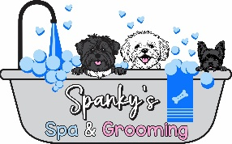

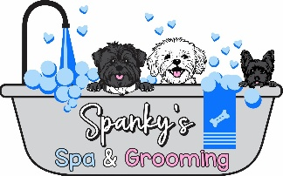 Spanky’s Spa

Pet Information

Pet Name Age Breed Color/Markings

Weight Sex Spayed/Neutered

Female Male Yes No

Vaccinations DHPP Rabbies Bordetella

Exp: ________ Exp: ________ Exp: __________

Temperament

Friendly Scared Aggression

Grooming/Cut Preference:

Can your Pet have Treats

Yes No

Any Allergies?

**Additional Information Needed for Groomer to keep pet safe: Health Issues, etc.**