January
2022
Subtitle
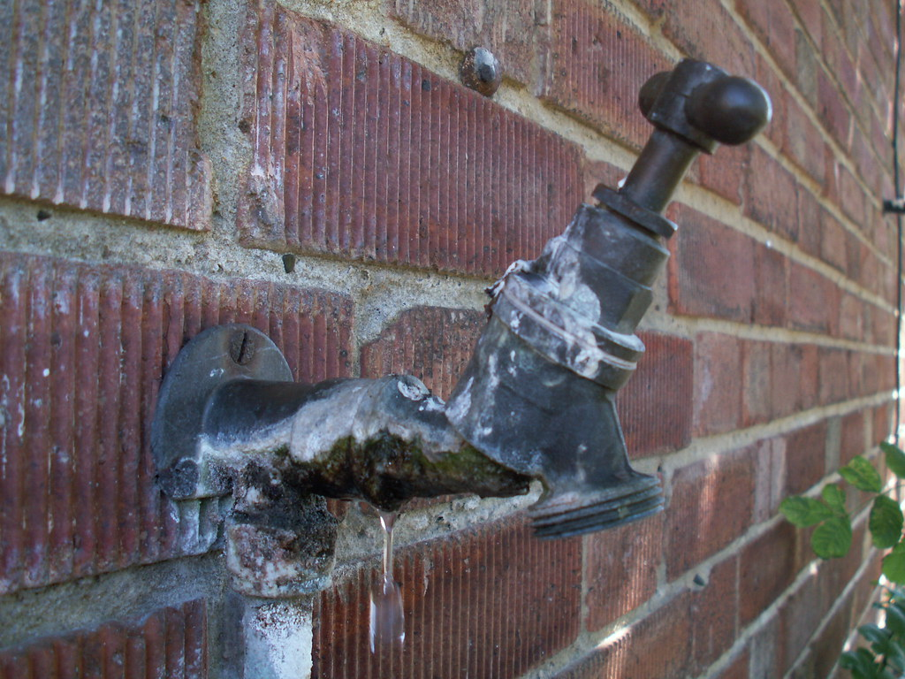
Sunday | Monday | Tuesday | Wednesday | Thursday | Friday | Saturday
 |  |  |  |  |  | 1
2 | 3 | 4 | 5 | 6 | 7 | 8
 | BURGERS 5=7 | VFW MEETING  7:30 | CLOSED | CHICKEN FRIED STEAK 5-7 |  | KARAOKE  7-12
9 | 10 | 11 | 12 | 13 | 14 | 15
CLOSED | BURGERS 5-7 | MARINE CORP  LEAGUE 6:00  CLOSED TO PUBLIC | VVA 6:00  CLOSED TO PUBLIC | SPAGHETTI  5-7 | TEJANO NIGHT  8-1 | KARAOKE  7-2
16 | 17 | 18 | 19 | 20 | 21 | 22
CLOSED | BURGERS 5-7 | VFW MEETING 7:30 | CLOSED | FISH FRY  5-7 | TEJANO NIGHT  8-1 | KARAOKE 7-12
23 | 24 | 25 | 26 | 27 | 28 | 29
CLOSED | BURGERS 5-7 | CLOSED | CLOSED | STEAK NIGHT 5-7 | TEJANO NIGHT  8-1 | KARAOKE 7-12
30 | 31
CLOSED | BURGERS 5-7
View and edit this document in Word on your computer, tablet, or phone. You can edit text; easily insert content such as pictures, shapes, and tables; and seamlessly save the document to the cloud from Word on your Windows, Mac, Android, or iOS device.

