 |  | Peaceful Mind Mental Health Newsletter
 | Acceptance and Commitment Therapy (ACT)
Rebecca Koskiniemi, MSW, LICSW |  |  |  |  |  | peacefulmindmentalhealth.com l Facebook- Peaceful Mind Mental Health, LLC
What is ACT?  ACT stems from relational frame theory. It is an approach used to understand how individuals develop language and cognition and how they intertwine with one’s environment.  ACT can be used for a variety of conditions such as anxiety, depression, post-traumatic stress disorder, obsessive-compulsive disorder, and psychosis disorders. It can even be used in conditions such as substance abuse, chronic pain, and diabetes. |  |  |  |  | 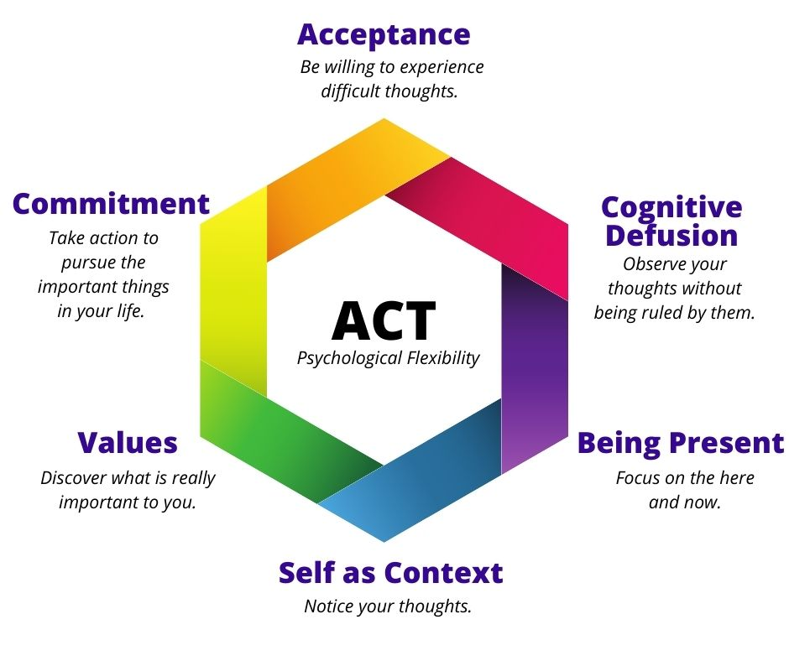 |  | Focus: Take Action  Purpose: Teach to recognize & normalize feelings such as pain, disappointment, failure, loss, etc. and learn to be comfortable with them, acknowledging they exist vs. letting them consume you / your mind and everyday life. |  | Treatment Focus
GOALS
- Increase psychological flexibility.
- Learn to accept things not in your control.
- Accept negative feelings/thoughts.
- Take action to achieve long term goals.
Peaceful Mind Mental Health provides mental health services in our New York Mills location and via secure, HIPAA compliant video conferencing.

To make an appointment, please create a free account on the online portal and schedule yourself in the next available opening or call the number 218.731.8896

