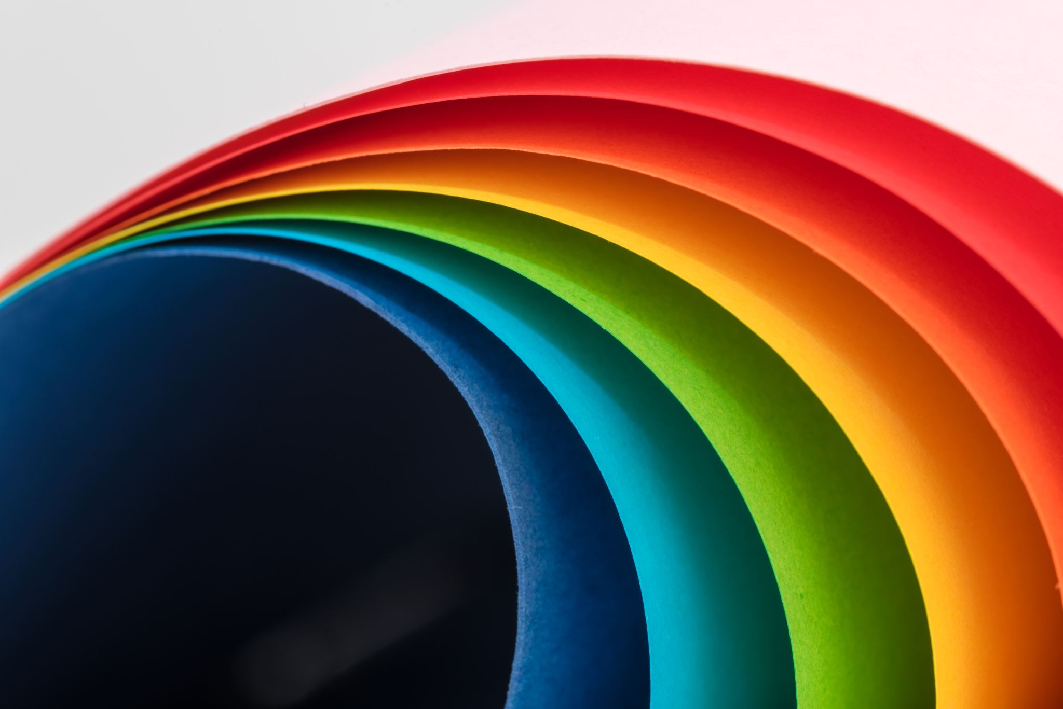

It Gets better
Skills/Psychoeducation/Support Group
Date | Time
Virtual group room, flexible start date/time
It Gets Better is a group dedicated to the LGBTQ+ community. We are filling seats for two groups, an adult, and an adolescent group for ages 12-17.
This group will run for 8 weeks and will focus on:
- Building peer connections
- Learn coping skills
- Psychoeducation
Other groups to follow completion of this one. Please call 218.731.8896 or email contact@peacefulmindmh.com to sign up. Once we have 8 members per group we will get started!
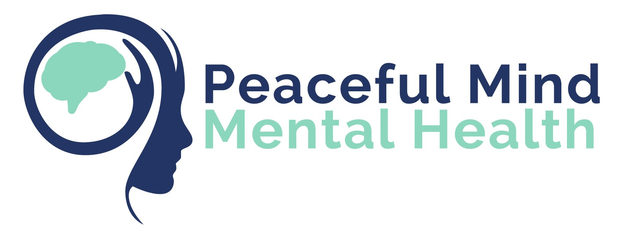
It Gets Better curriculum courtesy of Catherine Griffith, PhD

