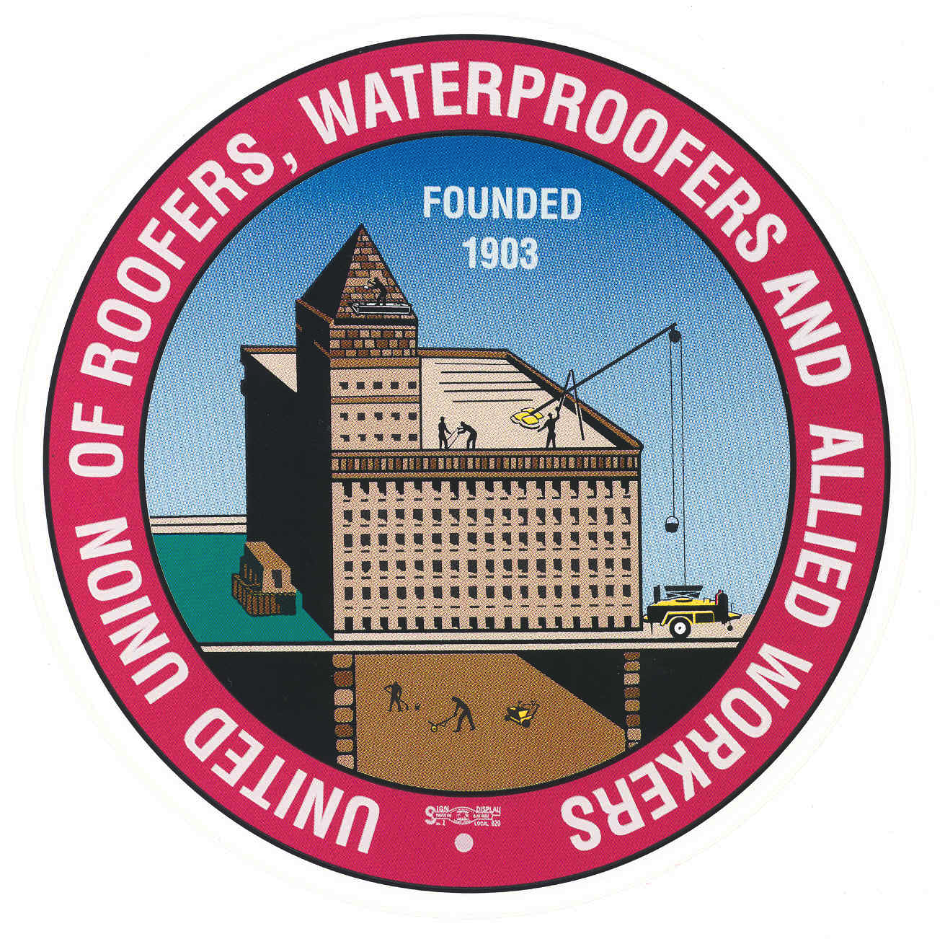

**HAWAII CONSTRUCTION INDUSTRY**

**AFL-CIO**

**BENEFICIAL TRAITS:**

MANUAL DEXTERITY.

GOOD SENSE OF BALANCE

ABILITY TO WORK IN HIGH PLACES

**ROOFERS UNION LOCAL, 221 JOINT APPRENTICESHIP TRAINING PROGRAM**

NATURE OF WORK: ROOFERS AND, WATERPROOFERS WATERPROOF ROOFS, AND MANY TYPES OF BUILDINGS AND, STRUCTURES, USING A WIDE VARIETY OF MATERIALS SUCH AS COMPOSITION SHINGLES, MODIFIED BITUMENS, SINGLE-PLY SYSTEMS, WOOD SHAKES, METAL PANEL SYSTEMS, CONCRETE OR CLAY TILE, ROOFERS ALSO WATERPROOF MASONARY, BELOW AND ABOVE GRADE CONCRETE INTERIORS OR EXTERIORS AND, FLOORS BY USING LIQUID COMPOUND OR SHEET MEMBRANE. THEY FOLLOW ESTABLISHED PROCEDURES, AND MANUFACTURES RECOMMENDATIONS IN APPLYING THE VARIOUS TYPES OF ROOFING AND, WATERPROOFING MATERIELS. ROOFERS USE ONLY APPROVE SAFETY EQUIPMENT, AND ADHERE TO ALL STATE, COUNTY AND FEDERAL LAWS. (HIOSH AND OSHA)

**ENRIQUE “RICK SUBIONO**

**ROOFERS JOINT APPRENTICESHIP**

**2045 KAMEHAMEHA IV ROAD, SUITE 203**

**HONOLULU, HI 96819-2600**

**PHONE: 808-847-5759 EXT. 223**

**FAX: 808-848-8707**

**CELL: 808-554-6055**

**ENTRANCE REQUIREMENTS**

**FOR APPRENTICESHIP:**

HIGH SCHOOL GRADUATE OR EQUIVALENT.

VALID DRIVERS LICENSE

MUST BE PHYSICALLY FIT TO PERFORM

THE DUTIES OF THE TRADE AND, SHOULD BE ABLE TO LIFT 100 LBS.

**WORKING CONDITIONS:**

THE WORK IS STRENUOUS AS IT INVOLVES CLIMBING, BENDING, SQUATTING AND, HEAVY LIFTING, ROOFERS RISK INJURIES FROM SLIPS AND, FALLS OFF ROOFS AND, SCAFFORDS. THEY WORK IN TIGHT SPACES, HIGH PLACES AND SOMETIMES STEEP AREAS.

**TERM OF APPRENTICESHIP:**

THE PROGRAM CONSIST OF 8,000 HOURS OF ON THE JOB TRAINING, 280 HOURS OF CLASSROOM RELATED INSTRUCTION.

**HELPFUL HIGH SCHOOL SUBJECTS:**

MATHEMATICS, MECHANICAL DRAWING, BUILDING CONSTRUCTION TECHNOLOGY, TECHNICAL SCIENCE