

The Annex, James Park Elementary School

1730 Coquitlam Avenue, Port Coquitlam, BC V3B 1H7

(604) 941-8286 [phtpreschool@gmail.com](mailto:phtpreschool@gmail.com)

Welcome to Our Preschool Community!

Dear Parents,

We look forward to welcoming your family to Poco Happy Times Preschool.

Class times are for school year 2025/2026

* 3 days/week Tuesday, Wednesday, Thursday: 9:15 - 12:15pm

Fees: - Registration Fee $80.00

We would like to invite you to attend our Annual General Meeting in May/June. At the meeting, new families will have the chance to participate, nominate and vote for the preschool’s volunteer administrative executive for next year.

In August, via email, you will be notified about the date for the September Parent Orientation meeting where discipline philosophy and safety policies, a gradual entry schedule for the first two weeks of classes as well as the date of the October general meeting will be available.

On the first day of class, please bring **2 current pictures of your child** (1 for the emergency card, 1 for the hook/locker). We will send a reminder about this in August.

If you have any questions please do not hesitate to contact the preschool at phtpreschool@gmail.com

We look forward to seeing you soon!

***Please keep for your files.***



The Annex, James Park Elementary School

1730 Coquitlam Avenue, Port Coquitlam, BC V3B 1H7

(604) 941-8286 [phtpreschool@gmail.com](mailto:phtpreschool@gmail.com)

**Class: 2 day 3 day Duty days: yes / no**

|  |  |  |  |  |  |  |  |  |  |  |  |  |  |
| --- | --- | --- | --- | --- | --- | --- | --- | --- | --- | --- | --- | --- | --- |
| **1. CHILD’S INFORMATION:** | | |  |  |  |  |  | Please fill out all the forms as completely as possible. | | | | | |
| SURNAME: |  |  | GIVEN NAME: | | |  |  |  |  |  |  | MIDDLE NAME: | |
|  |  |  |  |  |  |  |  |  |  | |  |  |  |
| NAME CHILD RESPONDS TO: |  |  | SEX: |  |  |  |  | BIRTHDATE: (M/D/Y) | | | | START DATE: (M/D/Y) | |
|  |  |  | M □ | F□ | |  |  | / | | / |  | / | / |
|  |  |  |  |  |  |  |  | |  | |  |  |  |
| STREET ADDRESS: |  |  |  |  |  | CITY, PROVINCE: | | | | | |  | POSTAL CODE: |
|  |  |  | | |  | | | |  |  |  | |  |
| PHONE #: |  | CHILD’S FIRST LANGUAGE: | | | | | | | |  | CHILD’S SECOND LANGUAGE: | | |
|  |  | | | | | | |  |  | |  |  |  |
| PERSON(S) WITH WHOM THE CHILD LIVES WITH: | | | | | | | |  | EMAIL ADDRESS: | | |  |  |
|  |  |  |  |  |  |  |  |  |  |  |  |  |  |

**2.** **PARENT/GUARDIAN:**



|  |  |  |  |  |
| --- | --- | --- | --- | --- |
| 1) NAME: (Mother’s Name) | PARENT | | □ | GUARDIAN □ |
|  |  |  | |  |
| ADDRESS (If different than Child’s information): |  | PHONE (Home): | | |
|  |  |  |  |  |
| PLACE OF WORK: | PHONE (Work): | |  | PHONE (Cell): |
|  |  | |  |  |
| 2) NAME: (Father’s Name) | PARENT | | □ | GUARDIAN □ |
|  |  |  | | |
| ADDRESS (If different than Child’s information): |  | PHONE (Home): | | |
|  |  |  |  |  |
| PLACE OF WORK: | PHONE (Work): | |  | PHONE (Cell): |
|  |  |  |  |  |

1. **ALTERNATIVE EMERGENCY CONTACTS OTHER THAN**

**PARENTS/GUARDIANS:**

|  |  |  |  |  |  |
| --- | --- | --- | --- | --- | --- |
| 1) NAME: | RELATIONSHIP: | | |  | PHONE: |
|  |  | | |  |  |
| ADDRESS: | SPEAK ENGLISH: | | |  | IF NOT WHAT |
|  | □ | YES | □ | NO | LANGUAGE: |
| 1) NAME: | RELATIONSHIP: | | |  | PHONE: |
|  |  | | |  |  |
| ADDRESS: | SPEAK ENGLISH: | | |  | IF NOT WHAT |
|  | □ | YES | □ | NO | LANGUAGE: |

1. **PERSON(S) AUTHORIZED TO PICK UP CHILD (INCLUDE MOTHER**

**AND FATHER):**



|  |  |  |  |  |  |
| --- | --- | --- | --- | --- | --- |
| NAME: |  |  | RELATIONSHIP: | | PHONE: |
|  |  |  |  |  |  |
| NAME: |  |  | RELATIONSHIP: | | PHONE: |
|  |  |  |  |  |  |
| NAME: |  |  | RELATIONSHIP: | | PHONE: |
|  |  |  |  |  |  |
| NAME: |  |  | RELATIONSHIP: | | PHONE: |
|  | |  |  |  |  |
|  | |  | |  |  |
| **5. HAVE ANY SIBLINGS ATTENDED** | | | |  |  |
| **POCO HAPPY TIMES:** | |  |  |  |  |
| NAME: |  |  |  |  | AGE: |
| NAME: |  |  |  |  | AGE: |
|  | |  | | |  |
| **6. HAS YOUR CHILD PREVIOUSLY ATTENDED DAY** | | | | |  |
| **CARE/PRESCHOOL:** | | | | |  |
| □ YES | □ NO | FACILTIY/LOCATION: | | |  |
|  |  |  |  |  |  |

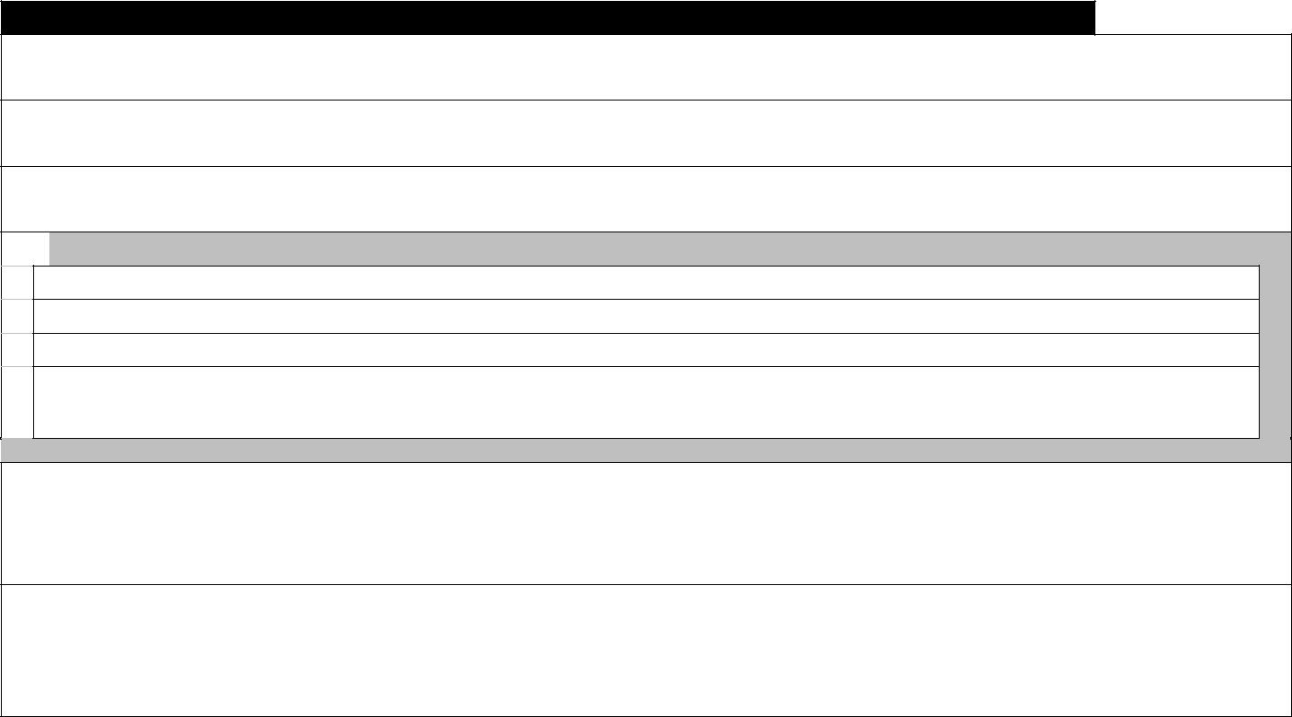**7.** **CHILD’S DEVELOPMENT:**

Does your child have any fears?

Does your child have any nervous habits?

How does your child react to new situations?

 **PLEASE INDICATE YOUR CONCERNS AROUND THE FOLLOWING:**

 Snack time:

 Toilet training:

Social Skills: Other:

Do you have specific expectations of the Preschool?

Do you have any concerns that have not been addressed above?

|  |  |  |  |
| --- | --- | --- | --- |
| **8. IMMUNIZATION:** | (Attach photocopy of immunization record, or indicate dates that | | |
|  | immunization was received) | |  |
| DIPTHERIA, TETANUS |  | POLIO |  |
| & PERTUSSIS (DPT) |  |  |  |
| MENINGITIS |  | MEASLES, MUMPS |  |
| (HIB D) |  | & RUBELLA (MMR) |  |
| Poco Happy Times Preschool Registration Form | | |  |
| **Please complete and return form.** | | |  |

**9.** **HEALTH/NUTRITION:**

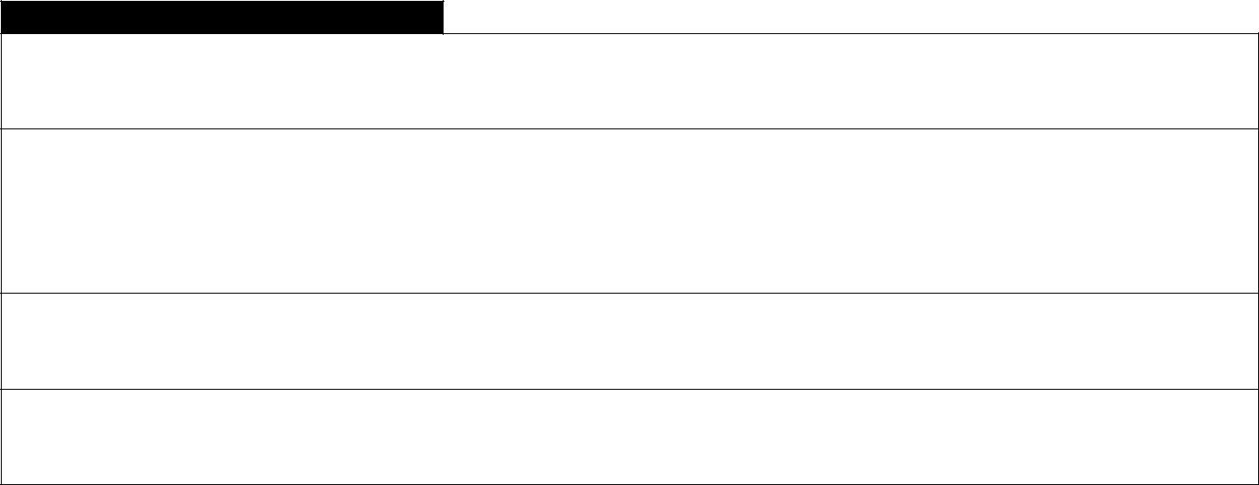

ALLERGIES:

DOES YOUR CHILD:

|  |  |  |  |  |  |  |  |  |  |
| --- | --- | --- | --- | --- | --- | --- | --- | --- | --- |
| HAVE VISION PROBLEMS? | □ | YES | □ | NO | TAKE MEDICATION? | □ | YES | □ | NO |
| HAVE SPEECH/LANGUAGE PROBLEMS? | □ | YES | □ | NO | HAVE OTHER HEALTH CONCERNS? | □ | YES | □ | NO |
| REQUIRE A SPECIAL DIET? | □ | YES | □ | NO | HAVE HEARING PROBLEMS?: | □ | YES | □ | NO |

PLEASE SPECIFY ON ITEMS MARKED AS “YES”:

DOES YOUR CHILD HAVE ANY PHYSICAL &/OR EMOTIONAL REQUIREMENTS?

1. **EMERGENCY HEALTH**

**INFORMATION:**



|  |  |  |
| --- | --- | --- |
| DOCTOR: | ADDRESS: | PHONE: |
|  |  |  |
| DENTIST: | ADDRESS: | PHONE: |
|  |  |  |
| OTHER: | ADDRESS: | PHONE: |
|  |  |  |

MEDICAL INSURANCE NUMBER/BRITISH COLUMBIA CARE CARD NUMBER:

1. **EMERGENCY**

**CONSENT:**



It is the policy of the Preschool to notify a parent when a child is ill or needs medical attention. If we cannot contact the parents/guardians and we need to get immediate help for the child. Our procedure is take the child to the nearest emergency service center.

Please sign below so that we can take appropriate action on behalf your child. Return the signed form to the Preschool immediately.

I hereby give consent for my child, _______________________________, when ill, to be taken to the nearest emergency center by the staff of Poco Happy Times Preschool, when I cannot be contacted. I consent to an ambulance being called to transport the child if necessary.

|  |  |  |
| --- | --- | --- |
| **REGISTRATION FEE IS NON-REFUNDABLE. _______** | |  |
|  | (Initial) |  |
| ___________________________ | __________________________ | ____________ |
| Signature of Parent/Guardian | Name (Please Print) | Date: |
| ___________________________ | __________________________ | ____________ |
| Signature of Supervisor | Name (Please Print) | Date: |

DOES YOUR CHILD CURRENTLY (OR PREVIOUSLY RECEIVE SERVICES FROM

Is your family support by Kinsight (please circle one) Yes No

If yes please provide consultants name ___________________________

Cysn Social Worker Yes No

Tri-Cities Children’s Centre Yes No

Spirit of the Children Society Yes No

IDP / SCD Consultant Yes No

Exceptional Children

When a special needs or exceptional child is identified, additional support may be required for the member and their family. This support may include working with Kinsight having a support teacher or providing additional assistance during class time. Any additional support required will be documented as port of an individual care plan for the child.

The repeated behaviours exhibited by the child while at preschool may require extra support are –

1. Repeatedly hurting other – hitting, kicking, biting, scratching or throwing of objects.
2. Repeatedly trying to leave the preschool grounds.

The staff will endeavour to keep everyone safe at all times.



The Annex, James Park Elementary School

1730 Coquitlam Avenue, Port Coquitlam, BC V3B 1H7

(604) 941-8286 [phtpreschool@gmail.com](mailto:phtpreschool@gmail.com)

**Parent Agreement:**

*\*Keep one copy for reference, sign the second and return it with your other application forms*

**Please INITIAL beside each point.**

_____Pay a registration fee of $80.00 which covers Insurance. I understand that this fee is non-refundable.

_____Make prompt payments of monthly fees on the 1st of the month, which are collected by post-dated cheques or e-transfers (no cash please) to be handed in together with the registration package. **The first monthly fee is payable on September 1st**

_____If for any reason one of the cheques is not going to clear my bank account, I will notify the Treasurer immediately and make other payment arrangements. Failure to notify the Treasurer at least two (2) days prior to the cheque cashing date will result in a $10.00 service charge.

_____I will give one (1) month notice in writing to the Teacher and the Treasurer or pay one month’s fee in lieu of notice if it becomes necessary to withdraw my child from the Preschool.

_____I agree that my phone number and email address may be shared with other parents within the preschool.

_____Undertake to attend the four General Meeting that are held within the school year. If I miss a General Meeting, I must read the minutes of that meeting posted at the school and sign that I have read them.

____I will not send my child to school if they are ill. My child must **not** have vomited or have had diarrhea in the last 48 hours. My child must **not** have had a fever in the last 24 hours. If my child contracts a communicable disease, I will notify the teacher or the president immediately.

____ I understand that, in the playroom and on the playground, the teacher, has overall responsibility for the program, teaching methods, discipline, health and safety measures.

_____ I will make every effort to be prompt in bringing my child to school and in picking them up after school closing. I understand that the Teacher is not legally allowed to release my child to anyone unknown to him/her and so I agree to advise the Teacher in advance if someone unknown to him/her is picking up my child.

_____I authorize the Teacher, after he/she has attempted to contact myself or my designated emergency numbers, to send my child home accompanied by a responsible adult if he/she appears ill or in case of emergency.

_____Waive all claims against Poco Happy Times Preschool in excess of public liability insurance carried by the Preschool in case of injury to my child while in the care, custody, or control of the Preschool.

_____Waive all claims against Poco Happy Times Preschool in excess of public liability insurance carried by the Preschool in case of injury to my child’s siblings during drop off or pick up times on preschool grounds.

_____I will keep the teacher informed of any event or change of routine at home which may affect my child’s behavior.

____ If I have questions about my child’s progress or the program of the school. I will direct them to the teacher; I will direct queries or suggestions about the administration of the preschool to the executive through the president.

____We will pay our child’s tuition fees promptly as arranged with the executive.

____ As our school is a cooperative, I will volunteer for a 'job' at the preschool to assist with the administration, fundraising or other as needed to successfully run the preschool.

____ I undertake to attend regularly and to participate in all general meetings.

*____ I understand that if I do not adhere to my agreement, I may be asked to withdraw from the preschool.*

Parent signature: __________________________________

Date: ___________________________________________

***Please complete and return a copy of the form.***



The Annex, James Park Elementary School

1730 Coquitlam Avenue, Port Coquitlam, BC V3B 1H7

(604) 941-8286 [phtpreschool@gmail.com](mailto:phtpreschool@gmail.com)

**Media Permission Form**

*\*please complete and return form*

Child’s Name: ___________________________________________

Children love to see themselves and their friends. Sometimes we use photos to record our projects, as part of games, books, and as labels around the classroom.

We may also send photographs home with Parents when we are finished with them.

Please indicate if you give permission for your child’s photo to be taken for classroom use.

**Please circle one:**

**YES** I give permission for my child to be photographed.

**NO**  I don’t give permission for my child to be photographed.

The Preschool is a member of Facebook and we also have a website.

Our Facebook page is used to share information, news, reminders and information about the Preschool program. Although we will never take a full face photo, we often would like to have photos showing side or back views of children engaged in activities.

**Please circle one:**

**YES** I give permission for my child to be photographed.

**NO** I don’t give permission for my child to be photographed.

________________________________ ____________________



The Annex, James Park Elementary School

1730 Coquitlam Avenue, Port Coquitlam, BC V3B 1H7

(604) 941-8286 [phtpreschool@gmail.com](mailto:phtpreschool@gmail.com)

**Parent Volunteer Positions:**

***\*complete and return form***

**EXECUTIVE POSITIONS -** *form the Board of Executives who run the Administration of the Preschool and participate at Executive meetings.*

**President** – Oversees the administration of the Preschool: coordinates the Executives, plans agendas and chairs Executive and General Meetings. The main liaison between the Teachers and the parents.

**Vice-President** – Assists the President with any overload tasks. Assumes his/her responsibilities as required by illness or absence. Presides at meetings if President is not present. Responsible for the annual review of the Constitution and By-Laws.

**Treasurer/Co-Treasurer** (2 parents) – Oversees the financial activities of the preschool in collaboration with the Co-Treasurer and Bookkeeper. Collects all fees, donations, and monies and deposits them in the Preschool’s bank account. Presents a yearly budget (drawn up with the advice of the Executives) for the members’ approval and presents a financial report at each general meeting. Presents the books for annual auditing in May/June.

**Secretary** –Maintains accurate minutes of the executive and general meetings, noting corrections or additions. Presents draft minutes to President for approval, and posts meeting minutes on the parent board. Handles correspondence, and keeps a file of all official letters sent and received by the Preschool.

**Parent Education** (One parent from each class)– Educates new parents about the Parent Involvement philosophy and the benefits of the membership. Builds a parent Library by collecting books, pamphlets, tapes and videos on a variety of parenting topics. Explains the responsibility of being a duty parent. Arranges for guest speakers on Parent Ed nights (if required).

**Enrolment** (2-3 parents) – Promotes the Preschool via posters and ads in newspapers and recruits new members. Oversees enrolment procedures and updates the enrolment package. Keeps track of new and returning families, and waitlists. Presents the philosophy of our Parent Involvement Preschool to all families and the responsibilities that come with registration.

**NON-EXECUTIVE POSITIONS** - *form the general membership who need to vote any changes proposed by the Executive Board.*

**Classroom Admin** – Prepares sign in sheets for the classes and keeps the parent bulletin board up to date. Files necessary documents in the filing cabinet, making sure everything is in good order.

**Cleaning Committee** (Ideally 4 parents, 2 from each class) – responsible for cleaning the classroom at the end of each month and the two big cleans each year (December and June).

**Duty Day Coordinator** (One for each class) – Prepares the duty day calendar, contact person if a parent needs to switch their duty days or if they can’t make it to school on their duty day.

**Equipment Coordinator** - maintains the preschool equipment in a state of good repair by enlisting the help or parents or arranging for professional work if necessary.

**Email/Newsletter** - Sends informative emails to parents on behalf of the Preschool (always use bcc not to disclose email addresses among users) when asked by Teacher or President. Creates newsletter and emails it to all parents on the first of each month.

**Fundraising Committee** (Ideally 4 parents, 2 from each class) – Organizes the main fundraisers for the year.

**Facebook/Website Manager**– posts relevant information when needed and keeps our Facebook and website up to date.

**Laundry Coordinator** – launders cloths, towels, painting smocks and costumes as requested by teacher (about once a month).

**Marketing** – helps with poster/flyer creation, distribution, open house and general publicity.

**Personnel Committee** (One from each class) – Photocopies, organizes, and reviews annual evaluation, inventory (end of April), mediator if conflicts arise, hiring committee for teachers and substitute teachers.

**Photo Day Coordinator** – coordinates the annual photo shoot (Oct or Nov).

**Purchasing Committee** (Ideally min. 2 parents) – Responsible for the purchasing of supplies as directed by the Teacher and President. This includes art supplies, cleaning supplies etc. Does research and cost analysis on other purchases the preschool wishes to make. (This might include toys, furniture etc.)

**Scholastic** – Distributes flyers and collects scholastic orders at least once a month.

We will try and honor your ‘top three’ choices, but may need to assign something different to you depending on enrolment numbers. Please know that every role at the preschool is valuable and important to the smooth running of our Centre.

Thank you for supporting your cooperative preschool community!

**Please fill out your choices and return this form with your registration package!**

My top three choices would be:

1. ____________________________________________________

2. ____________________________________________________

3. ____________________________________________________

Name: ________________________________________________

Child’s Name: _________________________________________

Lastly, please advise and share with us any special talents, skills, or interests that you would be willing to share with the preschool (ie – play an instrument, cook/bake with the children, share an art or science project):

***Please complete and return form.***



The Annex, James Park Elementary School

1730 Coquitlam Avenue, Port Coquitlam, BC V3B 1H7

(604) 941-8286 [phtpreschool@gmail.com](mailto:phtpreschool@gmail.com)

**Parent Information:**

\**for your files*

**Enrolment:**

Children enrolling in our program must be three years old before 31 of December of that current year.

Registration for returning families and siblings will be taken in January. Open registration will commence late January or early February of the enrolment year.

**Term:**

The preschool is in session from September through June and follows the School District 43 policies with regard to statutory holidays and school breaks (except for Pro-D days). Classes are from 9:15am-12:15am. Children are presumed to arrive on time and to be picked up promptly by the designated parent or guardian listed on the sign-in/out sheet.

**Gradual Entry:**

The teacher will design a structured gradual entry process at the beginning of each school year. It is expected that the teacher will facilitate the family’s adjustment to preschool, to enable the child to participate in class comfortably. Each child and family will have differing needs and adjustment periods. The goal is to create an atmosphere where the child is confident to play and participate independently. Parents are welcome and invited to stay in the classroom, to sign up for duty days as is needed and/or possible to share in and support their child.

**Fees:**

A $80 non-refundable enrolment fee is payable upon notification of an opening and will secure the child’s spot. If you register your child after December 31, the fee is reduced to $40. Families with more than one child enrolled in the preschool shall only pay one registration fee.

* 2 days/week – Tues &Thu: **$220.00 per month** (Duty Days)

**$265.00 per month** (No Duty Days)

* 3 days/week – Tue, Wed, Thurs **$255.00 per month (Duty Days)**

**$310.00 per month** (No Duty Days)

Post-dated cheques or e-transfers dated 1st of each month and should be submitted when handing in required paperwork.

**General Meetings:**

Parents are required to attend the 4 mandatory General Meetings:

* September Parent Orientation
* December/January Meeting
* March/April Meeting
* Annual General Meeting (AGM) in May/June.

**Duty Days:**

Parents have the opportunity to sign up for duty days as a benefit of membership in the preschool. Duty parents do not count for the adult: child ratio, and there would be two ECE/ECEA on staff in the classroom. Time spent in the classroom offers a unique perspective on your child and can support their early learning experience. Ways parents assist the teachers include classroom set- up, clean-up, sharing a special skill or helping with a special project in class, reading, playing and participating with the children in the day's preschool activities. The teachers have the overall responsibility for programs, teaching materials, discipline, and health and safety. Every duty parent would have approximately 1-2 duty days per month.

**Volunteer Responsibilities:**

Poco Happy Times Preschool is a cooperative, non-profit society and as such parents must participate in **at least one volunteer position**. The volunteer position list can be found in the included 'Parent Volunteer Positions' sheet. If parents have additional questions about their responsibilities, they should discuss it with the Teacher or a member of the Executive. Any parent who fails to carry out his/her volunteer responsibilities, will be reviewed with the possibility of membership being suspended or revoked.

**Clean-up Days:**

To keep the classroom germ free the preschool is cleaned on the last Friday each month. The cleanings is organized by the Cleaning Committee (see Volunteer Position Sheet) and additional parent volunteers.

**Conflict Resolution: Please refer to Poco Happy Times Preschool - Communication & Conflict Resolution Policy**

It is expected that any parent with a grievance would first attempt to resolve the conflict by speaking directly with the other person(s) involved. If this attempt has failed or is too uncomfortable, then the complaint should be discussed in confidence with the personnel representative, class representative or member of the executive who will initiate action to work towards a solution. A written account will be requested. If the problem concerns a child, then the parent would approach the Teacher first.

**Fire/Earthquake Drills:**

Fire drills are practiced monthly. One earthquake drill is practiced either before school starts or after so parent know where to pick-up their child or children.

**Illness:**

Children who have been sick during the evening or morning prior to class should NOT attend class. The general rule is if your child is not well enough to play outside, he/she is not well enough to attend preschool. If a child contracts a communicable disease, the Teacher or President must be notified immediately.

**Lice:**

Head lice are not a problem of poor hygiene. They are however common amongst children in groups. Parents are responsible for checking their children on a regular basis and notifying the teacher immediately if lice are found so appropriate actions can be taken. Please note that the preschool has a NO NIT POLICY.

**Clothing:**

Dress your child in comfortable casual clothing. Painting or crafts may cause clothes to get dirty. Please provide a change of clothes which will be kept in the classroom in the case of accidents or wet weather. Please also provide a pair of indoor shoes for your child. Please make sure that all clothing is appropriate for the season (change of shoes/boots in winter, sun hats, sunscreen in the summer, etc.) The children might play outside rain or shine, so please ensure they are appropriately dressed for outdoor play in any weather.

**Snacks:**

Please send a healthy snack to class with your child. Please let the teachers know if your child has any allergies that may need attending. Epipens and Care Plan should be left on site for easy access. We may set certain restrictions on snacks (i.e. no nuts/seeds etc.) if there are allergies in the class.

**Fundraising:**

There may be a few times in the year when parents will be asked to assist with fundraising for the operation of the school.



The Annex, James Park Elementary School

1730 Coquitlam Avenue, Port Coquitlam, BC V3B 1H7

(604) 941-8286 [phtpreschool@gmail.com](mailto:phtpreschool@gmail.com)

**INFO SHEET**

**Mailing Address: Telephone:**

P.O. Box 123 604-941-8286

Port Coquitlam, BC

V3C 3V5

**Email Address:**

phtpreschool@gmail.com

**Teachers:**

Joy Kinlock

Janice Loverock

**Class Times:**

2 days/week Tuesday/Thursday 9:15-12:15

3 days/week Tuesday/Wednesday/Thursday 9:15 – 12:15

**Fees:**

Registration $80 (non refundable), reduced to $40 if registered after Dec 31

2 day class $220.00 (Duty days) $265.00 (No Duty Days)

3 day class $255.00 (Duty days) $310.00 (No Duty Days)