Autoclaves are very dangerous machines and should be treated with respect.  With over 18 years of working with autoclaves we have seen and heard of many user experiences with autoclaves some true and some false.  We aim to expel any myths about autoclaves and try our hardest to ensure all our customers are happy and confident to use their machines.  Select Engineering Services can provide full safety training on all makes and models of autoclaves, if you are a new user or are experienced in using autoclaves we can teach you the correct, efficient and safe way to autoclave your products.  Lectures normally take from 30 to 40 minutes.  The following information is a brief guideline to autoclaving if you would like a safety lecture please contact us for current pricing. |  |  | Remember be safe with autoclaves, if in doubt, ask!  We are always there if you need help with your machine!  Select Engineering Services  Mobile 07935 351 626 |  | Select Engineering Services  - User guide to effective and safe Autoclaving  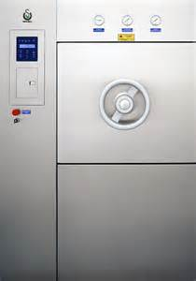

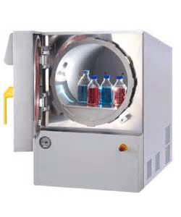  Autoclaving the basics  The following temperatures and times are for reference only, it is recommended that all cycles are tested and validated and a record of the test is kept  Sterilization (121°C 15 Minutes) General Sterilization of products including liquids. The autoclave will achieve the set temperature and times provided the machine is calibrated, most manufacturers of media and agars will recommend these parameters, therefore there is no need to ensure the load achieves the temperature throughout.  Liquids Waste (Min 126°C 30 minutes) As with any waste from the laboratory, the product must be autoclaved to a high level of efficiency. Therefore the recommendations for any waste product must, at least achieve 121°C for 15 Minutes throughout the load. In order to achieve this with liquids it would be recommended to have fitted a load sense probe or again, validation tests carried out to ensure the product is satisfactorily cooking.  General waste (Min 126°C 30 minutes) As with the liquid waste, it is vital to ensure the load is cooked throughout to the above mentioned parameters. General waste and liquid waste should not be mixed as liquids will react different to temperature than materials. It is also highly recommended that a load sense probe is used and | located in a suitable bottle, as the higher temperatures can melt the product and therefore melt around the probe.  High risk waste (Min 132°C 40 Minutes) Destruction waste of high risk products including liquids. For high risk waste such as category 2 and above laboratories a total destruction cycle is necessary in order to ensure all the load has been destroyed and the product is safe. 40 minutes is the minimum recommended time but it is highly recommended that the load is again tested before use.  How to load an autoclave for best results  Bottles and liquid loads. Ensure that all bottles are loaded with as much and equal spacing around them, let the steam get around the load, do not clump the bottles in one space in the vessel. Tighten lids and then turn a half back, this will stop them from re-pressurizing and breaking also reduce any liquid loss during the cycle.  Bagged waste loads. When loading bagged waste it is imperative that the steam can get all around the load, to ensure this do not over fill the bags, or over fill the machine. Open the bags at the neck as much as possible do not tie with tape unless really necessary. Load the bags evenly and try to get as much air space as possible. Place the bags in a suitable container that can withstand high temperatures.  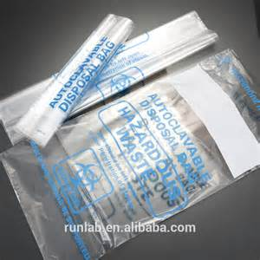 |  | Be Safe  Do`s  - Be safe, autoclaves are very dangerous machines, steam, electrics, electronics and mechanical parts all under pressure, a recipe for disaster if misused.  - Find out how to switch the machine off in an emergency including electrical and water supplies.  - Wait until the machine has finished its cycle, do not attempt to open an autoclave with any non-liquids in, above 80°C, bottles can re-pressurize and explode so do not open until 65°C if loaded with liquids.  - Always check the machine over before starting the machine.  - Check there is sufficient water.  - Check the seals are not worn.  - Check the load probe is sitting in cold fresh water in a suitable bottle. Also check the probe is not damaged.  - Check the correct program is selected and the temperature and times are correct.  Don’ts  - If you are not trained to use the machine, do not use it! Get training first.  - If you don’t know, don’t be afraid to ask.  - Don’t forget to fill the machine with water and a clean machine is a happy machine, therefore clean the water from the vessel at least once a fortnight.  - Don’t forget to wear the correct PPE, safety comes first! Goggles, gloves and lab coats!  - Don’t handle hot bottles of liquids especially if the liquid is bubbling.  - Don’t become complacent with autoclaves they are dangerous machines if misused, always respect them.  - Don’t continue to use the machine if you notice anything unusual, different noises, burning smells or steam leaks, always switch off! And call
 |  |  | an engineer.

Training Record for the use of Autoclaves within the University
By signing this document, you agree to the following statements on Autoclave usage within the university buildings.
- I have read and understood the User guide to effective and safe Autoclaving leaflet.

I have received full training on autoclaves to carry out any of the following.

- I can use the autoclaves safely and have capable knowledge of the autoclaves available to me.
- I can safely load and unload the products to be autoclaved.
- I know what to do in the event of a failed load.
- I know the safety procedures and shut off procedures in the event of an autoclave malfunction.
Date of training | Level of training | Name of trainee | Department | Signature

Training level
- Fully trained -trained on autoclaves for use, programming and to train other users
- Trained -trained on autoclave use and programming only
- User -trained on autoclave use only

