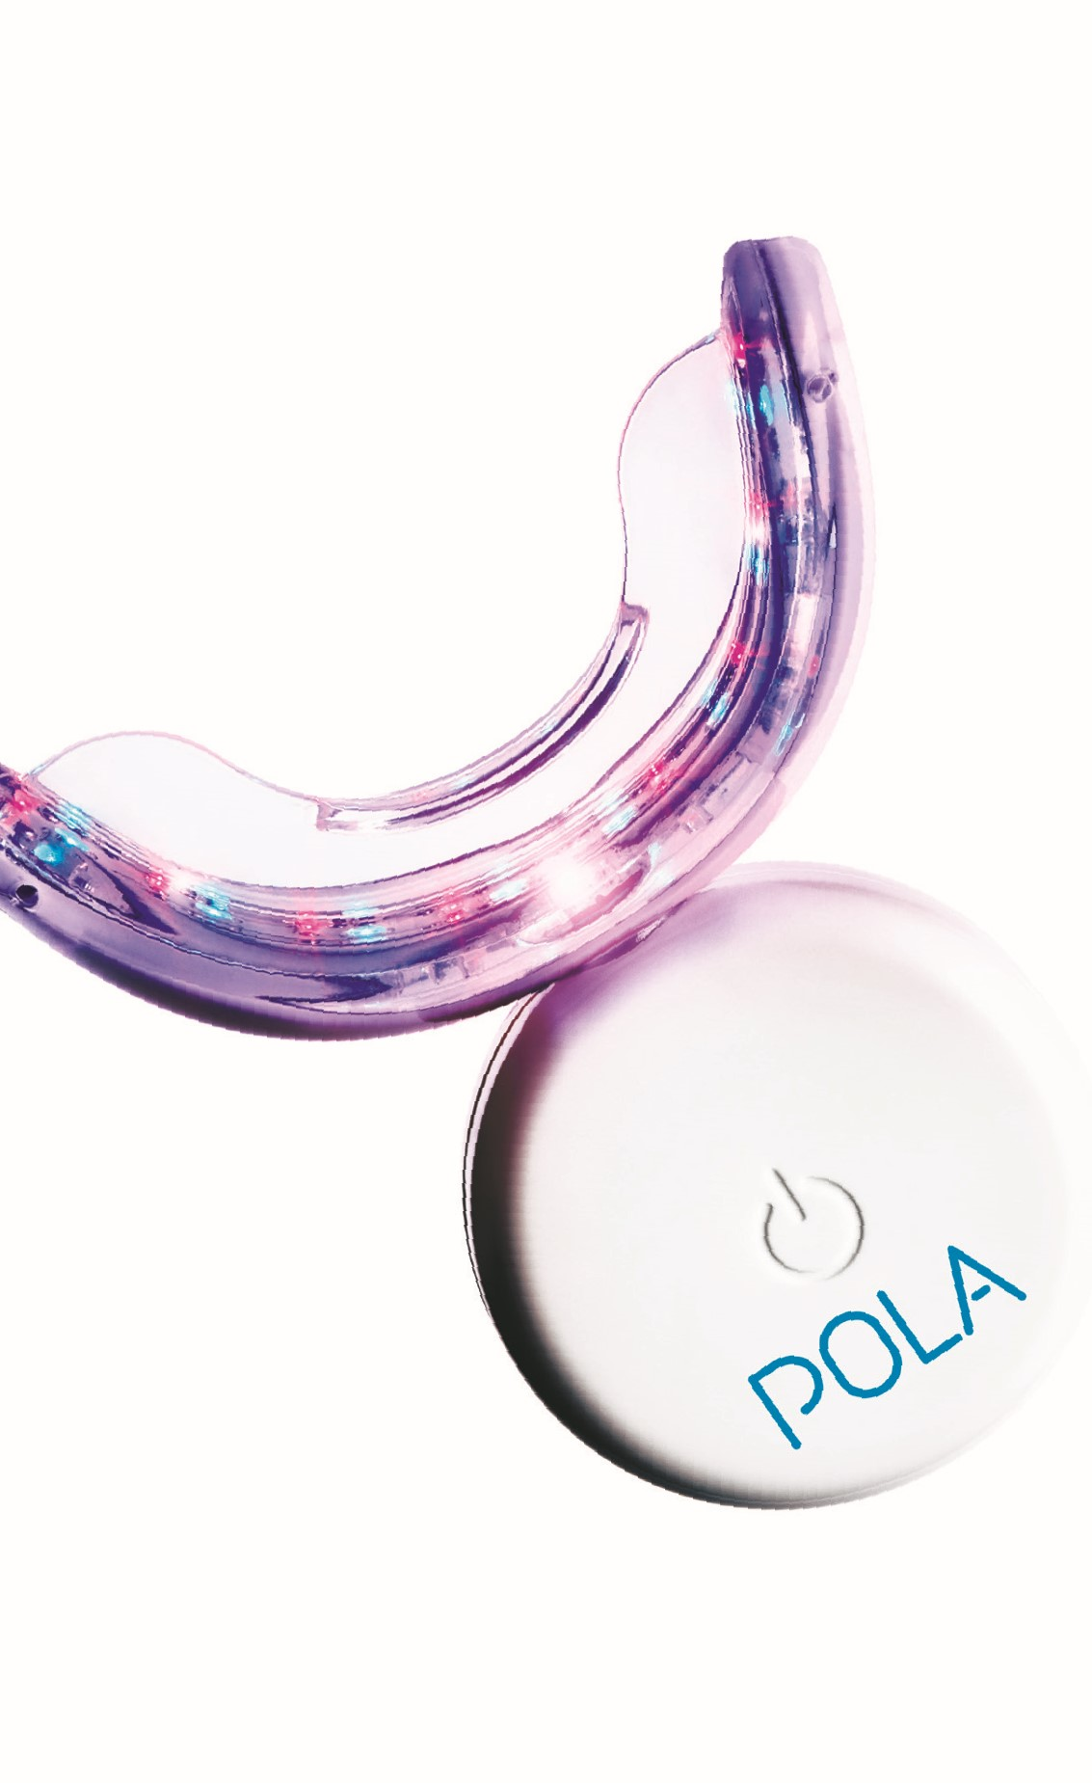

ENJOY A

BRIGHTER,

MORE CONFIDENT

SMILE IN 5 DAYS

EASY

TO USE

FROM JUST

MINUTES

20

A DAY

WHITER

TEETH IN

FIVE DAYS

PROFESSIONALLY

USED AND

RECOMMENDED

# PROFESSIONAL TOOTH WHITENING SYSTEM

Over 1 million people across 100 countries have trusted Pola to achieve a safer, quicker and whiter smile.

The Pola Light advanced tooth whitening system combines Pola’s award winning whitening formula, with targeted LED technology. And all from the comfort of your home.

* Fast acting, delivering you whiter teeth in 5 days
* Formulated to safely remove long term stains
* Returns your smile to your whitest natural shade possible
* Extra hydration to minimise sensitivity
* Remineralization to strengthen your teeth
* Fully rechargeable LED light for your future tooth whitening treatments

**POLA DAY 6% KIT**

1 x Pola LED mouthpiece

3 x 3g Pola Day 6% tooth whitening syringes

1 x 5.5mL Pola Luminate (for tooth whitening touch ups)

1 x USB charging cord

1 x Instruction guide

**POLA DAY 9.5% KIT**

1 x Pola LED mouthpiece

4 x 3g Pola Day 9.5% tooth whitening syringes

1 x USB charging cord

1 x Instruction guide

3

# INSTRUCTIONS FOR USE

FOR PATIENTS AND DENTAL PROFESSIONALS

**Pola Day 6%, Pola Day 9.5% hydrogen peroxide and Pola Luminate advanced tooth whitening system**

Pola Day and Pola Luminate are neutral pH take home tooth whitening solutions. Each is pleasantly flavoured, crystal clear with a unique blend of soothers, conditioners and a water content high enough to further reduce sensitivity. **INDICATIONS FOR USE:**

* Whitening of discolored vital teeth.
* Whitening of discolored non-vital teeth.

## STORAGE AND SHELF LIFE

* Store in a cool place and out of direct sunlight at temperatures between (2°-25°C / 35°-77°F).
* Do not use after expiration date.
* A warranty period of one (1) year is provided for the Pola LED mouthpiece. Please retain proof of purchase for you to claim the warranty.

## FOR EFFECTIVE RESULTS

* Do not eat, drink or smoke during treatment.
* Do not smoke immediately after treatment - wait for at least two hours.
* Foods and drinks containing strong colors should be avoided for at least 48 hours after the treatment period or consumed in moderation.
* Use gel at room temperature.

## PRECAUTIONS

* To be used under the supervision of a dentist.
* Keep out of reach of children and pets.
* Not to be used by pregnant or lactating women or children under 14 years old.
* Patients with a history of chemical allergies are advised to carry out allergy testing by a specialist before using these products.
* Discontinue use if any unusual sensitivity or reactions occur and consult your dentist.
* Do not inject Pola Day or Pola Luminate into the body.
* CAUTION: FEDERAL LAW RESTRICTS THIS DEVICE TO SALE BY OR ON THE ORDER OF A DENTIST.
* SDS available at www.sdi.com.au or contact your regional representative.

Note: Patients with sensitivity will require a day or two break between treatments. Shortening treatment time is also suggested.

## FIRST AID

**Eye (contact):** Hold eyelids apart and flush with running water for at least 15 minutes. Seek medical advice if symptoms persist.

**Skin (contact):** Wash thoroughly with water and seek medical advice if symptoms persist. **Ingestion (large amount):** If swallowed, do NOT induce vomiting. Rinse mouth. Drink plenty of milk or water and seek medical advice.

**Inhalation:** No symptoms expected.

# DIRECTIONS FOR USE

Attach the syringe tip provided to the syringe. Apply a small line of Pola Day gel evenly along the inner front

Clean your teeth and rinse your

Pola LED mouthpiece before use.

Optional:

Record your

tooth shade on the last page.

**1**

of the top and bottom of your Pola

LED mouthpiece.



**2**

TIP: Using the markings on the syringe as a guide, allow one sixth of the syringe (0.5g) per tooth whitening session for both top and bottom of the tray.

Fit the Pola LED mouthpiece to your

mouth and bite down.

For Pola Day, please use the following

instructions:

**3**

5

## POLA DAY 6% AND POLA DAY 9.5% HYDROGEN PEROXIDE WHITENING

* Press "on" button twice for the Blue / Red LED
* LED will activate for 10 minutes

When the LED activation ends, your whitening session is complete. Repeat twice a day for 5 days.

After reaching your treatment

duration, remove the mouthpiece

and wipe away any excess gel/saliva

with a dry tissue.

Rinse the mouthpiece and wash

it with lukewarm water. Do not

submerge it in water.

**4**

Rinse mouth or brush teeth once

whitening session is complete.

**5**

Or the treatment time can be 15 minutes if there are no signs of sensitivity.

* Press “on” button once for the Blue LED
* LED will activate for 15 minutes

When the LED activation ends, your whitening session is complete. Repeat twice a day for 5 days.

## ONLY AVAILABLE IN POLA DAY 6% KIT

|  |
| --- |
| **POLA LUMINATE INSTRUCTIONS FOR USE**   1. Blot dry the front surface of teeth with a tissue. 2. Whilst retracting the lips, apply a thin layer of Pola Luminate solution to the front surfaces of the teeth, re-loading brush as required. 3. After application do not let your lips touch your teeth for 30 seconds to ensure a thin whitening film forms on the teeth. 4. Leave Pola Luminate solution on teeth for a minimum of   minutes. Do not eat or drink during this time to maximize results.  Use Pola Luminate twice a day for 2 weeks for best results.  7 |

## MAINTAIN YOUR WHITE SMILE ANYWHERE AND ANYTIME

Easily fitting into your bag, jacket or pocket,

Pola Luminate is perfect for an instant whitening boost.

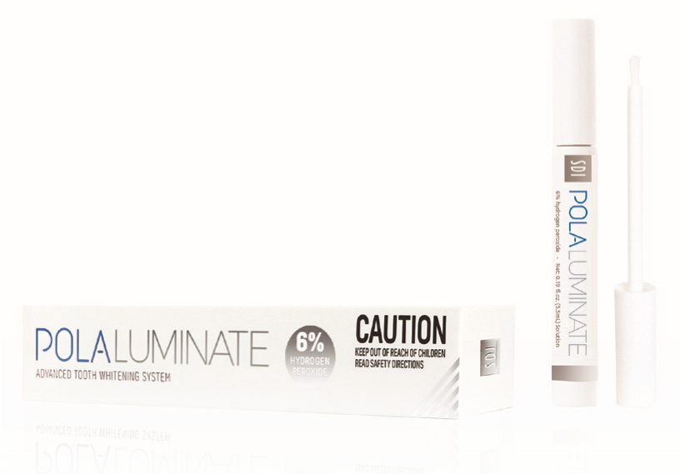Its whitening formula and easy to use brush applicator helps you maintain a confident white smile anywhere and anytime.

## FREQUENTLY ASKED QUESTIONS

**HOW MUCH WHITER WILL MY TEETH BE?**

Many teeth whitening manufacturers make claims of ‘5 shades’ whiter or similar. However, this can be misleading as it depends on the original shade of your teeth and the current staining on your teeth. Pola is formulated to remove the toughest stains from your teeth and return your teeth to their whitest natural color.

**HOW LONG WILL MY TEETH STAY WHITE?**

Your lifestyle is the greatest influence on your oral health. If you’re an avid drinker of coffee, wine or soft drinks, your teeth whitening will diminish quickly than someone who prefers water.

Typically, your whitening will be at its best for the first 6 months, before slowly diminishing. Your Pola Luminate is a perfect instant touch up solution at anytime.

**HOW MUCH POLA DAY WHITENING GEL DO I APPLY?**

Only a small amount is required for each session. Do not overfill your mouthpiece, as gel may spill on to your gums and cause sensitivity. Using the markings on the syringe as a guide, allow one sixth of the syringe (0.5g) per tooth whitening session on both top and bottom of the tray.

**THE TREATMENT GUIDELINES RECOMMEND TWO APPLICATIONS PER DAY. SHOULD I COMPLETE BOTH APPLICATIONS IN ONE SITTING?**

For best results, we recommend completing the two applications one after the other.

**IS POLA WHITENING SAFE?**

Yes. Clinical studies have shown that teeth whitening with carbamide peroxide or hydrogen peroxide is safe if performed under the guidance and supervision of a trained dentist. With a history of improving teeth for 50 years, our Pola whitening scientists have refined an industry leading tooth whitening formula that removes tough ‘rusted on’ stains, while remaining completely safe for your teeth.

**WILL THE WHITENING PROCESS HURT?**

A small minority of people may experience short term teeth sensitivity during the whitening process. This sensitivity will subside quickly and does not lead to tooth or gum problems. If you are experiencing pain, stop the whitening process and consult your dentist.

**HOW DO I CHARGE THE POLA LED MOUTHPIECE?**

Once the LED light starts to flash, charge the Pola mouthpiece using the supplied USB charger cord. The light will continue to flash while charging and will stop flashing once fully charged.

**HOW SHOULD I STORE THE POLA LIGHT KIT?**

For best results, store the Pola whitening gel in a safe location with a temperature between 35°F - 77°F (2°C - 25°C).

**HOW CAN I ORDER MORE POLA WHITENING GEL?**

To order more Pola whitening gel for future treatments, simply contact your dentist. Your dentist can provide you with additional Pola whitening gel syringes, which are compatible with the Pola Light system.

**HOW DO I CLEAN THE POLA LED MOUTHPIECE?**

Please use only water and soap to clean the Pola mouthpiece. Avoid the use of abrasive materials and cleaning substances.

9

# SHADE GUIDE

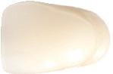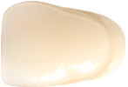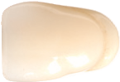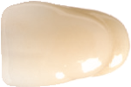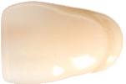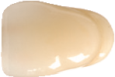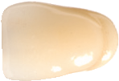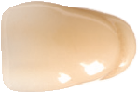

upper

1

2

3

4

5

6

7

8

lowe

r

Name:

Date:

SDI Limited

3-15 Brunsdon Street

Bayswater, Victoria 3153 Australia

**AUSTRALIA** 1 800 337 003 **www.sdi.com.au**

Connect with us! Share your Pola Light moments! We look forward to hearing from you.

PAK41405 A

INSTAGRAM

@pola_smile

FACEBOOK

Pola Smile



FOR MORE INFORMATION VISIT

polawhite.com.au