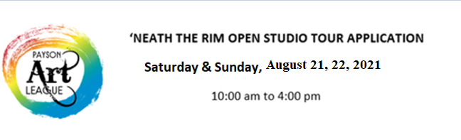
RULES/INFORMATION
All Artists are invited to participate in the Open Studio Tour. If you are not a member of PAL, you need to fill out a membership form and pay a $30 fee.
Artists that have not participated in any PAL Art Shows will be juried.
All ART work shall be designed and hand crafted by the Artist. Prints and castings, etc. are allowed. Acceptable items include all media Artwork: painting, sculpture, etchings, silkscreen, photography, jewelry, glass, enamel, ceramics, rock, wood, metal, fiber Art, pine needle craft and leather.
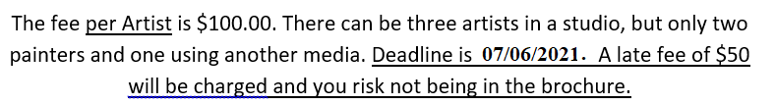
Artists may donate Artwork, prints, cards, etc. for the raffle. Proceeds go to the educational fund.
Artists will be notified of their acceptance or rejection as soon as possible after their application, photo and fee is received.
Each Artist is required to have an AZ transaction tax ID number and is responsible for collecting sales tax.
Artists are encouraged to demonstrate how they create their ART.
Light refreshments may be served.
For more information, contact chairman, Sally Myer 928 472 8651 solveig4art@yahoo.com

