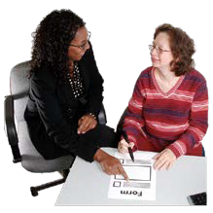
If you need help filling out this application form, please
📧Email: Hello@bridgecreative.org
or
☎ Phone: 01388 449410

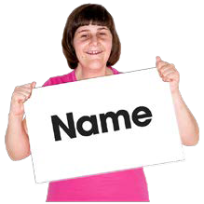
Please put your Name in the box below

Please put your Home Address & Postcode in the box below

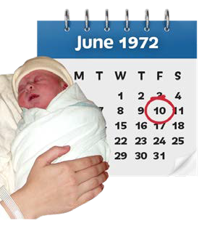
Please put your Date of Birth in the box below using the DD/MM/YYYY format
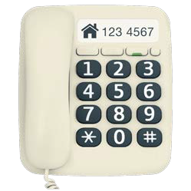
For example, if you were born on January 1st 2001, it would look like: 01/01/2001

Please put your Home Telephone Number in the box below if you have one

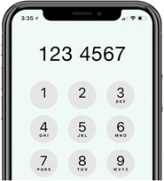
Please put your Mobile Telephone Number in the box below

Please put your Email Address in the box below

Please put an X in the box that shows the best way to contact you
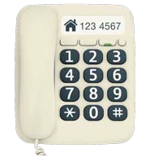
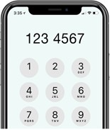

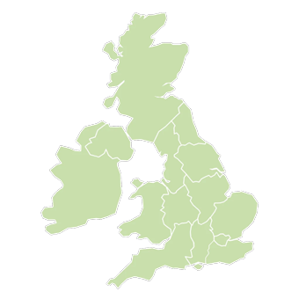
Are you allowed to work/ volunteer in the UK?

Yes No

For some questions you might need an extra piece of paper or text document. If everything you want to write does not fit in the box write the question down and continue your answer on your extra paper/text document. When you have finished your application remember to attach any extra paper you’ve used.

We need to know about any work experience, volunteering or skills you have that could help you in this role. In the box below tell us about the name of the place you worked/volunteered and what you had to do on a day-to-day basis.

💡 Tip: If you’ve done any similar work to the work you want to do with us, make sure to write about it.

Job Name/Role | Who You Worked Or Volunteered With | When Was This? | What Did You Do Daily? | What Skills Did You Use?

We need to know about your education and training. In the box below please tell us any schools, colleges, universities and independent places of study you’ve been to.
Please also include any training you have completed.

Tell us about yourself. In the box below write about:
- Why do you want to work with us?
- Why do you think you would be good at this job?
- What do you like to do in your spare time?
💡 Tip: Read the Job Description and Person Specification. That will tell you the kind of person we’re looking for. If there’s anything there that you do really well, make sure to write about it!

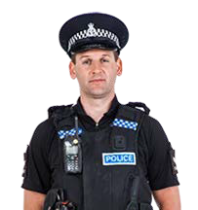
Have you ever been in trouble with the police? This might be:
- been found guilty of a crime
- had a caution
- had a reprimand
- had a final warning

Yes No

If you answered yes, please use the box below to tell us about what happened.

We need to talk to 2 people who know you well who could write a reference for you.
A reference is a form someone fills in to say if they think you will be good at the job.

One of these people can be a friend or relative, the other person should be someone like:
  - A Teacher or Tutor
  - Someone you have worked with

  - Someone who supports you

A Work Coach
Person 1
●
Name

Name
Person 2

Home Address

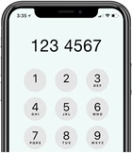
Telephone Number
Home Address

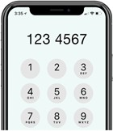
Telephone Number

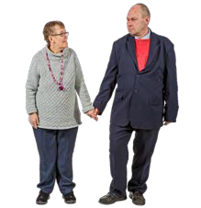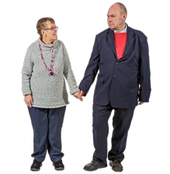

Email Address
Relationship To You
Email Address
Relationship To You

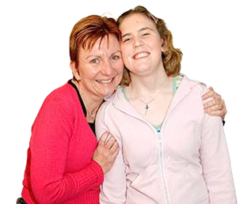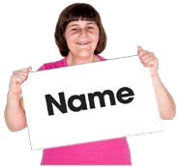

We hope an emergency never happens but if it does, we need to know who to contact. in the boxes below please write down the details of a friend or family member you trust. This person should be someone we can contact in an emergency if we need to.
Name

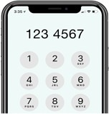

Telephone Number
Relationship To You
Your GP Surgery
Your GP Surgery Phone Number

If an emergency happens and we need to talk to a medical professional we may need to share your Emergency Contact details with them.
Before we can do that, they need to say were allowed to do that. Is your Emergency contact happy for us to do this?
Yes No

9

If you agree that all of the answers you have written are true then write your signature and the date below. If you are using a computer, just write your name in the signature box instead.

Please put your Signature in the box below

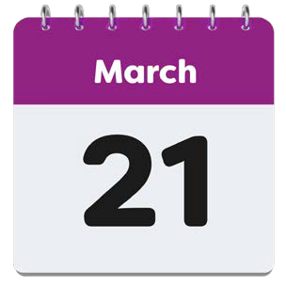
Please put Today's Date in the box below using the DD/MM/YYYY format
For example, if today was January 1st 2001 it would look like: 01/01/2001

It is the law (GDPR) that we keep your information safe. Please read the statements below carefully and let us know what you are and are not happy with.

I am happy for my details to be kept securely online or on paper and for it to only be shared with the Managing Director and the board of Directors

Yes No

I am happy for Bridge Creative to contact me using the details I have given.

Yes No

If you are happy with your answers to the statements above please put your
Signature and Today's Date using DD/MM/YYYY format in the boxes below

You have completed the application form. It’s a good idea to go back and check you have answered every question.
If everything is complete then send us back this form and any extra paper/documents you have used.

If you have printed and filled this form, please send a stamped letter with all of the documents you have filled out to:
If you have completed this document online or on a computer, please attach it to an email and send it to:

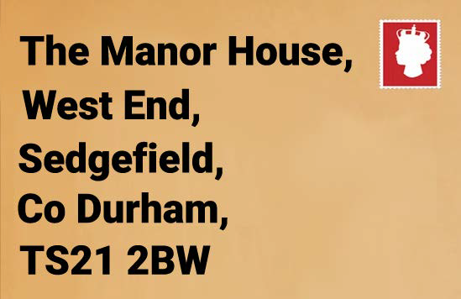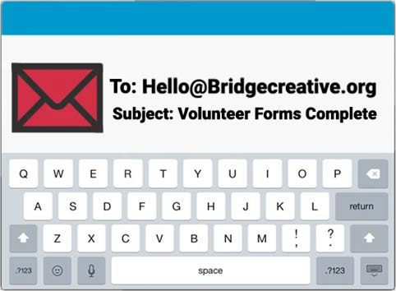

Thank you for taking the time to complete this application form! We will be in touch soon.

