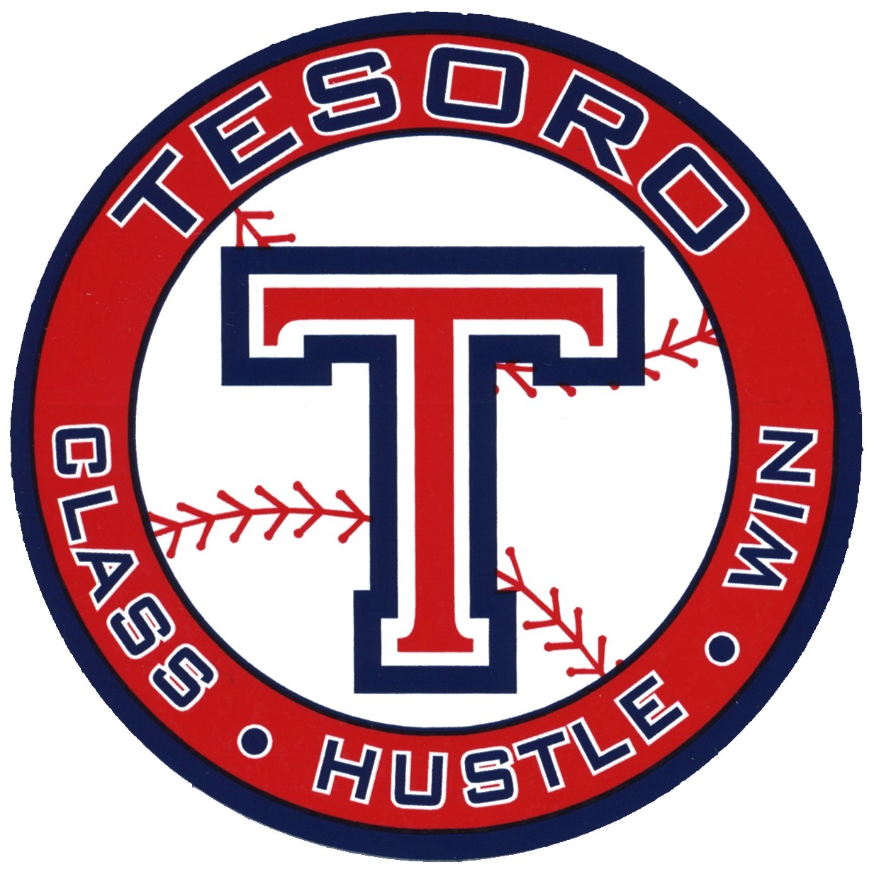

Unique Opportunity to promote your business!
TESORO BASEBALL BANNER SALE

Get your banner today to be seen by thousands at Tesoro High School
Banners: 3’x5’ at $300.00, 3’x8’ at $400.00, 3’ x 10’ at $500.00, renewals are $50 off,
5’ x 8’ $600.00 On Outfield Fence, renewals are $150 off, One 5’ x 10’ banner for the top of the snack bar for $1000.00, renewals $200 off.
Banners are high quality and will be displayed for maximum visibility and exposure to spectators attending all outdoor sporting events, Football, Baseball, Softball, Band Competitions, Pop Warner...
Limited Supply of Banners: Order Your Banner Today! Banners are multi colored and will be prominently displayed for 1 year starting January 1st 2018. Send CAMERA READY artwork to Michelle Farber, Sponsorship Chairman at 5farbers@cox.net or call 714-335-6403 with questions. We need high resolution photos and vector artwork for fonts and logos. Design software, such as Photo Shop, Corel Draw, or Adobe Illustrator is preferred.
We have limited space for banners which will make your banner more exclusive. We will post all banner sponsors on display board in multiple locations. Order by February 1st, 2018 to be included in our 2018 Season and busy Alumni Baseball game

------------------------------------------- Sponsorship information ------------------------------
Name of Tesoro Baseball Player: ____________________________________
Name of Company: ________________________________________________
Contact Person: __________________________________________________
Company Address:________________________________________________
E-mail:_________________________________
Phone Number:__________________________
Total Amt. Due: $___________________ Make checks payable to The TESORO Baseball Booster Club.

Please mail checks to the following:
Tesoro Baseball Boosters
23052-H Alicia Parkway, #197
Mission Viejo, CA 92692

We are registered as a Non-Profit 501 (c) (3), corporation.
Federal Tax ID Number is 26-4060764.

We are happy to accept any donations to help pay for our program.

