**PRE-K CLASSES**

**SUPPLIES REQUESTED**

* WIPES
* BOX OF TISSUES
* BLANKET/SHEET (for rest-time)
* 2 COMPLETE SETS CLOTHING (appropriate for current weather/climate including 2 pairs of socks & 2 underwear)
* HAIRBRUSH & COMB
* LARGE BACKPACK (to easily carry daily supplies & projects)
* ART SMOCK/OLD SHIRT (that covers clothing)
* GLUE STICKS (6)
* MARBLE NOTEBOOK (2)
* BOX OF CRAYONS & MARKERS
* BOX OF COLORED PENCILS
* #2 PENCILS (12)
* HARD PLASTIC PENCIL CASE
* 2-INCH WHITE BINDER
* PLASTIC POCKET FOLDERS (2)
* CURRENT FAMILY PHOTO

**Please be sure to**

**LABEL ALL your child’s items with** **COMPLETE FIRST & LAST NAME**

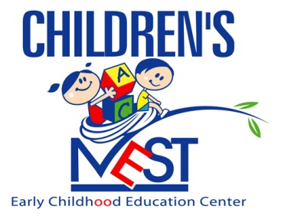

**“Nurturing Tomorrow’s Leaders”**

*Welcome to the new school year and “Let’s Dream it, Believe it,*

*And Achieve it!!!*