PRESCHOOL CLASSES
SUPPLIES REQUESTED

- WIPES
- BOX OF TISSUES
- BLANKET/SHEET (for naptime)
- 2 COMPLETE SETS CLOTHING (appropriate for current weather/climate)
- 2 EXTRA UNDERWEAR
- EXTRA SOCKS
- HAIRBRUSH & COMB
- LARGE BACKPACK (to easily carry daily supplies & projects)
- ART SMOCK/OLD SHIRT (that covers clothing)
- GLUE STICKS
- MARBLE NOTEBOOK
- 2-Pocket Folder
- BOX OF CRAYONS/MARKERS
- INDIVIDUAL PICTURE OF YOUR CHILD
- CURRENT FAMILY PHOTO

Please be sure to
LABEL ALL your child’s items with COMPLETE FIRST & LAST NAME

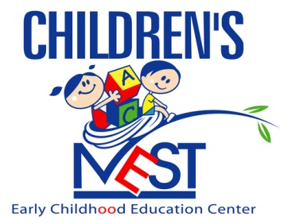

“Nurturing Tomorrow’s Leaders”

Welcome to the new school year and “Let’s Dream it, Believe it,
And Achieve it!!!

