**TODDLER CLASSES**

**SUPPLIES REQUESTED**

* DIAPERS/PULL-UPS
* DIAPER CREAM/OINTMENT
* WIPES
* BOX OF TISSUES
* BLANKET/SHEET (for naptime)
* 2 COMPLETE SETS CLOTHING (appropriate for current weather/climate)
* 2 EXTRA UNDERWEAR
* EXTRA SOCKS
* HAIRBRUSH & COMB
* LARGE BACKPACK (to easily carry daily supplies & projects)
* ART SMOCK/OLD SHIRT (that covers clothing)
* BOX OF CRAYONS
* 2 SIPPY CUPS (milk/water)
* INDIVIDUAL PICTURE OF YOUR CHILD
* CURRENT FAMILY PHOTO

**Please be sure to**

**LABEL ALL your child’s items with** **COMPLETE FIRST & LAST NAME**

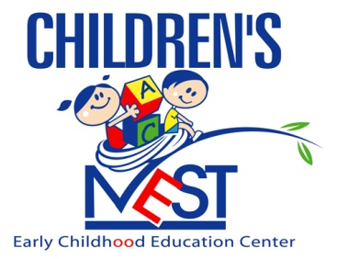

**“Nurturing Tomorrow’s Leaders”**

*Welcome to the new school year and “Let’s Dream it, Believe it,*

*And Achieve it!!!*