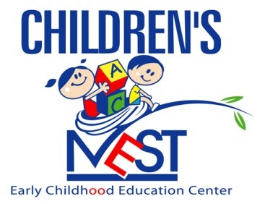

Dear Parents,

The following checked items are needed in your child’s cubby at school. It’s important that you bring these items in as soon as possible so that they may be readily accessible when needed. All items you bring in should be labeled with your child’s full name. I thank you in advance for your cooperation.

Thank you,
Your Child’s Teacher

Items for Infants: Items for Toddlers/Pre-School/Pre-K:
___Wipes ___Wipes
___Diapers ___Diapers
___Diaper Ointment ___Diaper Ointment
___2 Sets of Warm / Cool Clothing ___Pull-Ups (For Potty Training)
___Pair of Socks ___2 Sets of Warm / Cool Clothing
___Bibs ___Pair of Socks
___Sheet (For Crib) ___Underwear
___Hair Brush/Comb ___Sheet & Blanket (For Nap Time)
___Box of Tissues ___Hair Brush/Comb
___Sleeper Sack ___Smock or Old Shirt
___Box of Tissues

OTHER____________________________________________________________________________________________________________________________________________________________________________________________________________________________________________________

**All children’s items must be labeled with the child’s full name*

